**Earth and Planetary Surface Processes**

**Winter 2017 - Lab 4. River channel long profiles.**

**Wieboldt 310C, 10:30a-11:20a**

*Grades are not assigned for lab, but attendance is required.*

*If you are unable to make a lab, email* [*kite@uchicago.edu*](mailto:kite@uchicago.edu) *to set up an alternate time.*

Download TopoToolbox

<https://topotoolbox.wordpress.com/download/>

Unzip it, launch Matlab, and at the command prompt enter the following (recall that the ‘up’ arrow brings back the previous command). Substitute the actual location of the TopoToolbox-2 directories for “C:\path\to\wherever\you\installed\this\”

*addpath C:\path\to\wherever\you\installed\this\TopoToolbox-2*

*addpath C:\path\to\wherever\you\installed\this\TopoToolbox-2\utilities*

*addpath C:\path\to\wherever\you\installed\this\TopoToolbox-2\topoapp*

*addpath C:\path\to\wherever\you\installed\this\TopoToolbox-2\DEMdata*

**1. From raw topographic data to a river long-profile analysis.**

At the Matlab prompt, type

*DEM = GRIDobj('srtm_bigtujunga30m_utm11.tif');*

(Explanation of the filename: Space Shuttle Radar Topography Mission, Big Tujunga Creek – Southern California in the San Gabriel mountains, 30m resolution, Universal Transverse Mercator projection). You are looking at a small portion of a transpressional mountain belt, undergoing rapid (~mm/yr) tectonic uplift. Uplift is localized between the San Andreas Fault Zone (SAFZ) to the north, and the Sierra Madre Fault Zone (SMFZ) to the south. The area of the DTM is in the W of the gray box shown below (from DiBiase et al. Earth and Planetary Science Letters 2010).

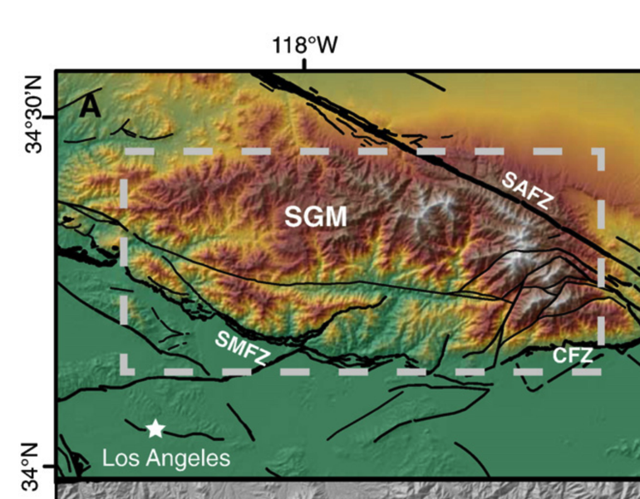

View the DEM:

*imagesc(DEM)*

and the DEM slope:

*imageschs(DEM,min(gradient8(DEM),1))*

Use ‘colorbar’ to look at the scale for Matlab images.

We will now carry out a standard hydrography workflow for this DEM. The steps are not specific to TopoToolbox, although the command names are. Before each command, type “help <commandname>” and read the description. For example, before entering the fillsinks command, type “help fillsinks.”

*DEMf = fillsinks(DEM);*

*FD = FLOWobj(DEMf); A = flowacc(FD);*

View a map of the stream network:

*imageschs(DEM,dilate(sqrt(A),ones(5)),'colormap',flipud(copper));*

*DB = drainagebasins(FD); DB = shufflelabel(DB);*

*A = flowacc(FD);*

Ignore parts of the DEM with a drainage area of <=10000 pixels, i.e. 0.9 km2; assume these are hillslopes.

*W = A>10000;*

Map view of the major streams:

*S = STREAMobj(FD,W);*

*plot(S)*

*S = klargestconncomps(S,1);*

*hold on; plot(S,* *'r')*

*plotdz(S,DEM)*

Note that there is a small dam 21km upstream (not important for this lab).

What is the overall slope of the main stem?

What is the overall slope of the tributaries?

**2. Average concavity, and deviations from the mean concavity.**

What is the elevation of the knickpoints? How tall are the knickpoints? Where are the knickpoints located?

*C1 = slopearea(S,DEM,flowacc(FD))*

What is the concavity index for these data?

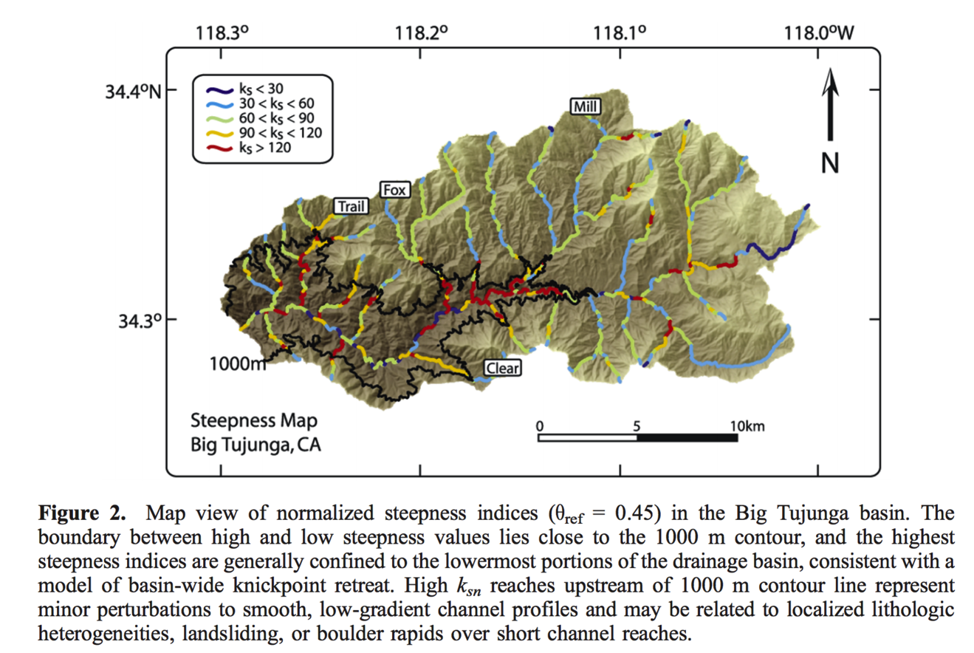

(From Wobus et al. JGR 2006).

Recall:

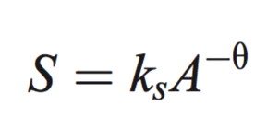 is equivalent to from lecture.

Here, theta is the concavity index, and *ks* is the steepness index. Notice how *ks* is related to uplift rate (i.e. tectonics), whereas the concavity index is related to *m* and *n*  in the streampower law which can be independent of tectonics.

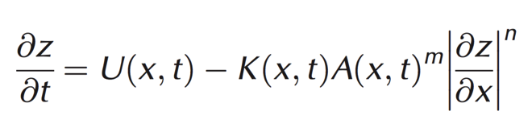

(note *k* in the streampower law is **not** the same as *ks*).

Now use the interactive ‘slopeareatool’

*slopeareatool(FD,DEM)*

“Change color” to red, and select some streams topographically below the knickpoints until you have built up many red dots on the slope-area plot. Change color to black, and do the same for some streams above the knickpoints (you may find it helpful to refer to Fig. 2 from the Wobus paper). Select “Curve fitting” and fit to both the red and the black data. What is the ratio of steepness indices between the two? Which is steeper for a given drainage area?

**3. Chi-profile analysis.**

Chi-profiles (also known as the “integral approach”) were developed to reduce noise in slope-area analysis, and to collapse multiple tributaries onto a single river profile. With elevation on the y axis, instead of distance along profile on the x axis, we plot instead



where xb is the beginning (downstream) of the profile and A0 is a reference drainage area (we will use 1 km2, which is the program default). In general we do not know m/n in advance. Enter

*C2 = chiplot(S,DEM,flowacc(FD))*

How does the program-reported best-fit (m/n) compare to your measurements and fits from slopeareatool?

You should see most of the tributaries collapse onto a single line with scatter that is much-reduced compared to ‘slopeareatool’. The non-linearity of this profile corresponds to changes in uplift rate with time. The signal of changes in uplift starts at the base of the river profile and propagates uphill (as a retreating knickpoint, for example as a back-eroding waterfall).

Based on the chi plot, what (qualitatively) is the history of uplift of the San Gabriel mountains? You can assume that uplift is spatially uniform between the San Andreas and the Sierra Madre fault zones, and varies only with time.

You should be looking at results that are qualitatively similar to those from Perron & Royden, Earth Surface Processes and Landforms, 2013 (copied below).

