Stratigraphy of Aeolis Dorsa, Mars: sequencing of the great river deposits
Draft by Edwin Kite. Intended for submission to ‘Icarus.’

Contents
1. Introduction
1.1 River deposits form part of a clastic wedge abutting the hemispheric dichotomy scarp
2. Photogeologic lithofacies
2.1 Pre-River Deposits (Sequence I)
2.2 River Deposits (Sequence II)
2.3 Alluvial Fans (Sequence III)
2.4 Yardang-Forming Layered Deposits (Sequence IV)

3. Key relationships
3.1 River deposits embay a dissected landscape formed of sedimentary rock
3.2 River deposits consist of at least three units, sealing a stratigraphic record of paleohydrology
3.3 Alluvial fans unconformably postdate thrust faults which crosscut thick river deposits
3.4 The unconformity below the yardang-forming materials corresponds to a >1 x 10⁸ yr time gap
4. Summary of stratigraphy
5. Discussion
5.1. Correlation between Aeolis Dorsa and Aeolis Mons (Gale crater’s mound, Mt. Sharp)
5.2. Intra-crater river deposits point to vast vanished sheets of river-deposit containing materials

5.3. Hypothesis: orbital forcing modulated erosion-deposition cycling in Aeolis
6. Conclusions
Abstract.
We use crosscutting relationships to establish the stratigraphic context of river deposits in Aeolis Dorsa, Mars. The Aeolis Dorsa river deposits form part of a clastic wedge abutting the dichotomy scarp and 10° E of Gale crater. Wind erosion has exhumed a stratigraphic section of sedimentary rocks consisting of at least four unconformity-bounded sequences. Pre-river deposits (>700m thick) are embayed by river deposits (>400m thick), which are in turn unconformably draped by alluvial-fan deposits (<100m thick), and yardang-forming layered deposits (>900 m thick) unconformably drape all previous deposits.

River deposits embay a dissected landscape formed of sedimentary rock. The river deposits consist of at least three apparently-concordant units with a consistent stratigraphic order. The stratigraphic order of the river deposits is the same as the order of the units that host them, so the river deposits seal a stratigraphic record of climate-driven river-forming episodes. The total interval spanned by river deposits is >(1 x 10⁶ – 2 x 10⁷) yr, and this is extended if we include alluvial-fan deposits. Alluvial-fan deposits unconformably postdate thrust faults which crosscut thick river deposits. This relationship suggests a relatively dry interval of >4 x 10⁷ yr after river deposits formed and before the alluvial fans formed, based on probability arguments. Yardang-forming layered deposits unconformably postdate all of the earlier deposits. They contain rhythmite and their induration suggests (near-)surface liquid water availability at the time of deposition. The time gap between the end of river deposition and the onset of yardang-forming layered deposits is constrained to >1 x 10⁸ yr by the high density of impact craters embedded at the unconformity. The time gap between the end of alluvial-fan deposition and the onset of yardang-forming layered deposits was at least long enough for wind to erode 20-30m into the alluvial-fan deposits. We correlate the yardang-forming layered deposits to the upper layers of Gale crater’s mound (Mt. Sharp / Aeolis Mons) and the alluvial fans to Peace Vallis fan in Gale crater. Alternations between periods of low mean obliquity and periods of high mean obliquity may have modulated erosion-deposition cycling in Aeolis.

1. Introduction
The key to boiling down data about ancient Mars into constraints on ancient climate change is to reduce the data to stratigraphic records (that is, time series). Stratigraphic records of orbiter-resolved river deposits hold particular promise because rain or snowmelt must exceed infiltration plus evaporation to allow sediment transport by rivers. Therefore, river deposits could constrain the number, magnitudes, and durations of the wettest (and presumably most habitable) climates in Mars history. An exceptionally dense concentration of exceptionally well-preserved river deposits (Burr et al. 2010) exists in the Aeolis Dorsa sedimentary basin, 10° E of Gale crater: placed end-to-end, these wind-exhumed channel outcrops would lap Mars three times. The range of river-deposit styles, the high frequency of interbedded impact craters, and evidence for major erosional episodes interspersed with deposition all suggest that Aeolis Dorsa’s time series of constraints on climate is unusually long and complete (Kite et al. 2013a, Kite et al. 2014). Within a single sedimentary basin such as Aeolis Dorsa, wet-climate events can be placed in time order using crosscutting relationships. (This is an advantage, because it sidesteps the uncertainties involved in using crater retention ages and lithostratigraphy to correlate small fluvial deposits between sedimentary basins.) However, the stratigraphy of Aeolis Dorsa has not been clearly defined at the ~100m stratigraphic scale needed to isolate river-forming climate episodes. The number and relative timing of river-forming climate episodes therefore remains an open question. Nor has it been clearly demonstrated that the river deposits are as old as the rocks that contain them. Are they embedded within the basin stratigraphy, or are they much younger cut-and-fill? To engage with the full complexity of the paleohydrologic record at Aeolis Dorsa, we need this stratigraphy.
Our aim in this study is to identify river-containing basin-scale geologic units in the basin and show their distribution in space and time. We describe concordant and unconformable superposition relationships between these units that constrain the relative timing of river-forming climate events. Our focus on the stratigraphic context of the river deposits is complementary to broader regional studies (Irwin & Watters 2010, Zimbelman & Scheidt 2012). The key results of this study are summarized in Fig. 22.
1.1 River deposits form part of a clastic wedge abutting the hemispheric dichotomy scarp
Aeolis Dorsa sediments form part of a clastic wedge thinning N-ward away from the equatorial dichotomy boundary (Figure 1) (Irwin et al. 2004, Irwin & Watters 2010). The dichotomy boundary (~5 km relief) was formed very early in Mars history (Andrews-Hanna et al. 2008b, Marinova et al. 2008, Nimmo et al. 2008, Irwin & Watters 2010, Andrews-Hanna 2012). Aeolis Dorsa sediments are thickest towards the S (near where they contact the equatorial dichotomy boundary scarp), and thin in the N (where they contact basaltic lava plains), defining a clastic wedge. Sediments in our study area consist of two rises (Aeolis and Zephyria Plana), separated by a trough with abundant river deposits (Aeolis Dorsa) (Fig. 2a). The deposits are not older than Late Noachian based on regional geologic mapping by Irwin & Watters (2010).

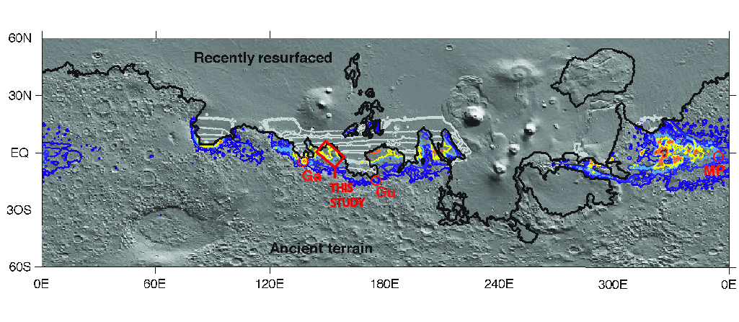
Figure 1. Our study area (red rectangle) in global context (modified from Figure 14b in Kite et al. 2013b). Background is shaded relief Mars Orbiter Laser Altimeter (MOLA) topography, illuminated from top right. The colored contours show the relative likelihood of seasonal melt-water availability from an orbitally-integrated model of surface liquid water production (Kite et al. 2013b). Contours are at 1%, 5%, 10%, 25%, 50%, 75% and 90% of the global maximum liquid-water availability. The black line marks the border of the area of recently-resurfaced terrain, and approximately corresponds to the hemispheric dichotomy. Within the area of recently-resurfaced terrain, liquid-water availability contours are grayed out. Landing sites of long-range rovers are shown by red circles: Ga = Gale (Mars Science Laboratory Curiosity rover); Gu = Gusev (Spirit, Mars Exploration Rover MER-A); MP = Meridiani Planum (Opportunity, Mars Exploration Rover MER-B).

2. Photogeologic lithofacies
In §2 we describe orbiter lithofacies in the order of their timing relative to key unconformities that are described in §3. Details of our approach are given in the Supplementary Methods.
a)
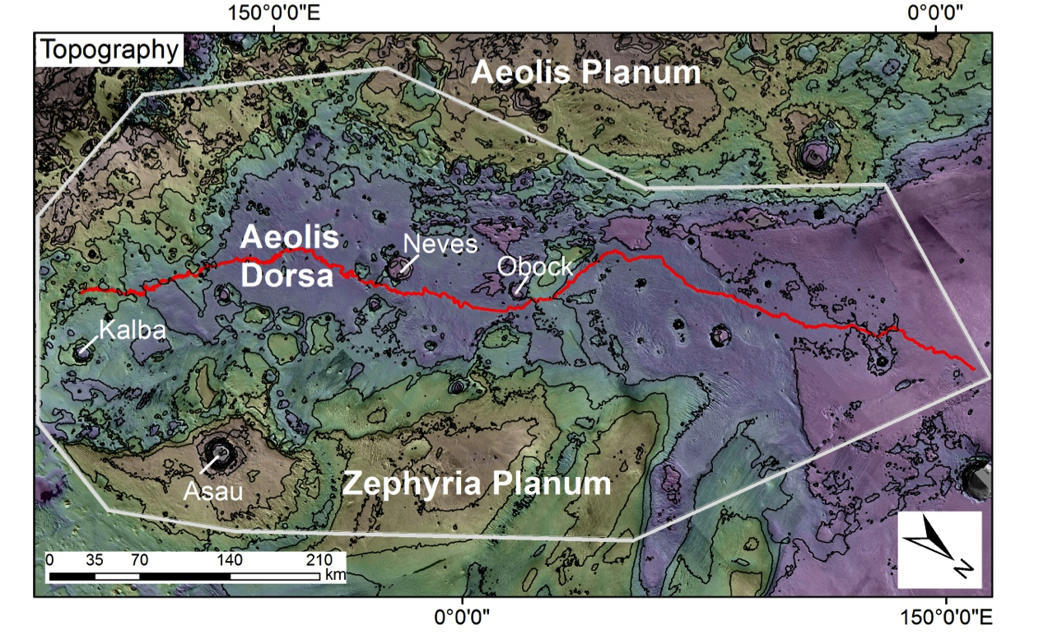
b)
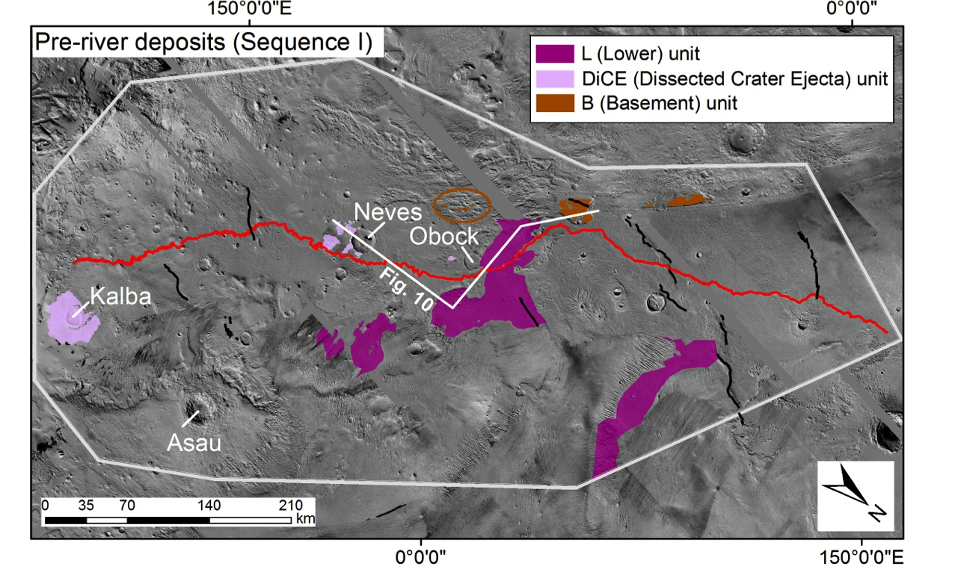

c)
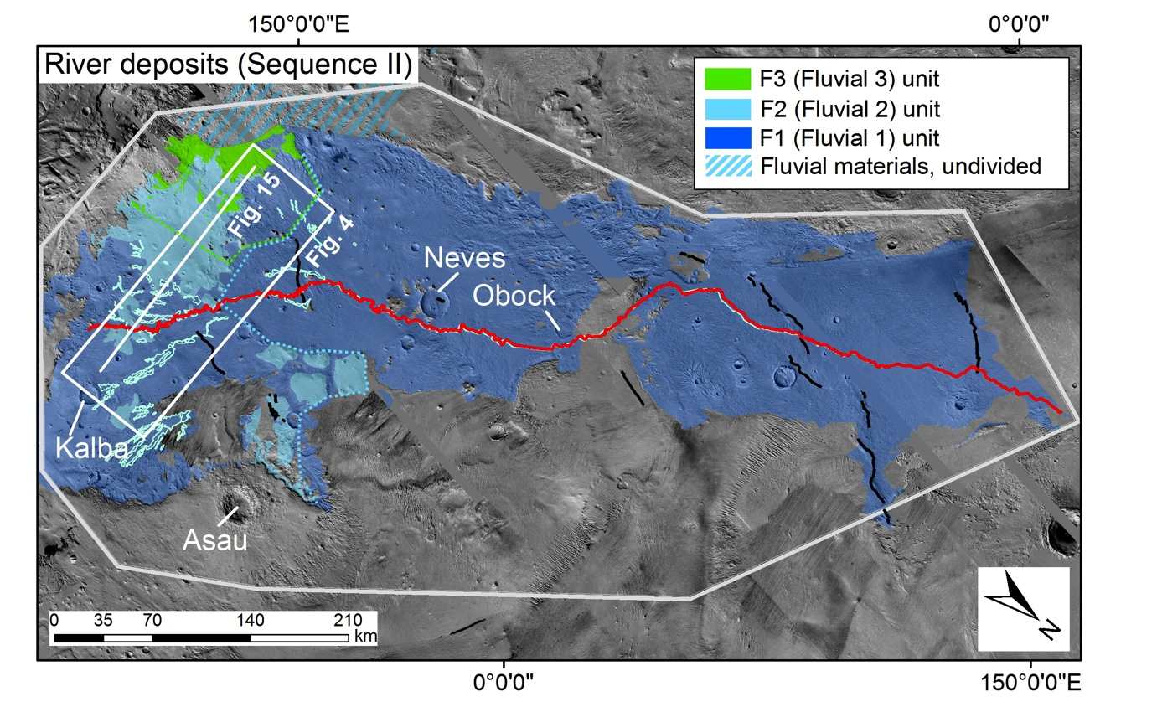
d)
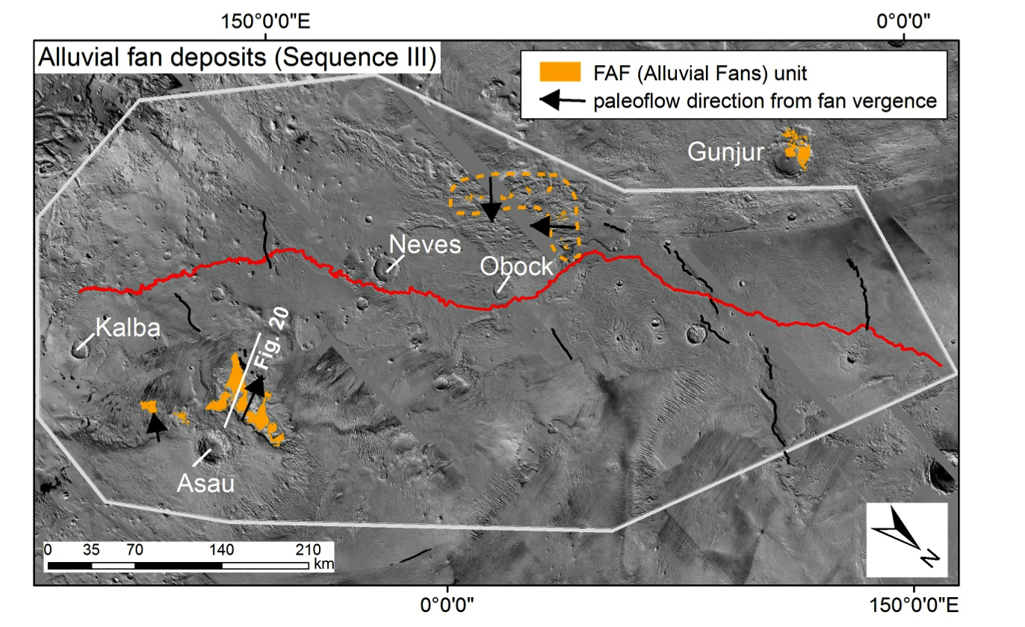

e)
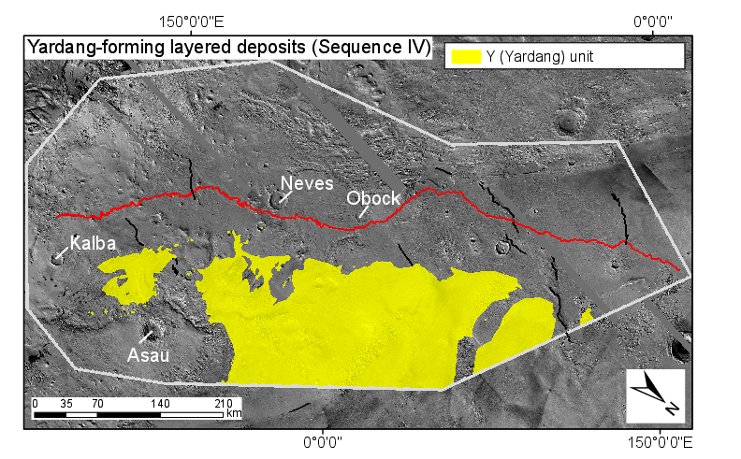
Figure 2: Maps showing distribution of unconformity-bounded sedimentary-rock sequences in Aeolis Dorsa. Red line traces the longest chain of river deposits on Mars. Black lines show mapped wrinkle ridges, which are the surface expression of thrust faults (Golombek et al. 2001). The white line shows the outer limits of our study area. (a) Topography. (b) Pre-river deposits (Sequence I). (c) River deposits (Sequence II). Dashed lines show northern limit of outliers of F2 (dashed cyan line) and F3 (dashed green line). (d) Alluvial-fan deposits (Sequence III). (e) Yardang-forming layered deposits (Sequence IV) – note 3 main lobes, plus small scattered outliers. (Figure S1 shows distribution of material not assigned to a sedimentary sequence.)
2.1 Pre-River Deposits (Sequence I).
We define pre-river materials as Sequence I (Figure 2a). Pre-river materials consist of three informally-defined units: the L (Lower), DiCE (Dissected Crater Ejecta) and B (Basement) units. All three units represent patchy remnants of the hummocky landscape that the river deposits flooded (Figures 2b, 2c). The river deposits are interbedded with impact craters. The high frequency of these interbedded impact craters requires that the basin- and sequence-averaged accumulation rate of the river deposits was ≲(13-200) μm/yr (Kite et al. 2013a).
L: Lower Unit. Description: L consists of material that is topographically high-standing relative to the river deposits, generally to the E of Aeolis Serpens, and with a high density of km-sized craters. The craters are variably degraded, with some being very degraded. Topographic continuity implies the unit continues as subcrop under much of northern Zephyria Planum (the area draped by the central lobe of Y: Fig. 2e). In turn, this implies a proto-rise in the area of present-day Zephyria Planum rise and northern Aeolis Dorsa consisting of L. The erosional expression of L at CTX scale is variable. Erosionally resistant ridges and/or knobs at 500m-1km scale are common, and layering is visible within and between the knobs. Layering is also visible in planform as elliptical and highly-distorted breaks-in slope, reflecting nonuniform wind erosion by serial retreat of <10 m-high scarps (Farley et al. 2013). Near 149.8°E 1.7°S, the layering is traced by a series of ~50m high risers separated by flats. The flats are traced by trains of aeolian bedforms. In HiRISE, fine-scaled layering is common. We interpret L as sedimentary rocks of unknown origin (e.g. volcaniclastic, aeolian, fluvial, lacustrine, or marine). Near 149.5°E 1.72°S, the L lobe is 700m above surrounding terrain (along a profile which rises ~700m in <14 km). Because the strata appear horizontal, we interpret this elevation difference as a stratigraphic thickness.
Qualitative description of paleoclimate indicators: None.
DiCE: Dissected Crater Ejecta. Description: DiCE consists of the remnant ejecta blankets of Neves crater (diameter, φ = 21 km), Obock crater (φ = 15 km), and Kalba crater (φ = 14 km). The river deposits onlap the ejecta blankets, and river channels also cut into the ejecta.
Neves crater: Crater ejecta, marked by ejecta sculpture including radial grooves and terminal ramparts, forms isolated, locally high-standing lobes (Figure 3a). The ejecta blanket of Neves is not visible to the N and W of the Neves rim. Topographic depressions between the high-standing lobes are 3-6 km wide.
Obock crater: Two lobes of Obock ejecta are visible in an erosional inlier beneath finely-layered materials. They can be identified by impact sculpture. Both terminate 14km from the Obock rim.
Kalba crater: The original distal margin of Kalba crater ejecta blanket including radial grooves and terminal ridges is preserved to the N, E and S of the rim. To the W it is absent. Meander-belt deposits overlie the ejecta blanket. The northernmost meander belt deposit is broken in two by the distal rampart of Kalba's ejecta blanket; the two parts of the meander belt deposit are joined by a valley cutting across the rampart ridge (inset of Figure 3b).
Qualitative description of paleoclimate indicators: Around Neves, DiCE is crosscut by branched, highly sinuous valleys. These channels significantly postdate the Neves impact: they run in a consistently N-S direction rather than draining radially away from the crater, crosscut a φ = 1.5 km crater on the ejecta blanket (Fig. S2), and run across terminal ramparts of Neves ejecta without deflection (E1001, inset). These relationships suggest that the channels formed after river-containing deposits had accumulated around Neves up to the level of the ramparts. These channels cannot result from localized precipitation triggered by the Neves impact. Impact-triggered runoff shuts down within 10⁻⁵-10³ yr (Kite et al. 2011, Mangold et al. 2012). This is much less than >3 x 10⁸ yr, which is the expected wait time for φ ≥ 1 km diameter impacts on a 270 km² area (remnant Neves ejecta) using a typical Hesperian impact flux (Michael 2013). There is also no evidence for point sources of surface water near Neves, such as volcanic vents or chaos terrain. We conclude that these channels must record regional or global climate processes.
(a)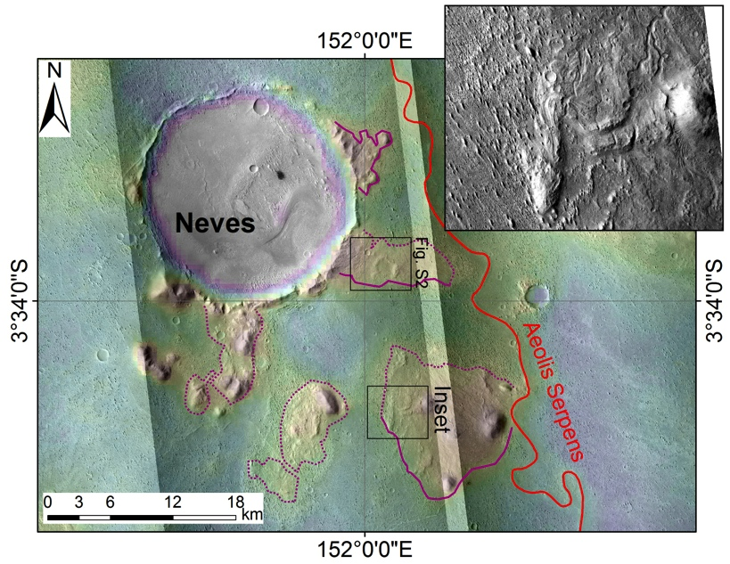
(b)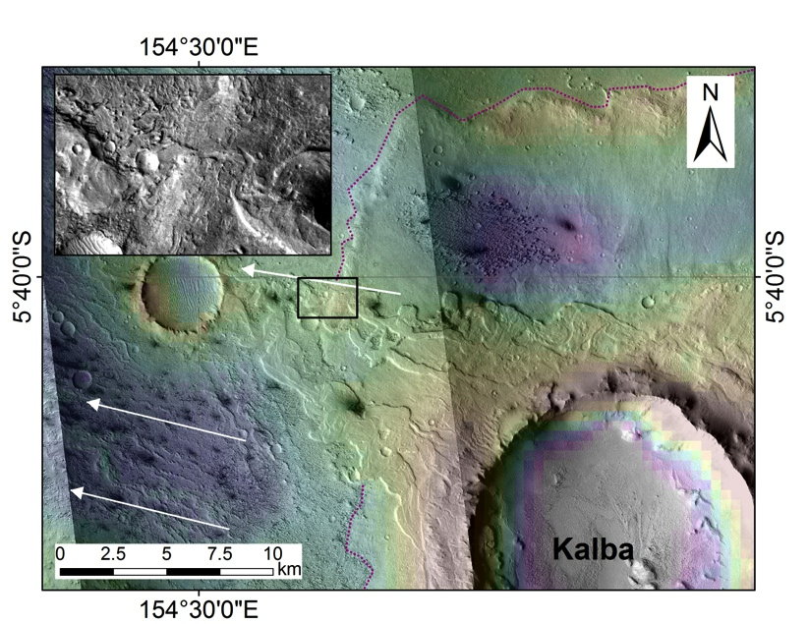
Figure 3. (a) Distribution of locally-highstanding dissected crater ejecta (DiCE) around Neves crater. Color ramp is MOLA Mars Experimental Gridded Data Record (MEGDR) 128ppd topography (red is high). Purple line corresponds to the contact of DiCE (dashed where inferred or gradational), which is onlapped by river deposits. Red line is the trace of the Aeolis Serpens river deposit (Williams et al., 2013). Inset shows details of Neves ejecta sculpture (rampart margin of ejecta lobes), which is incised by channels (Fig. S2). Described features are best visible in in P15_006894_1744_XI_05S208W and P05_003136_1746_XN_05S208W. (b) Kalba’s ejecta blanket is onlapped to the W by finely-layered, yardang-forming material containing numerous river deposits (Burr et al. 2009). White arrows show general trend of the rivers. Meander-belt deposits encircle the Kalba rim, less than 1km from the rim. Where the northern meandering river crossed the distal rampart of Kalba ejecta, it cut a valley (inset). The described relationships are best visible in P06_003215_1752_XI_04S205W and B11_014014_1746_XI_05S205W.
B (Basement) unit. Description: B is exposed in small patchy inliers stretching along the W margin of Aeolis Dorsa from 0°N to 3°S (>200 km) (Fig. S3). Each inlier is bounded by inward-facing scarps of F1. B is identified by retention of a large number of craters with intact rims, absence of yardangs, and absence of layering. Each of these attributes distinguish B from almost all of the other orbital facies in Aeolis Dorsa, allowing straightforward correlation (Fig. S3). These attributes are consistent with volcanic materials. High crater density suggests a low crater-obliteration rate in the modern environment.
Qualitative description of paleoclimate indicators: None.
2.2 River Deposits (Sequence II).
Sequence II consists of the main river deposits of Aeolis Dorsa (Burr et al. 2009, Williams et al. 2013), plus concordant rocks above and below those river deposits (Fig. 4). We identify 3 informally-defined units within Sequence II (F1, F2, and F3) using erosional expression and channel morphology.
The courses of the larger rivers are preserved as inverted channels. Unconformities exist within the river deposits - they are easily recognized as knicks in the rims of large river-cut craters - and it is possible that some of these correlate with unrecognized basinwide disconformities (§5.2). The total interval spanned by river deposits is >(1 x 10⁶ – 2 x 10⁷) yr (Kite et al. 2013a).
Qualitative description of paleoclimate indicators: River deposits require runoff ultimately sourced by precipitation (rain or snowmelt). In turn, runoff requires surface liquid water production in excess of infiltration plus evaporation.
F1 (Fluvial 1) unit. Description: F1 consists of large meander-belts, often with preserved scroll-bars; sinuous ridges at the same level as the meander belts, or below; and the materials that surround the large meander belts (Figs. 4, 5). Large meander belts are especially obvious S of the Equator (Burr et al. 2009). The longest river deposit on Mars is a meandering channel – Aeolis Serpens (red line in Fig. 2) (Williams et al. 2013). Aeolis Serpens defines the axial spine of F1; myriad smaller sinuous ridges are oriented transversely to it. We find river deposits exposed at all stratigraphic levels within F1, and the channel-deposit proportion appears high, so we interpret the unit as river deposits. F1 forms yardangs and retains few recognizable small impact craters. There is a prominent cliff-forming member of F1 at (roughly) the stratigraphic level of the best-preserved meandering channels including Aeolis Serpens. In a terrestrial context this caprock within a fluvial succession would be interpreted as a coarse-grained layer (Armitage et al. 2011).
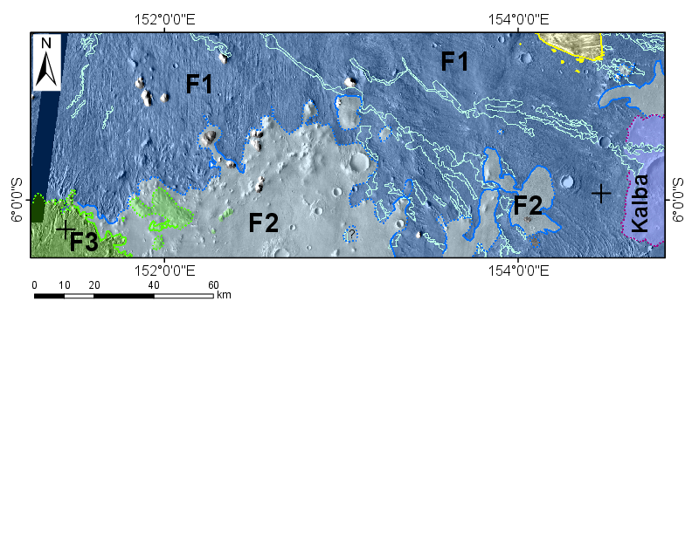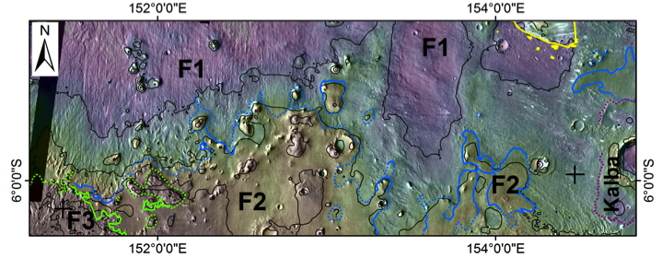
Figure 4. To show distribution of river deposits in S Aeolis Dorsa. Top panel: Topographically lower fluvial unit (F1) erodes to form yardangs, and contains broad meander belts (cyan outlines) and a high density of sinuous ridges. The overlying F2 unit is smoothly eroding and contains few meander belts – although it does contain many channel deposits that are not visible at this scale. F3, which overlies F2, marks the return of meandering-channel belts. Contacts are shown as a solid lines where mapped with high confidence, and as dotted lines where inferred. Pre-river materials include Kalba ejecta (lilac tint with red edge), and post-river materials include yardang-forming rhythmite (yellow tint). Background image is THEMIS VIS mosaic. Crosses mark the end of the sketch cross-section drawn in Figure 15. Bottom panel: Topographic context for river deposits. Contours are at 200m intervals.
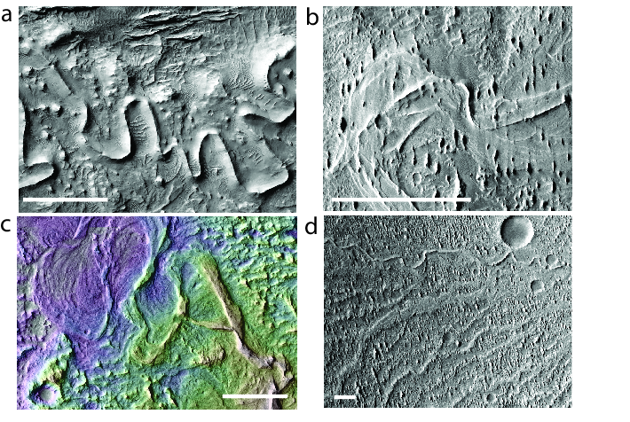
Figure 5. Examples of unit F1 orbital facies. Scale bars correspond to 500m. Details: a) Near 154.6°E 4.9°S, ESP_016269_1750. b) Near 151.6°E 5.0°S, ESP_024985_1750. c) Near 153.6°E 5.9°S, ESP_019882_1740. d) Near 150.6°E 4.2°S, P16_007105_1774_XN_02S209W.
F2. (Fluvial 2) unit. Description: F2 consists of slope-forming, smoothly eroding materials. Yardangs are uncommon. F2 concordantly superposes F1 and is smoothly eroding, retaining many small craters, and with fine-scale channels. Sinuous channels are common but scroll bars are very uncommon – in contrast to F1. CTX and HiRISE resolution is generally necessary to see the channels (Fig. 6).
F3. (Fluvial 3) unit. Description: F3 is defined by a prominent cliff-forming member stratigraphically >200m above the Aeolis Serpens (Fig. 7). HiRISE shows that undermining of the cliff-forming member produces large blocks and boulders. Sinuous inverted channels are obvious even in 18m-per-pixel THEMIS VIS images. Scroll bars are again found although the extremely detailed preservation of F1 is absent. The material underneath the prominent cliff-forming member is easily removed by wind erosion. It is seen only in a few inliers, but appears to be layered sedimentary material. We group this underlying material with F3.
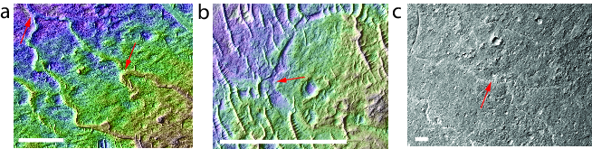
Figure 6. Examples of unit F2 orbital facies. Scale bars correspond to 200m. Red arrows highlight junctions between channels. a) Near 154.6°E, 5.4°S. PSP_007474_1745. b) Near 153.7°E, 6.1°S. ESP_019882_1740. c) Near 154.0°E, 6.0°S. B20_017548_1739_XI_06S206W.
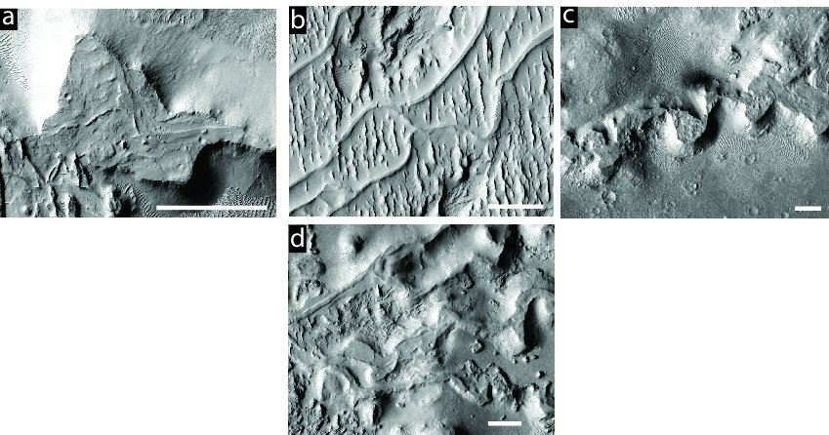
Figure 7. Examples of facies in unit F3. Scale bars are 500m across. a) Near 152.3°E, 6.8°S; ESP_018181_1730. b) Near 151.4°E, 6.2°S. PSP_002279_1735. c) Near 152.0°E, 6.1°S. P05_003136_1746_XN_05S208W. d) Near 151.7°E, 6.3°S. G05_02034_1735_XI_06S206W.

2.3 Alluvial Fans (Sequence III).
Sequence III consists of the alluvial fans in Aeolis Dorsa. We recognize alluvial fans by their branching network of ridges radiating downslope away from a locally high-standing fan apex (Fig. 8). These low-sinuosity ridges are interpreted as inverted channels (e.g. Moore & Howard 2005, Lefort et al. 2012, Morgan et al. 2014). Alluvial-fan deposits are only found superposing large-river deposits in Aeolis Dorsa, and are always directed away from highs in the modern topography (Aeolis Planum Rise, Zephyria rise; Fig. 2d). All alluvial fans in Aeolis Dorsa have hollows or shallow moats at their apex, which we interpret as the water and sediment sources for the alluvial fans (Kite 2012). Alluvial-fan deposits are volumetrically minor in Aeolis Dorsa. No single alluvial fan covers >100 km². However, the deposits are key climate indicators and are bounded top and bottom by major unconformities (§3.3, §3.4). There are no cases where large-river deposits embay or crosscut alluvial-fan deposits.
Qualitative description of paleoclimate indicators. Alluvial fans require surface overland flow – surface liquid water production in excess of infiltration plus evaporation. Morgan et al. (2014) argue that the alluvial fan-forming paleoclimate supported snowmelt; we think that their conclusions can be carried over to our study area (Kite et al. 2013a).
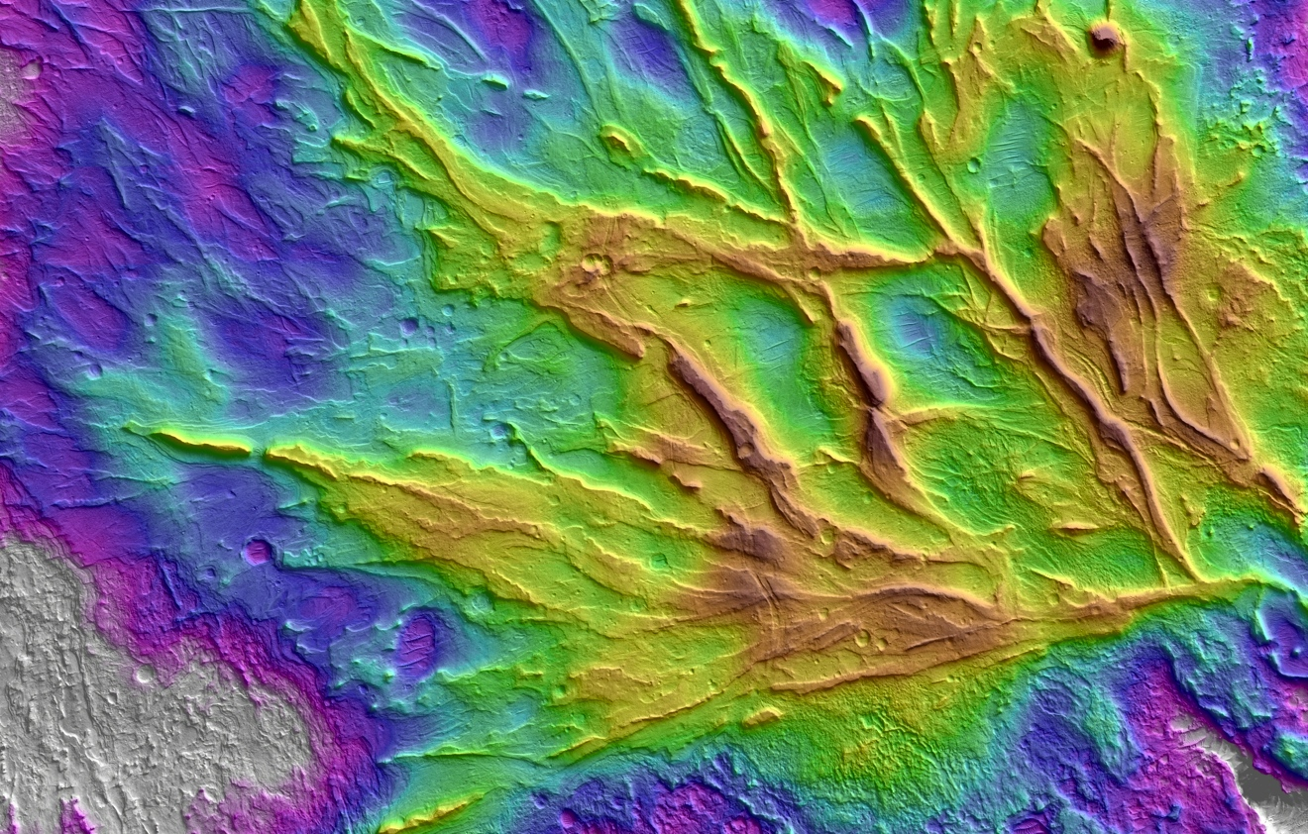
Figure 8. Example of alluvial fan facies (alluvial fan near 154.8°E 4.6°S). North is to the right. This DTM (constructed from HiRISE stereopair PSP_009795_1755/PSP_009623_1755) is publicly available at http://geosci.uchicago.edu/~kite/stereo.

2.4 Yardang-Forming Layered Deposits (Sequence IV)

Description. The youngest deposits in Aeolis Dorsa are defined by steep-sided outcrops of layered material that is densely and deeply grooved by aeolian erosion (Ward 1979). These youngest deposits (Y, yardang-forming) drape all older materials unconformably (Fig. 2e, §3.4) suggesting correlation with the rhythmite-capped unconformity at Gale crater (§5.1, Edgett & Malin 2001, Anderson & Bell 2010, Thomson et al. 2011, Wray 2013, Le Deit et al. 2013). The yardang-forming layered deposits in Aeolis Dorsa form three main lobes and numerous smaller outliers, suggesting that Y once formed a continuous sheet across Zephyria Planum and eastern Aeolis Dorsa (Fig. 2e; see also Harrison et al. 2010). The northernmost lobe of Y is >900m thick.
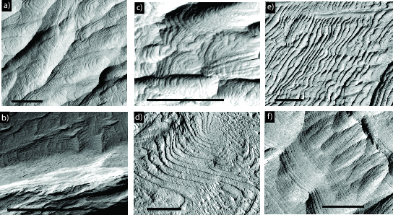
Figure 9. Rhythmite on Mars. (a)-(c), from within our study area; (d), in the central lobe of the Medusae Fossae Formation; (e-f), previously described rhythmite from Grotzinger & Milliken (2012). In all images, scale bars are 100m long, N is up, and illumination is from the left. Details: (a) near 154.8°E 4.2°S, ESP 019605_1755; (b) near 154.7°E 4.9°S, ESP_016269_1750; (c) near 154.7°E 4.4°S, ESP_026897_1755; (d) near 179.4°E 10.5°S, ESP_028650_1695; (e) near 24.1°E 9.9°N, PSP_010353_1900 – Henry Crater; (f) near 137.7°E 4.9°S, PSP_008002_1750 – upper formation of Gale crater’s mound (Mt. Sharp / Aeolis Mons.)
“Rhythmite” facies rocks are very extensive on Mars (Grotzinger & Milliken 2012a). In the words of Grotzinger & Milliken (2012a): “Primary attributes of the rhythmite facies are very thin (~1-5m) beds that exhibit a repeatable thickness (are rhythmic) within a vertical sequence […] Planar bedded stratal geometries dominate, perhaps uniquely so.” The youngest deposits in Aeolis Dorsa contain many layers that are rhythmite by this definition. Examples of regularly spaced layers are shown in Fig. 9. Layers of constant stratigraphic thickness will be constantly spaced on outcrops of constant slope.

Qualitative description of paleoclimate indicators. Rhythmite formation probably involved orbitally-paced accumulation of atmospherically-transported dust or sand (Lewis et al. 2008). Consistent with this interpretation, radar sounding of the northernmost main lobe of Y shows that it has a low permittivity of ~3, indicating high porosity (consistent with loess) or a high percentage of buried water ice (Carter et al., 2009).
The yardang-forming deposits sustain locally >60° slopes (from our DTMs) and resist deflation to allow yardangs to form. Both observations indicate rock-like strength. This rock-like strength shows that the sediments are indurated. This induration probably required some (near-)surface liquid water for cementation – fog, thin films, snowmelt or groundwater upwelling (Andrews-Hanna & Lewis 2011, Head & Kreslavsky 2001, Kite et al. 2013b, Lewis et al. 2008, Moore 1990, Nickling 1984). Therefore, orbitally-paced surface liquid water availability some time after the rivers flowed is suggested by the rhythmic bedding and rocklike strength of the youngest deposits in Aeolis Dorsa (Lewis et al. 2008).
All four sequences are bounded above by the mobile cover (aeolian bedforms, sand sheets) and by the modern erosion surface.

3. Key relationships
Three main unconformities define the sedimentary sequences of Aeolis Dorsa:
- Erosion of pre-river sediments followed by embayment of this eroded landscape by an ordered stack of river deposits (§3.1, §3.2);
- Tectonic deformation and probable erosion of the river deposits followed by alluvial-fan formation (§3.3);
- A lengthy period of region-wide erosion followed by deposition of yardang-forming materials containing rhythmite (§3.4).
3.1 River deposits embay a dissected landscape formed of sedimentary rock
Our stratigraphic interpretation of the Sequence I – Sequence II contact is summarized in Fig. 10.
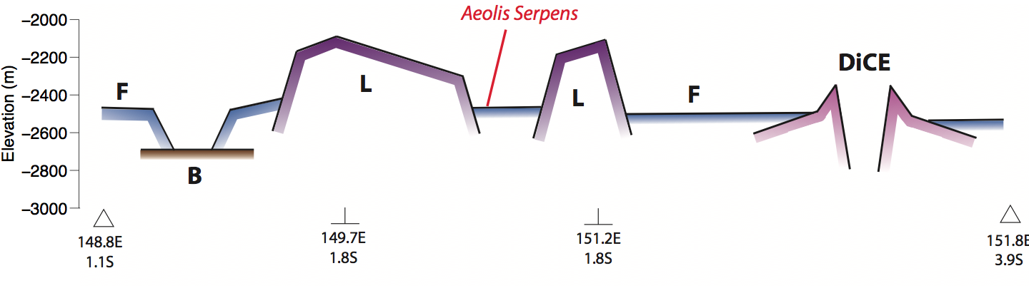
Figure 10. Interpretative cross-section showing the relationship between river deposits (F) and pre-river deposits (L, DiCE, B).
Our evidence for this is as follows.
L and DiCE underwent patchy erosion prior to deposition of F. The pattern of erosion can be reconstructed if we assume that L originally formed a nearly-horizontal sheet, and that crater ejecta blankets were formed as axisymmetric deposits. Especially around Neves, crater-ejecta erosion was very heterogeneous at 10⁰-10¹ km scale. Most of Neves' ejecta blanket was completely eroded away but the remaining parts retain detailed ejecta sculpture (Fig. 3). This irregular pattern of erosion (for material of the same lithology) is not consistent with aeolian deflation. It is consistent with glacial erosion, piping erosion, or river erosion (Rose et al. 2013, Pederson & Head 2011). River deposits are extremely abundant <100m stratigraphically above the unconformity surface, and river deposits are found within, surrounding and incising all three craters. Therefore, river erosion is the simplest explanation for erosion of L and DiCE to form the sub-river-deposits unconformity surface.

a)
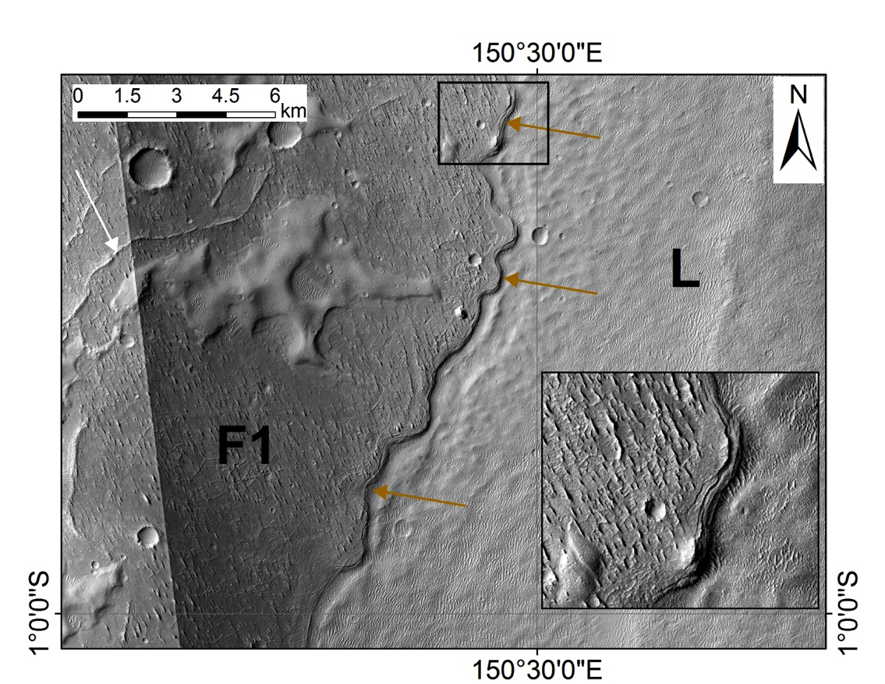
b)
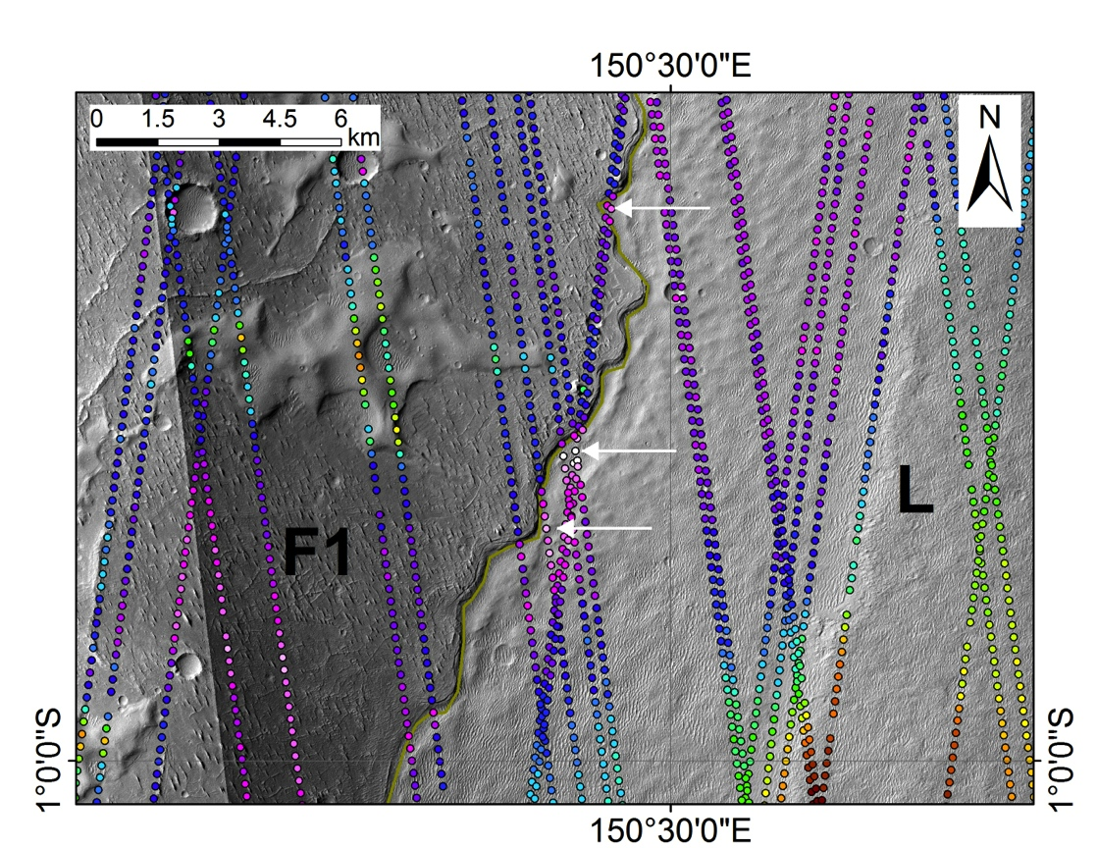
c)
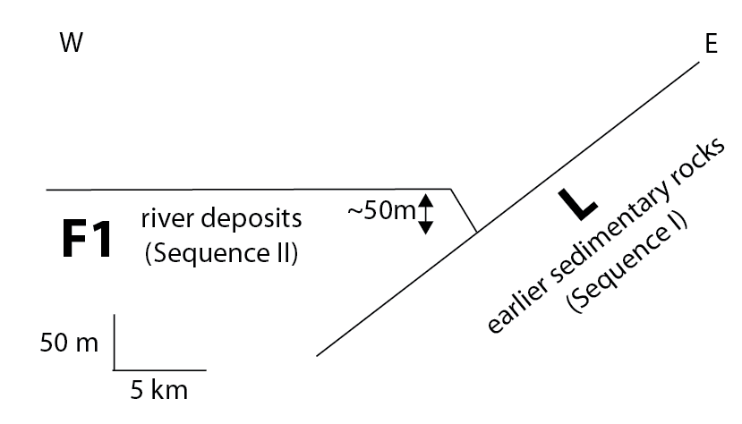
Figure 11. (a) showing undulating contact (brown arrows) between L and F1, with F1 embaying L. See text for discussion and Fig. 14 for context. Inset (black rectangle) shows marginal graben on F1. Sinuous ridges (example: white arrow) interpreted as inverted channels superpose sheet of yardang-bearing material. (b) showing topographic relationships near L-F1 contact (brown line). White arrows highlight points along the contact where F1 locally overlies L. The described features are best visible in P19_008397_1791_XI_00S209W and P16_007105_1774_XN_02S209W. Color range is -2250m (red) to -2470m (white). (c) Sketch interpretation.
Williams et al. (2013, their Figure 15) showed evidence that L is onlapped by the river deposit Aeolis Serpens. We agree, and present additional evidence that the river deposits embay an erosionally-dissected proto-rise built up of L (Figs. 11-14). In Fig. 11a there is an undulating contact between an outcrop of L to the E that rises to >-2250m, and a topographically low-standing sheet of material containing sinuous ridges (interpreted as river channels) to the W that never rises above -2380m. However, Precision Experimental Data Record (PEDR) tracks prove that everywhere along the contact, the river-deposit-containing unit is higher than L (Fig. 11b), typically by 50m. These topographic relationships show that the river-channel-containing material embays L.
The embayment relationship can be traced for ~50 km along the undulating contact. Fig. 12 shows a similar onlap relationship at the margin of a separate lobe of L 70km to the SW. Fig. 13shows a similar onlap relationship at the margin of a separate (smoothly-eroding) lobe of 130 km to the SSE. In each case, L outcrop is less resistant to late-stage erosion than the river-deposit-containing material so it is topographically lower than the river-channel-containing material at the contact. Fig. 14 summarizes these relationships.
(a)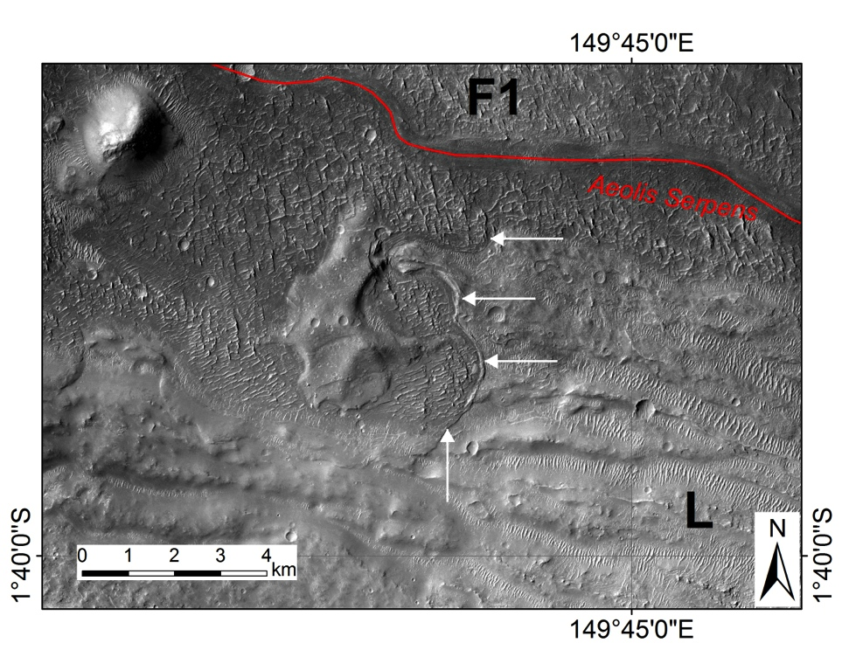
(b)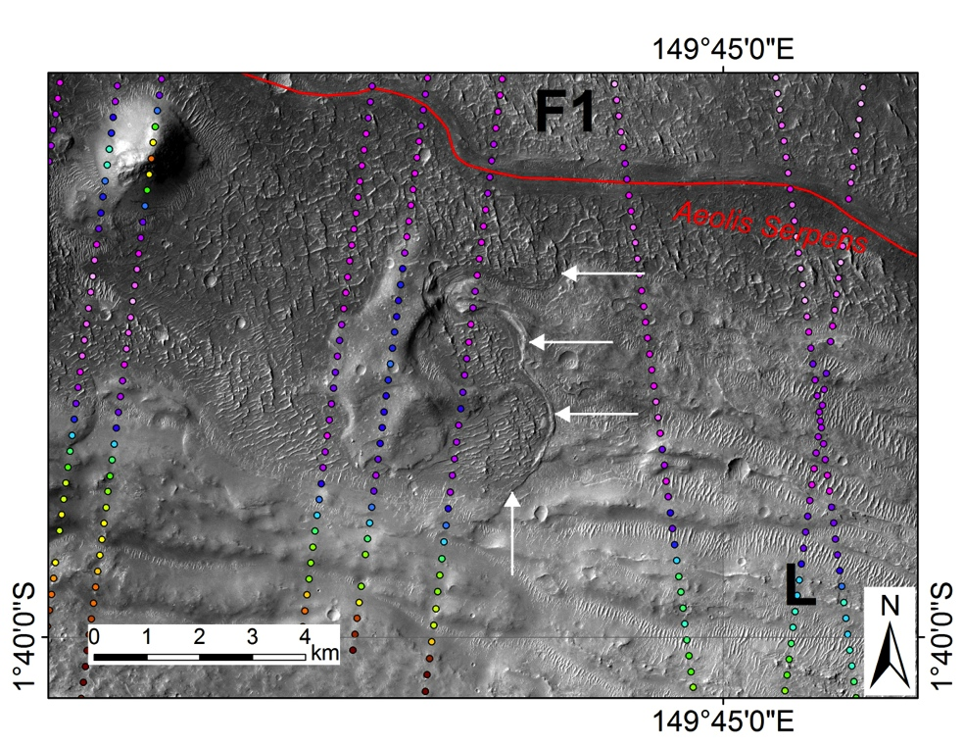
Figure 12. (a) showing contact between L and F1, with F1 embaying L (white arrows). See text for discussion and Fig. E1009 for context. Red trace corresponds to Aeolis Serpens. Illumination from top left highlights overriding of L by F1. (b) With PEDR to highlight topographically highstading outcrop of L embayed by F1. Color range for PEDR spots is -2040m (red) to -2500m (light pink).
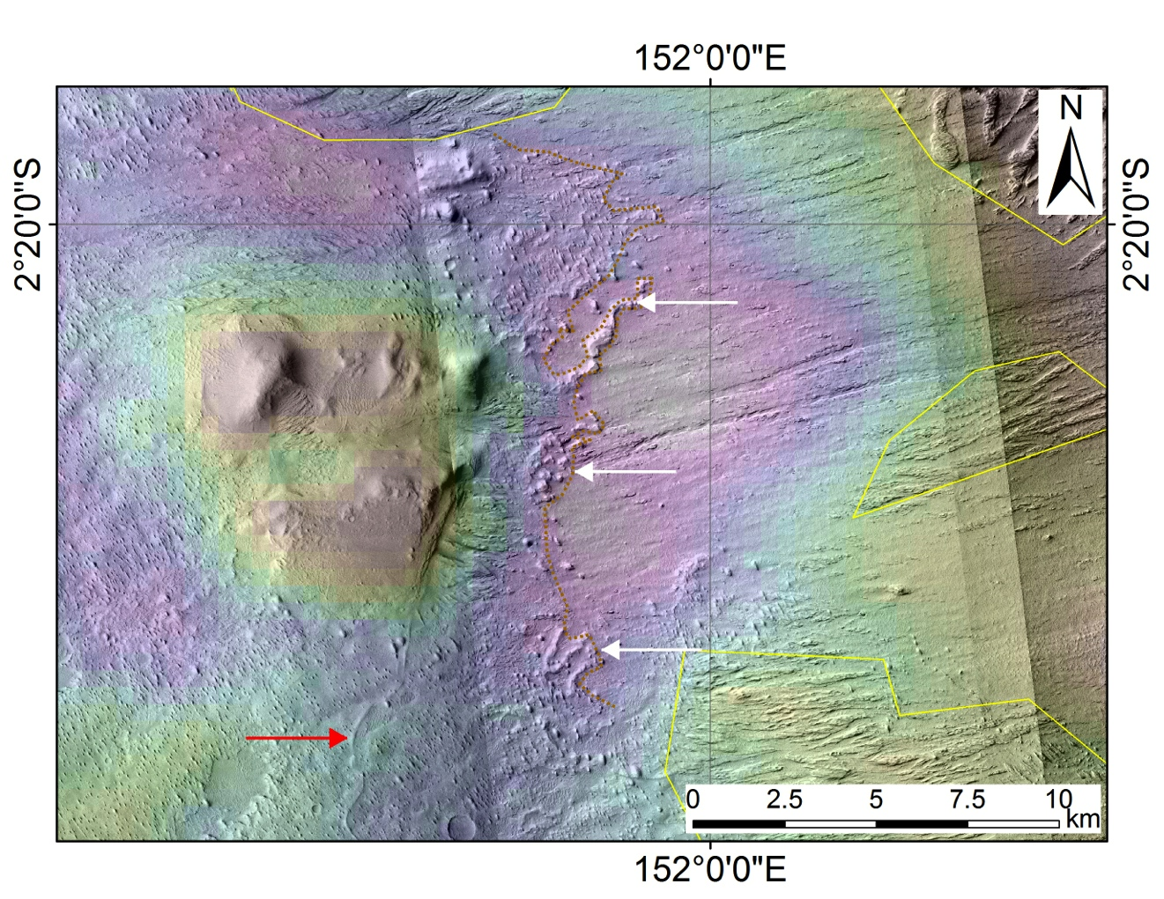
Figure 13. To show contact (brown dotted line) between river-deposit-containing materials (F1) to W and deeply grooved materials (L) to E. One river deposit is highlighted by red arrow. River-deposit-containing materials overlie (white arrows) the deeply grooved materials. The deeply grooved early-stage materials rise steadily to the E (~1° slope). River-channel-deposits within F1 are erosionally resistant and are locally highstanding at the contact between F1 and L. In this area, yardang-forming materials (topography above solid yellow lines) form a relatively thin drape above the deeply grooved materials (L). Crosscutting relationships elsewhere prove that yardang-forming materials postdate the river-deposit-containing materials as well. We do not know the relative age of the highstanding mesas and knobs W of the contact. Range of topography is from -2100 (red) to -2600m (white). PEDR tracks (not shown) confirm the onlap relationship described here.
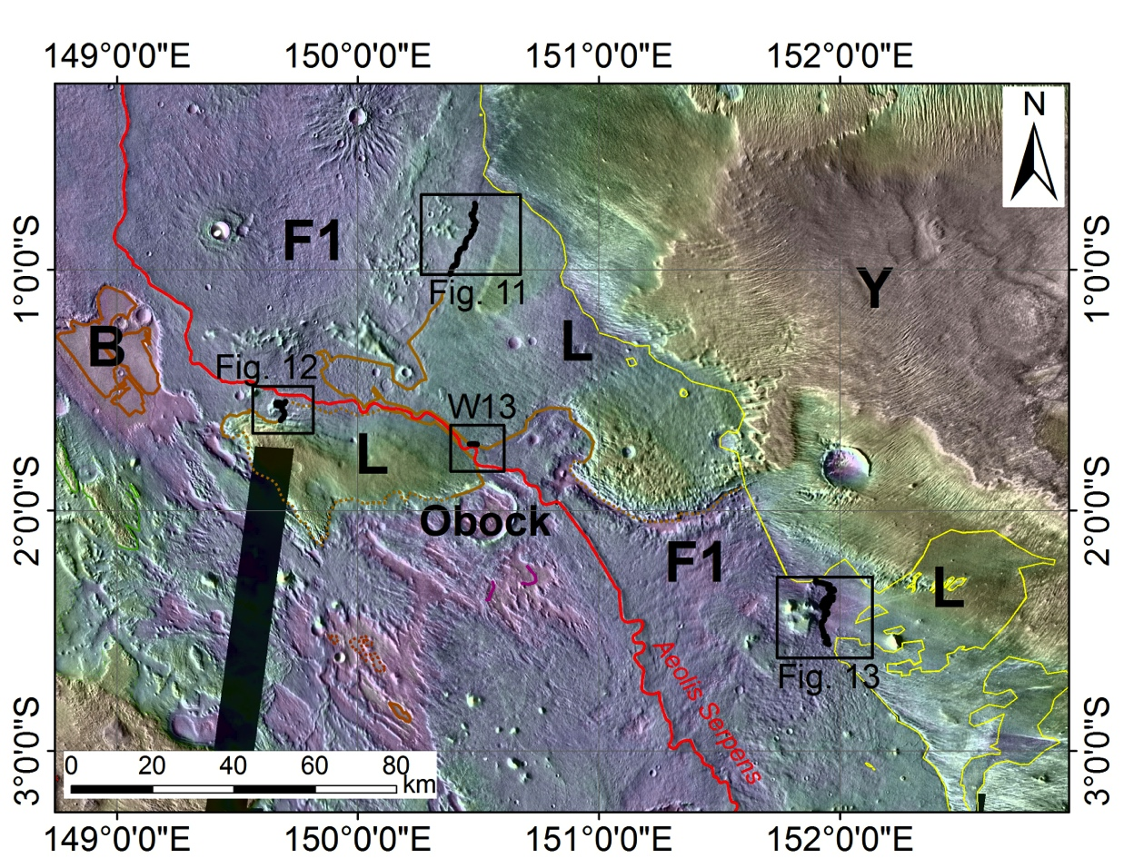
Figure 14. Summary of relationships shown in Figs. 11-13. Black highlights areas where onlap relationship between F1 (river deposits) and L (locally high-standing pre-river sedimentary rocks) is clearly exposed. Yardang materials (Y) unconformably superpose both L and F1. “W13” refers to area shown in Williams et al. (2013), their Figure 15.
River-containing deposits also onlap the ejecta of Neves, Obock and Kalba (the DiCE unit). Kalba ejecta is superposed by meander belts, and these continue to the W where they superpose finely-layered material. In turn, this finely layered material embays the hole cut in Kalba ejecta blanket. Additionally, the ejecta of Obock and Kalba have been dissected by valleys at 100m scale (Fig. 3).
B only outcrops in the deepest pits within Aeolis Dorsa, forming inliers within F (Fig. S3). Because the pit floors are smooth and within 100m of each other in elevation, we interpret B as forming a smooth basement surface underlying the river deposits. Because B is not observably wind-eroded, we interpret the depth of wind-cut troughs within the river deposits that do not expose B as a lower limit on the thickness of river deposits.
3.2 River deposits consist of at least three units, sealing a stratigraphic record of paleohydrology
In §2.2 we described three units within the river deposits – F1, F2 and F3. These units always have a consistent stratigraphic relationship (Fig. 15). F3 is only found topographically above and concordant with F2, and F2 is only found topographically above and concordant with F1. These relations show that the relative-time order of deposition is first F1, then later F2, with F3 later still. However, the relative time-order of units need not be the same as the relative time order of river deposits contained within those rocks, because the depths of incised valleys can be very large (one Earth example is discussed in Christie-Blick et al. 1990). How then can we be sure about the time order of the river deposits that are contained within the F1, F2, and F3 units?
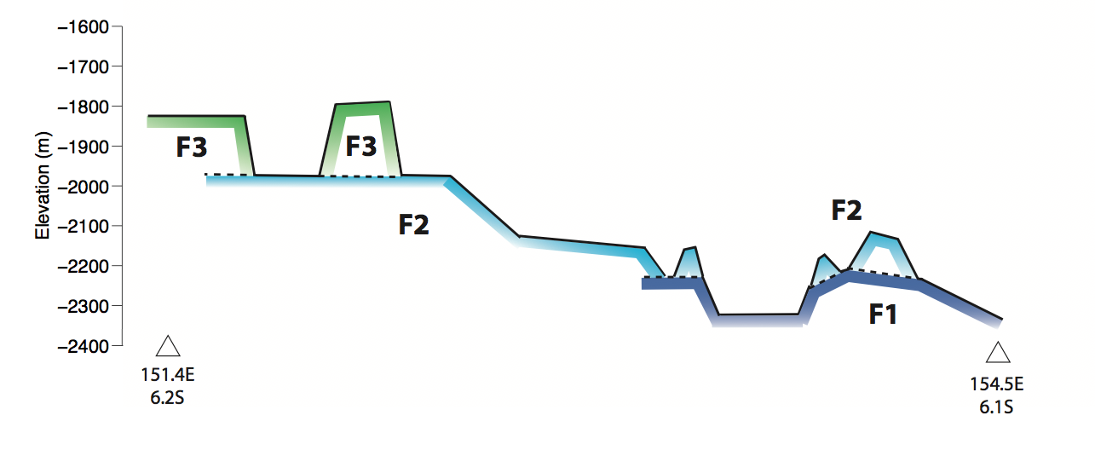
Figure 15. Sketch of concordant relationships between river-hosting units. Ends of cross section correspond to black crosses in Fig. 5, and white line in Fig. 2c. Wind erosion has cut back on the extent of F2 and F3 outcrop, which is less than the original extent. A lower bound on the original extent of F2 and F3 is the northern limit of outliers of F2 and F3. These northern limits are shown by the dashed lines on Fig. 2c. F3 is visible mostly in the SW of Aeolis Dorsa, where wind erosion has not yet cut deep into the river-deposit stratigraphy.
We now describe crosscutting relations that show that the relative time order of the river deposits in F1, F2 and F3 is the same as the stratigraphic order of the rock units that host them. In other words, the rock units stratigraphically encapsulate the river deposits.
F1. Erosionally-resistant meander belts – broad ridges with corrugated edges – disappear beneath / reappear from underneath smooth lobes of F2 at >10 locations along the F1/F2 contact. Three examples are shown in Fig. 17. In each case, the superposing F2 lobes are much wider than the superposed F1 meander belts. If the F1 meander belts are the fill of incised valleys, then this relationship constrains the timing of incision that predated the fill: incision must have occurred before F2 or the valleys would be visible as cuts into F2, which they are not. The stratigraphic tie between river deposits and hosting strata is even tighter if the meander belts were instead deposited as part of an aggrading floodplain. In an aggrading floodplain, the maximum elevation of the channel deposits above the floodplain is <<1 channel depth (<< 10m). Super-elevation of the channel-bed above the landscape leads to levee breach, avulsion, and incision of a new channel (Slingerland & Smith 1998, Mohrig et al. 2000, Jerolmack & Paola 2007).
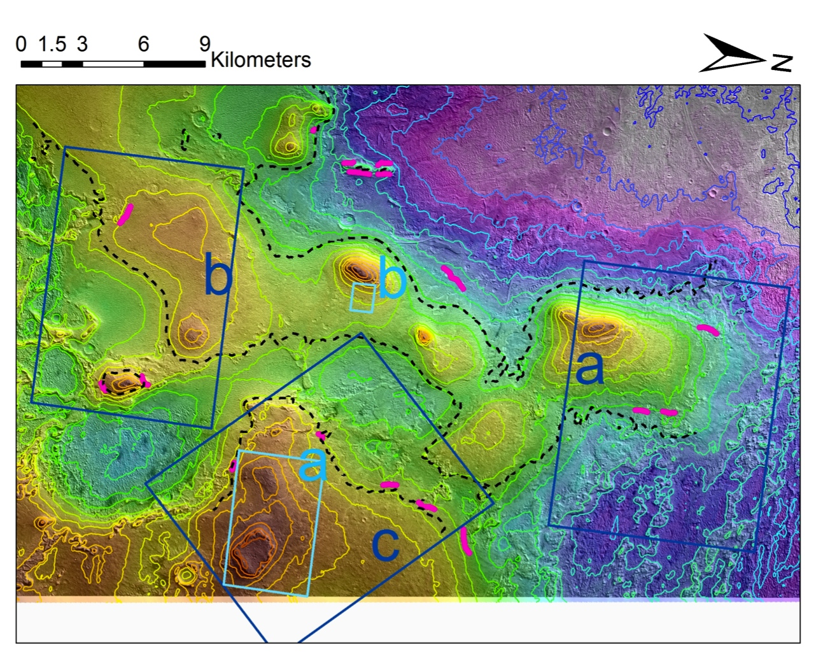
Figure 16. Showing locations of river deposit - host rock relationships detailed in the next two figures. Center location is near 153.9°E 6.0°S. Contours (25m intervals) and background colors are from a CTX DTM constructed by Antoine Lucas using the B20_017548_1739_XI_06S206W/ G02_019104_1740_XI_06S206W stereopair. Dark blue: F1 meander belt – host rock relationships shown in Fig. 18. Light blue: F2 channel-deposit relationships shown in Fig. 19. Pink highlights areas where meander belts disappear or reappear beneath overlying layered river-deposit-containing sediments. Dashed black line shows interpolated contact between F1 (above) and F2 (below). Note generally rugged contour lines below contact and generally smooth contour lines above contact.

a)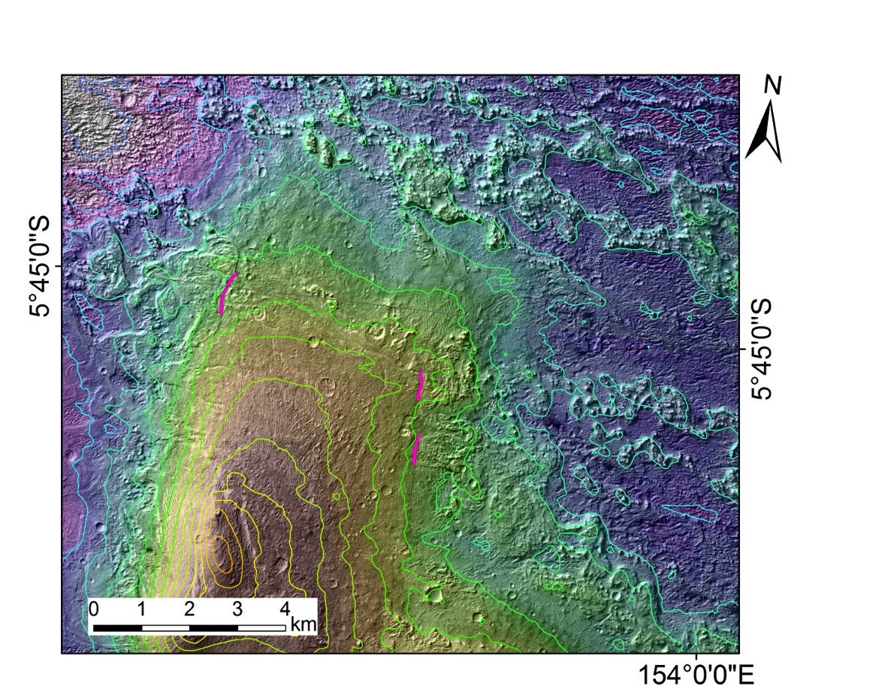
b)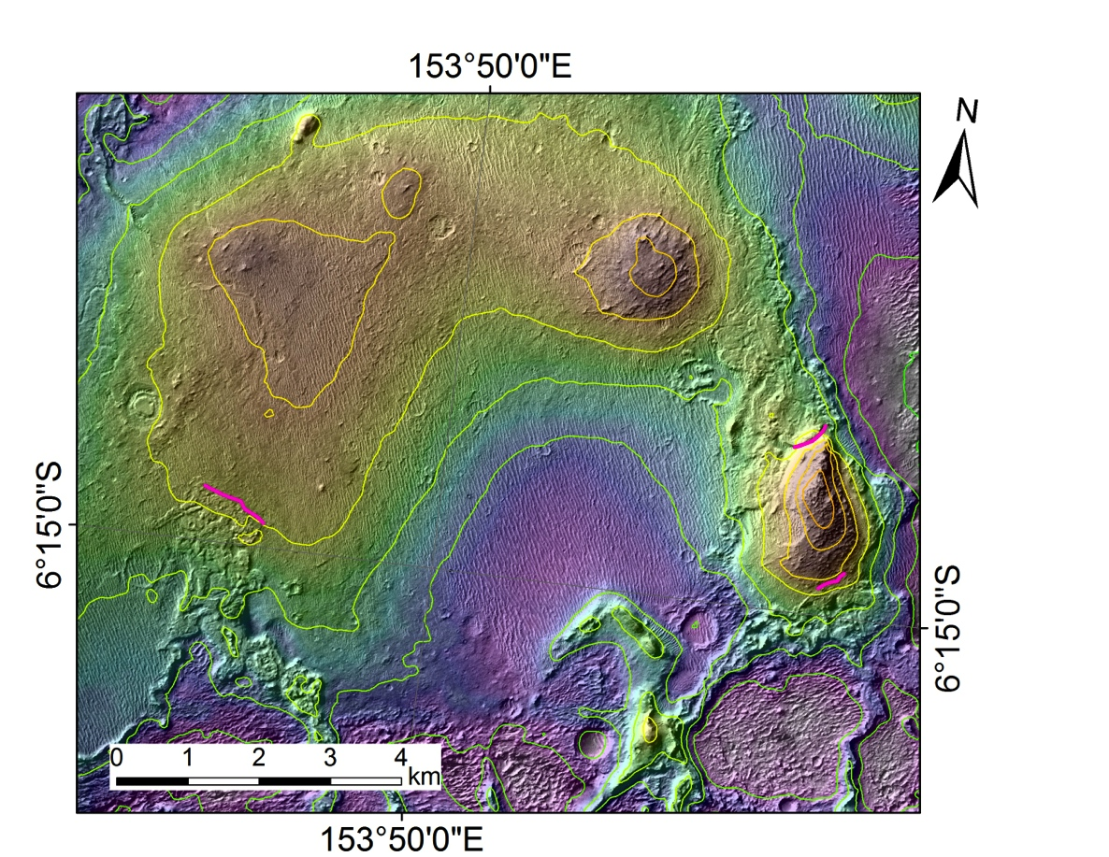

c)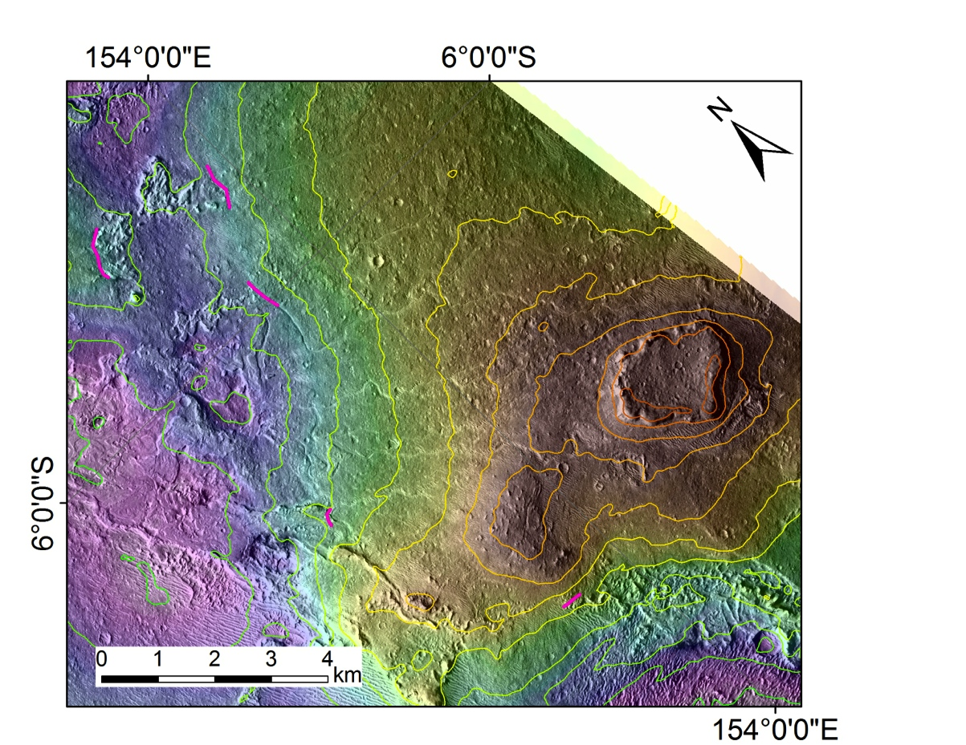
Figure 17. Showing locations (pink highlights) where meander belts disappear and reappear from beneath overlying river-deposit containing unit. Contours (25m intervals) and background colors are from a CTX DTM constructed by Antoine Lucas using the B20_017548_1739_XI_06S206W/ G02_019104_1740_XI_06S206W stereopair. (a) Color ramp is -2335 to -2068m. (b) Color ramp is -2226m to -2036m. (c) Color ramp is -2245 to -2050m.
F2. Channels and channel deposits in F2 frequently run obliquely or sub-parallel to contour lines (e.g, Figure 19). This rules out the channels forming on close-to-modern topography, and suggests instead that these river deposits are eroding out of the rock.
River channels in F2 to the E of 153°E generally trend SSE-NNW or SE-NW. This is consistent with the trend of the underlying F1 rivers, and inconsistent with the patchy modern pattern of F2 outliers (Figs. 2c, 15, 16). Consistency of paleo-flow trend with stratigraphic elevation implies that the F2 outcrops are outliers of a sheet of F2 that was once more continuous, and that the F2 rivers formed prior to the erosion of that sheet back to leave patchy outliers.
There is evidence for differential compaction of river deposits in F2. When draping erosionally resistant features such as embedded craters, channel fill often bows upward when crossing the erosionally resistant feature (e.g. Kite et al. 2014, their Figure 1f). Additionally, F2 river-channel fill is often high in the margins buts sags in the middle. Differential compaction shows that the F2 river deposits have been exhumed from beneath at least 10s of m of overburden (see also §5.2). Past burial by thick overburden is required to squeeze out pore space under Mars’ weak gravity.
Many of the river channels within F2 are preserved via inverted relief of channel-fill, requiring at least one post-fluvial cycle of deposition (to fill the channels) and erosion (to invert the fill).
a)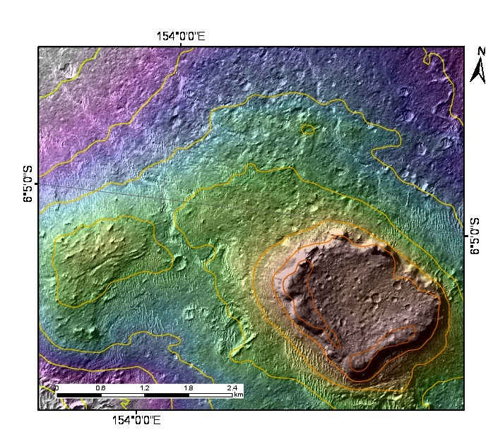
b)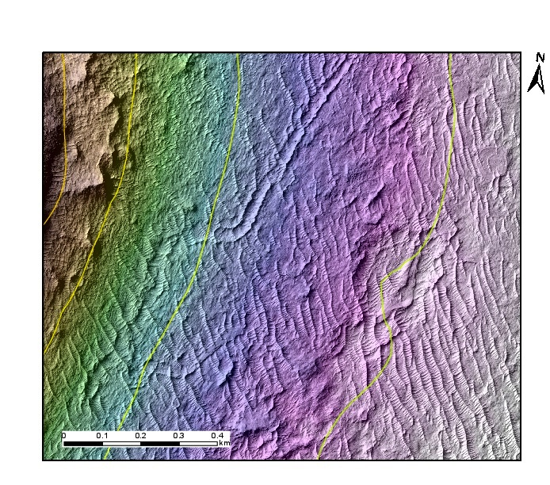
Figure 18. Locations where river channels within F2 run parallel to modern topographic contours (drawn at 25m intervals).

F3. F3 is defined by a sheet-like erosionally resistant member with a high proportion of channel deposits, which extends out over F2 as chains of resistant mesas. These mesa-chains are generally oriented NE-SW, like beads on a string. The consistent flow vergence implied by the mesa-chain orientations implies that the erosion of southern Aeolis Dorsa to form the topographically lumpy pattern seen in Fig. 4 had not yet occurred at the time F3 was deposited. Supposing that the F3 deposits are the fill of incised channels, there is no evidence that the channels cut any deeper than the cliff-forming resistant unit. In particular, there are no F3-parallel valleys cut into underlying F2 (~200m below F3 caprock). Channel erosional expression implies preferential preservation of fluvially transported channel fill.
We rule out the possibility that F3 is tectonically-uplifted and stratigraphically equivalent to F1 because F3 mesas extend out above F2, which superposes F1 (Figs. 4, 15). Additionally, the trend of all mapped wrinkle ridges is perpendicular to the F1-F3 topographic step; wrinkle ridges trend SW-NE and the topographic step trends SE-NW (Fig. 2).

3.3 Alluvial fans unconformably postdate thrust faults which crosscut thick river deposits
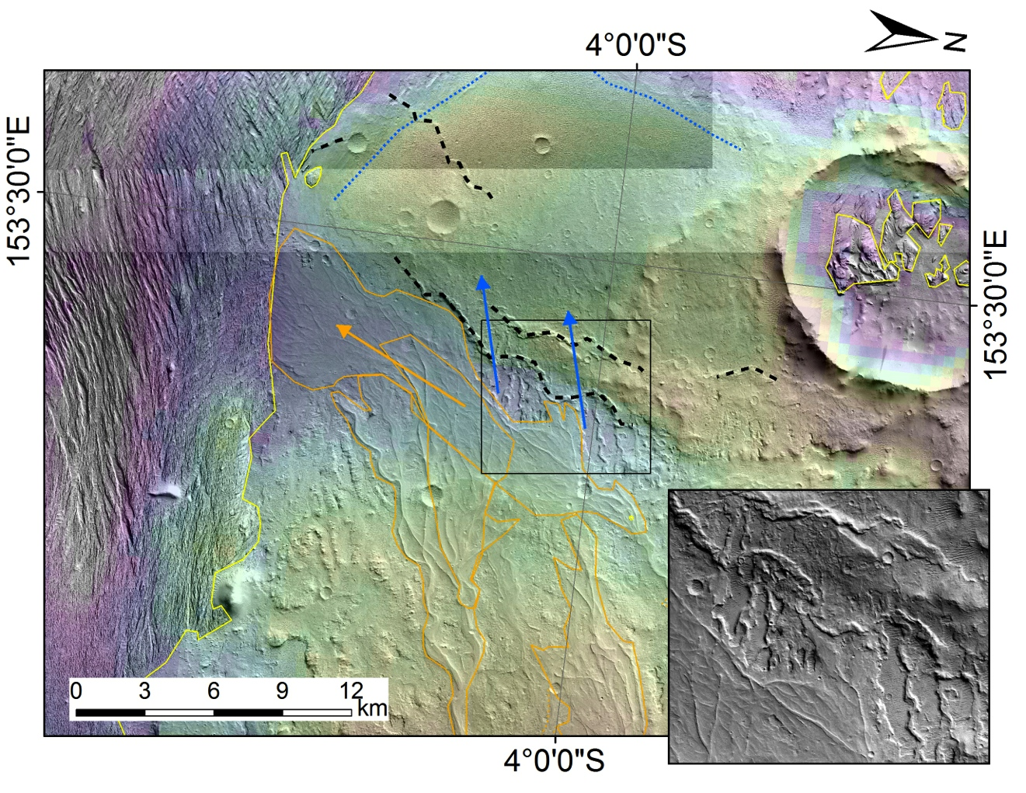
Figure 19. To illustrate unconformity between alluvial fans and large-river deposits. Wrinkle ridges (black dashed lines) deflect alluvial fans (orange arrows) but inverted channels underlying the alluvial fans (blue arrows). Inset (thin black rectangle outlines location) shows detail. Rugged, yardang-forming material overlies alluvial fans – yellow arrow. The main relationships are covered by P17_007830_1754_XI_04S206W.
Fig. 19 shows that alluvial fans are deflected by thrust faults and that the thrust faults crosscut large-river deposits. Specifically, wrinkle ridges (which are the surface expression of thrust faults; Golombek et al. 2001) deflect alluvial fans but inverted channels underlying the alluvial fans can be traced across the wrinkle ridge. Therefore thrusting occurred after inverted channels and before the alluvial fans. Therefore, the alluvial fans must postdate the large-river deposits.
This raises two questions: how big is the time gap here? And is the gap correlative underneath alluvial fans across the basin?
What is the time gap on the sub-alluvial-fan unconformity? A conservative lower limit on the time gap on the unconformity is 4 x 10⁷ yr, based on the low likelihood of the change in river deposit style occurring at the same time as thrusting.
Thrusting must have occurred after the river deposits. This is because faulting in the presence of crosscutting rivers leaves distinctive offsets (Burbank & Anderson, 2011) that are not seen here – and because there is no evidence for fluvial erosion of the wrinkle ridges. However, none of the alluvial fans flowed across the fault. Flow on the alluvial fans might have been diverted by a barrier (fault scarp) formed by the displacement from a single quake. In theory, the sequence of events visible in Fig. 19 could have occurred over a single Mars year, as follows. In year 1, river-deposits form during the wet season; during the dry season, a new fault breaks the surface and the climate shifts to favor alluvial fans; and in the following wet season, the first alluvial fan deposits are laid down (deflected by the new fault). In practice, a one-year time gap is extraordinarily unlikely. This is because the evolving state of stress in the Mars lithosphere (which sets the timing of new faults) and the evolving climate of Mars (which dictates the transition between rivers and alluvial fans) are not directly causally related (Andrews-Hanna et al. 2008a, Solomon et al. 2005). In other words, the event “a new fault breaks the surface” and the event “climate shifts to favor alluvial fans” can be approximated as independent and uncorrelated. Lack of correlation of independent and random events implies that the most likely time gap is ½ the duration of the era within which large-scale climate-driven surface runoff could have occurred. Both planetary contraction and runoff episodes appear to have concentrated in the Late Noachian, Hesperian, and Early Amazonian (Nahm & Schultz 2011, Fassett & Head 2008a, Grant & Wilson 2012). We assume that the runoff episodes and the major shift in faulting style could only have occurred in the Hesperian (which is conservative in terms of setting a lower limit on the time gap at the unconformity). We assume further that there were only 2 intervals of climate-driven runoff and 1 major shift in faulting style during the Hesperian, that all 3 events were brief in comparison to the duration of the Hesperian, and that they were independent random processes. With these assumptions the most likely time gap is ½ the duration of the Hesperian (i.e., ~1.5 x 10⁸ yr), and a conservative lower limit on the time gap at the unconformity is 4 x 10⁷ yr, which is the 2σ lower limit on the time gap.
A second, independent line of evidence for a long time gap on the sub-alluvial-fans unconformity comes from large-scale topography (Fig. 2a). Zimbelman & Scheidt (2012) state that the Asau rise (their unit “Hmm” / “middle member Medusae Fossae Formation”), which looms above the river deposits (part of their unit “Ahml1” / “lower member Medusae Fossae Formation”), is superposed on them (Fig 2). This corresponds to the “preferred option” in Fig. 20. The Asau rise exposes layers all around its margin (e.g. HiRISE ESP_019605_1755) so must have originally extended further out, probably extending over the current location of the alluvial fan heads, >10 km to the W. Therefore, if the Asau rise postdates the river deposits, then all of the alluvial fans E of 152°E must unconformably postdate the river deposits because they drew water (and presumably sediment) from catchments that are preserved as hollows which erode back into Asau-lobe strata. Scarp retreat of >10 km would require >13 Gyr at modern rates (Farley et al. 2014).

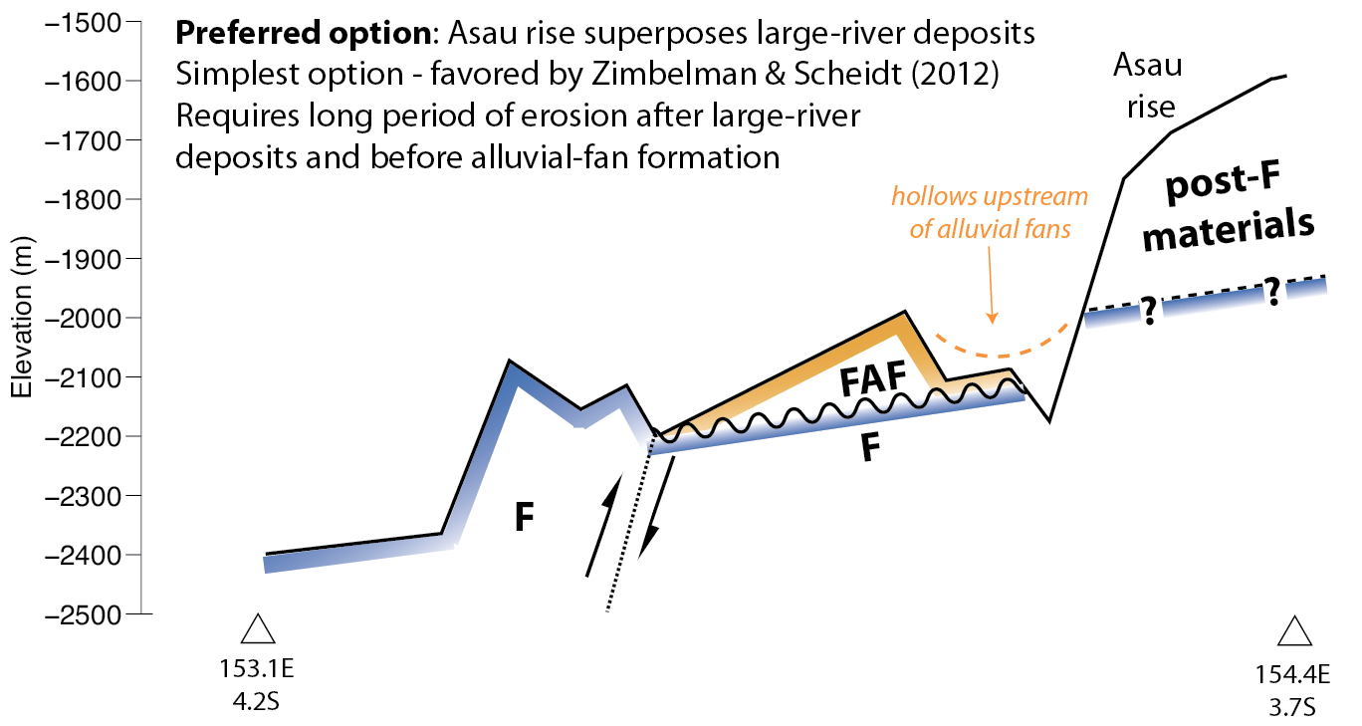
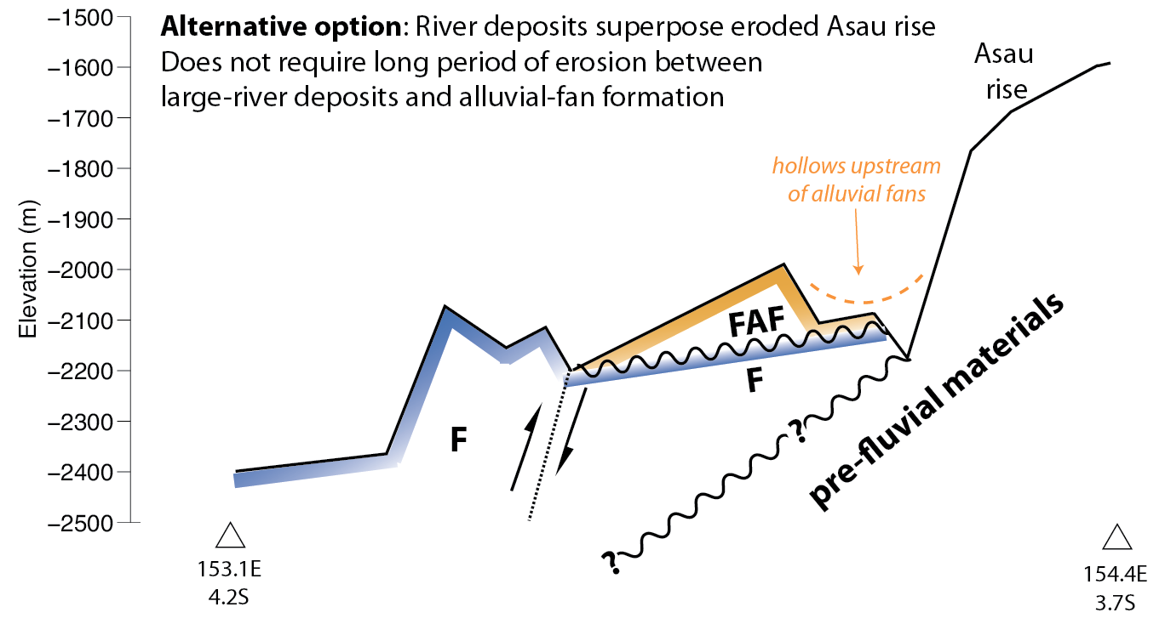
Figure 20. Possible stratigraphic relationships between Asau lobe and fluvial deposits.
We think this argument is probably correct. Although we are unable to rule out the alternative option (lower panel in Fig. 20), Zimbelman & Scheidt’s interpretation (top panel in Fig. 20) is the simplest because it does not introduce an unseen erosion-deposition cycle. Apparent conformity of ‘Aeolis rise sedimentary materials’ and ‘Southern materials’ on the river deposits in the S and W of the study region (Fig. S1) also suggests that postfluvial aggradation continued for hundreds of m. Intra-crater river deposits (5.2) also require at least hundreds of meters of postfluvial aggradation. All these observations are stratigraphically consistent with Zimbelman & Scheidt’s interpretation of Asau rise as being conformable on the river deposits (“preferred option” in Fig. 20).
Did the alluvial fans form at the same time? Three arguments (taken together) persuade us that alluvial fans around Aeolis Dorsa are broadly correlative with each other.
(1) Aeolis Dorsa alluvial fans are at similar elevations, always superpose river deposits, are never found beneath river deposits, and are always associated with upstream moats/hollows and alcoves cut back into high-standing deposits. An example of the moats/hollows/alcoves pattern (from the NW corner of Aeolis Dorsa) is shown in Fig. S4. This similarity of stratigraphic relationships suggests similar relative timing.
(2) Clusters of alluvial fans found elsewhere on Mars also appear to have formed around the same time (Grant & Wilson 2012). The most detailed study of alluvial fans elsewhere on Mars states that “[F]ans merge concordantly at their lateral boundaries, but no clear superposition relationship was identified and they likely formed simultaneously, resulting in interfingered deposits” (Morgan et al. 2014).
(3) Although alluvial fans can result from a palimpsest of brief localized events that are widely spaced in time (Williams & Malin 2008, Kite et al. 2011), there is a notable absence of evidence for point-sources of meltwater (such as volcanic fissures) in Aeolis Dorsa. There is also no evidence for localized impact-induced precipitation. This favors the alternative of alluvial-fan formation triggered by regional/global (“synoptic”) climate change (Grant & Wilson 2012). In this latter case, we would expect alluvial fans pointing in the same direction and draining the same topographic rise at roughly the same slopes to form at roughly the same time.
3.4 The unconformity below the yardang-forming materials corresponds to a >1 x 10⁸ yr time gap
Many impact craters formed after the river deposits (F) but before the yardang-forming materials (Y) (Fig. 23a), so there must have been a long time gap between the end of river-deposit deposition and before deposition of yardang-forming materials. That time gap can be quantified by counting the craters which are partly covered by yardang-forming materials (i.e. that are embedded within the stratigraphy, at the unconformity).
Comparing crater counts (#) to chronology functions and crater-production functions requires that the raw counts are first normalized by dividing by a count area (#/km²) (Michael 2013). We obtained normalized crater counts using 3 different methods (Fig. S5):
BCC – Buffered crater counting (Fassett & Head 2008a, Smith et al. 2009). In our implementation of this approach, the embedded-crater counts are divided by the area of a strip bracketing the contact and twice as wide as the crater diameter of interest (Fig. S5). This assumes no correlation between the position of the contact and the presence/absence of an embedded crater. It also assumes that the overlying unit is very thick, so that the rims of craters formed in the river deposits never poke up through the yardang-forming layered deposits.
LO – Lobes-only. This approach is similar to buffered crater counting, but considers only the craters that intersect the contact bounding those 3 main lobes. The lobes-only method ignores craters containing outliers of Y that are not connected to the main lobes of Y and the “buffer” areas for those outliers (Fig. S5).
ION – Inlier-Outlier annulus Normalization. In this approach, we consider each of the 3 main lobes of Y separately (Fig S5). For each lobe, we draw a polygon that is tightly wrapped around neighboring outliers of Y – connecting their outermost apices with straight lines. This polygon defines the outer boundary of the annulus of inliers and outliers for that lobe. Next, we draw a polygon that connects the innermost apex of all inliers of sub-Y materials with straight lines. This polygon defines the inner boundary of the annulus of inliers and outliers for that lobe. We define the annulus between the polygons as the inlier-outlier annulus. We use the area of the inlier-outlier annulus to calculate the crater densities.
Methods LO and ION are more realistic than method BCC. We can see this by first noting that outliers of Y are preferentially preserved in embedded-crater interiors (e.g. Fig. 23a), where they are protected against the wind. Imagine that the large lobes of Y were entirely removed so that the only Y remaining was the material preferentially preserved in embedded-crater interiors. Then, because every part of the perimeter of Y would onlap a crater, buffered-crater counting would return a fractional crater cover close to the oldest age possible (100% cover, crater saturation). This absurdly high age results from a thought experiment. The real bias will be less severe, but still in the direction of overestimating the time gap at the unconformity. Methods ION and LO attack this bias by taking account of correlations between the position of the Y/sub-Y contact and the location of embedded craters (Fig. S5). In method ION, the current area spanned by the farthest-flung outliers of Y is taken to correspond to the area within which some Y would be preserved, if there were embedded craters present to protect them from obliteration by the wind. In method LO, we count only craters that intersect the margins of one of the three main lobes of Y. These margins are in erosional retreat, but the current position of the margins is not obviously correlated with the locations of embedded craters. Therefore such craters should not suffer from the age-overestimation bias adhering to the BCC method.
The results (Table 1) are consistent with our expectations. The BCC method produces an impossibly large time gap (larger than the age of Mars). The LO and ION methods produce more realistic (lower) time gaps. There are fewer small craters embedded at the unconformity than expected for a pristine population of craters. This is consistent with preferential undercounting of smaller craters due to geometric effects (Lewis & Aharonson, in review), survey incompleteness, obliteration by erosional processes (Jerolmack & Sadler 2007), or some combination.
φ (km) | #craters φ> (lobes only) | N (per 10⁶ km²) |  |  | Time interval <1.s.f.>
 |  | BCC | LO | ION | BCC | LO | ION
0.5 | 34 (19) | TBD  (Area: 2.3 x 10³ km²) | TBD  (Area: 1.7 x 10³ km²) | 2700  (Area: 1.2 x 10⁴ km²) | @3.0  @3.7 | @3.0  @3.7 | 5 x 10⁸ yr @3.0 Ga  2 x 10⁷ yr @3.7 Ga
1 | 22 (10) | TBD  (Area: 4.6 x 10³ km²) | TBD  (Area: 3.4 x 10³ km²) | 1800  (Area: 1.2 x 10⁴ km²) | TBD x 10⁹ yr @3.0 Ga  TBD x 10⁸ yr @3.7 Ga | TBD x 10⁹ yr @3.0 Ga  TBD x 10⁸ yr @3.7 Ga | 3 x 10⁹ yr @3.0 Ga  1 x 10⁸ yr @3.7 Ga
2 | 11 (5) | TBD  (Area: 9.1 x 10³ km²) | TBD  Area: 6.6 x 10³ km²) | 900  Area: 1.2 x 10⁴ km²) | @3.0  @3.7 | @3.0  @3.7 | 6 x 10⁹ yr @3.0 Ga  3 x 10⁸ yr @3.7 Ga
Table 1. Time gap at the sub-Y unconformity. (Note to coauthors: ‘TBDs’ for BCC and LO will be filled in a later draft; they correspond to unrealistically old ages.) Only “definite” craters are considered. Bold border highlights preferred conservative estimate (see text).
Time gaps <10⁸ yr are very unlikely. Such short time gaps can only be obtained with method ION, and only if relatively small craters (1 km > φ > 0.5 km) are representative of the true time gap. It is very unlikely that the 1 km > φ > 0.5 km population is representative of the true time gap because of the high density of φ > 1km craters. The number of φ > 1km craters is 22, which is not small, and it is very improbable that this large number of φ > 1 km craters could have formed in the small time interval suggested by the 1 km > φ > 0.5 km population. On the other hand, there are many processes that can preferentially remove smaller craters from our counts. We conclude that the time gap on the unconformity is >10⁸ yr. We emphasize that this is a lower limit. It assumes the highest possible impact flux (the one corresponding to 3.7 Gyr). If the unconformity is younger, then the impact flux was lower and so the time gap on the unconformity must have been longer. Our estimation procedure linearizes the flux at the assumed start time of the unconformity. In reality the flux declines over time, so this linearization underestimates the time gap at the unconformity. Many processes not in this model can efface craters, but none can create craters. If more craters formed, then the time gap would be larger.
(a) 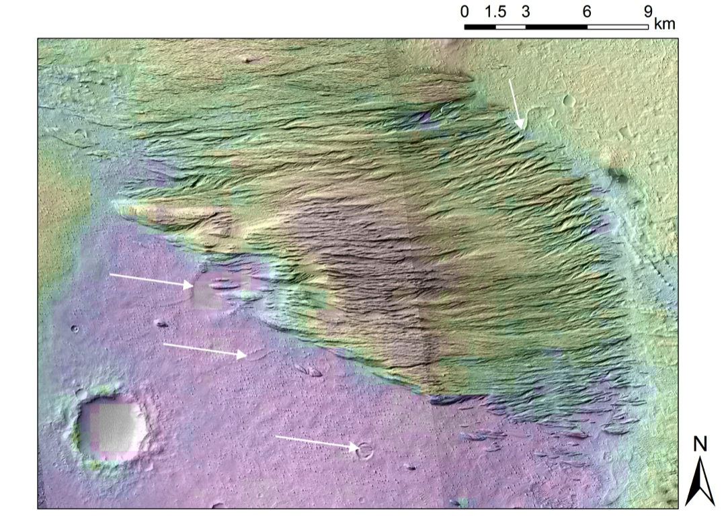
(b) 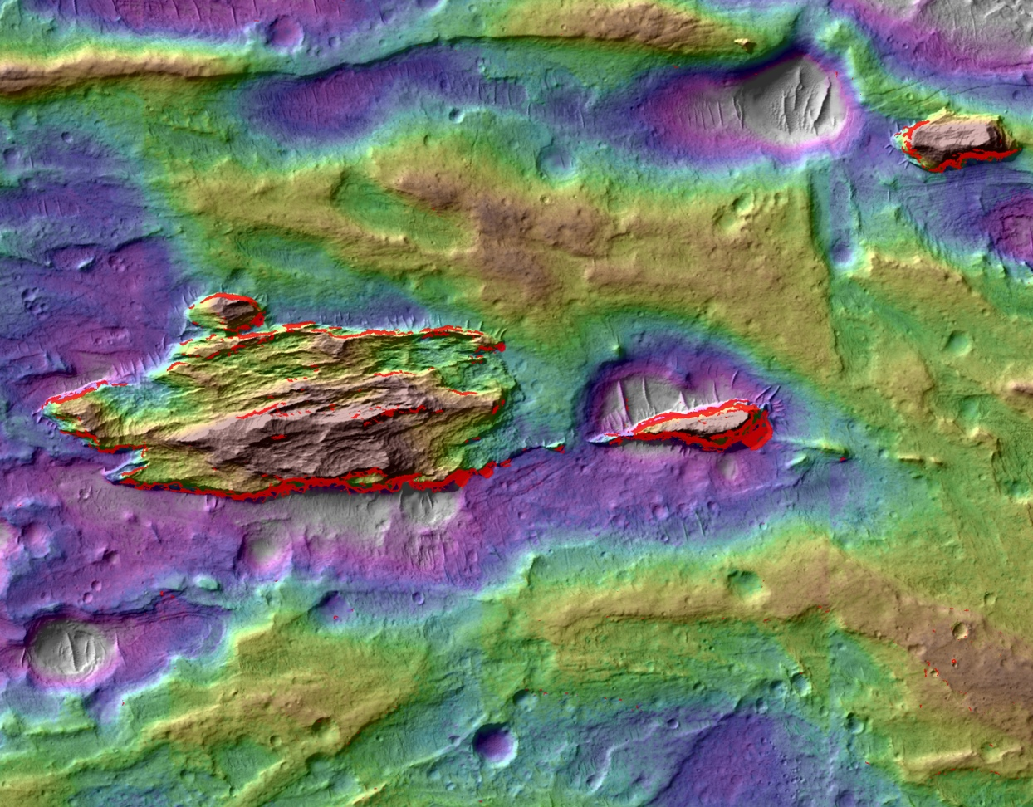
(c) 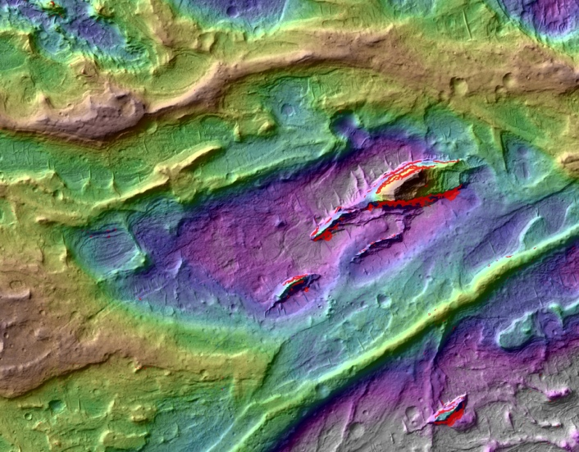
Figure 21 – Yardang-forming layered deposits unconformably superpose both river deposits and alluvial fans. (a) Yardang-forming layered material (highstanding grooved terrain) superposes a surface containing both river deposits and embedded craters (shown by white arrows). Near 154.3°E, 5.1°S. (b) Steep-sided outcrops of regularly-layered yardang-forming material in hollows on alluvial fans. Opaque bright red tint corresponds to slopes steeper than 40°. The pit just S of the largest steep-sided outcrop is 20m below inverted-channel elevation. Image is 1.65km across, near 154.85°E 4.72°S. (c) Steep-sided outcrops of regularly-layered yardang-forming material in hollows on alluvial fans. Opaque bright red tint corresponds to slopes steeper than 40°. The drop from the north inverted channel to the pit is 30m; the drop from the south inverted channel to the pit is 20m. Image is 1.65km across, near 154.90°E 4.72S. (b) and (c) are from DTM constructed from HiRISE stereopair PSP_009795_1755/PSP_009623_1755. This DTM is publicly available at http://geosci.uchicago.edu/~kite/stereo.

Relative crater densities at the unconformity below the yardang-forming materials are consistent with the stratigraphy established by crosscutting relationships – in which a topographically high-standing pre-river landscape (Sequence I) predates river deposits (Sequence II), which in turn predate alluvial fans (Sequence III). Although there are large uncertainties (Table 1), the density of craters found embedded at the unconformity is highest where Sequence IV drapes Sequence I, intermediate where Sequence IV drapes Sequence II, and we found only 1 crater embedded at the unconformity where Sequence IV drapes Sequence III.
Nevertheless, there must have been a significant time gap between the end of alluvial-fan (Sequence III) deposition and the start of yardang-forming layered deposits (Sequence IV) deposition. A significant time gap is required to explain the observation that outliers of rhythmite sit in hollows between inverted channels in the alluvial-fan deposits (Fig. 23b, 23c). Therefore, alluvial-fan flow ceased, and erosion of >20-30m took place to define the inverted channels and the elongated pits between the channels, before deposition of rhythmite in the inter-channel gaps. At modern Mars sedimentary rock wind-erosion rates of ~1 μm/yr (Golombek 2012), this would take 20-30 Myr.
In summary, our results show nondeposition or erosion from pre-Y to Y all along the currently exposed pre-Y/Y contact. This suggests a period of regionwide nondeposition/erosion.
4. Summary of stratigraphy
Crosscutting relationships from §3 allow time-ordering of the lithofacies described in §2 (Fig. 22).
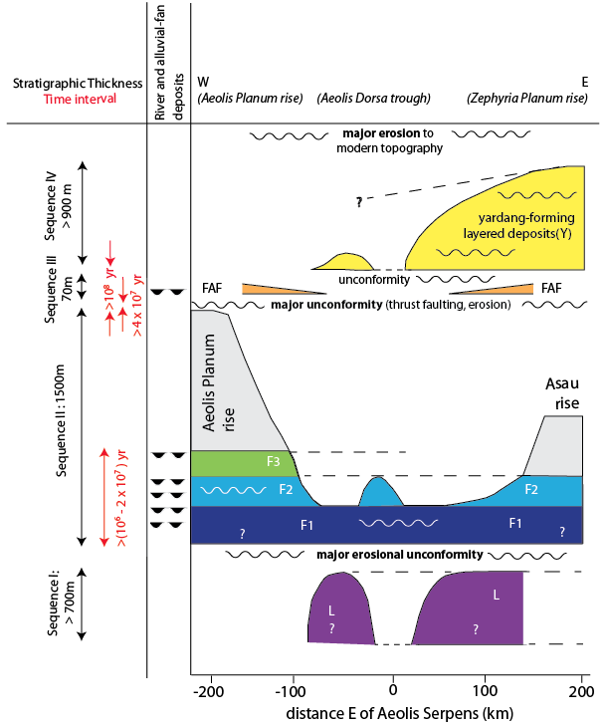
Fig. 22. (Relative time)-(stratigraphy) diagram showing stratigraphic context of river and alluvial-fan deposits in Aeolis Dorsa, and time constraints discussed in this paper. Wavy lines correspond to unconformities. Filled “U” shapes in the column at left correspond to the stratigraphic levels at which river and alluvial-fan deposits are found.
In Aeolis Dorsa, topographic elevation is only a weak proxy for relative youth: the age order is only weakly correlated with topographic elevation. Topographic elevation is an imperfect guide to relative age in the presence of major unconformities, moderate tectonism, deformation, differential compaction, long-baseline slopes, possible ice removal, and possible crustal flow (Jacobsen & Burr 2012, Kite et al. 2012, Lefort et al. 2012, Nimmo 2005).
5. Discussion
5.1. Correlation between Aeolis Dorsa and Aeolis Mons (Gale crater’s mound, Mt. Sharp)
Correct placement of rover-traverse stratigraphic sections in the global context of orbiter data would allow constraints on process from global surveys to be integrated with the higher-resolution constraints from rover traverses (e.g. Ehlmann et al. 2011). This motivates correlating Gale crater, which is the field site for the Mars Science Laboratory (MSL) Curiosity rover, to the wider Aeolis region. In this subsection, we set out the evidence that yardang-forming layered material in Aeolis Dorsa correlates to the Upper Unit of Gale crater’s mound (Aeolis Mons, Mt. Sharp), which is the destination of Curiosity. We also set out the temptations and dangers of further stratigraphic correlations between the rover field site and Aeolis Dorsa.
Aeolis Dorsa is 10°E of Gale, and like Gale it has accumulated light-toned sedimentary rocks carrying evidence for overland flow and aqueous cementation (e.g. Malin & Edgett 2000). In physical models, surface liquid water tends to be available at Gale when it is available at Aeolis Dorsa, and vice versa (Andrews-Hanna et al. 2012, Kite et al. 2013a). Therefore we might expect the rock record of surface liquid water at Gale to correlate with the rock record of surface liquid water in the wider Aeolis region, including Aeolis Dorsa (Andrews-Hanna et al. 2012, Kite et al. 2013a). Such correlations have been previously proposed (Irwin et al. 2004, Zimbelman & Scheidt 2012).
Yardang-forming layered materials. When can a lithostratigraphic correlation between arbitrary points A and B be supported? Necessary conditions are that there are multiple lines of geologic evidence that rocks at A and B were deposited by the same process, and that there is a physical basis for a one-to-one correlation between times when that process was active at A, and times when it was active at B. Both of these conditions are satisfied for Aeolis Dorsa rhythmite and the upper Gale crater mound.
Both the Aeolis Dorsa yardang-forming materials, and the upper mound of Gale crater, are light-toned, regularly bedded materials that unconformably drape underlying sediments. This implies that the sediment source was atmospherically-transported sediment – i.e., airfall. Geologically recent airfall deposits on Mars accumulate from the deposits of regional-to-global dust storms and have a wide regional extent (>1000km; Bridges & Muhs 2012, Mangold et al. 2009). This wide regional extent suggests that ancient airfall events that deposited suspended sediment in Gale would also have deposited suspended sediment in Aeolis Dorsa.
An alternative to settling-out of dust from regional-to-global dust storms is ashfall. GCM experiments show a broad distribution of distal ash from the major volcanoes on Mars, such that deposition of distal ash in Gale crater would also lead to deposition in Aeolis Dorsa (and vice versa) (Kerber et al. 2013). Landscape-terrain feedbacks can explain preferential preservation of rhythmite and/or ash on preexisting local-to-regional topographic highs such as Mt. Sharp and Zephyria Planum (Brothers et al. 2013, Kite et al. 2013c).
Because of the strong evidence for correlation of the youngest deposits in Aeolis Dorsa to the youngest deposits at Aeolis Mons, we suggest that the >10⁸ yr duration of our unconformity can be correlated to the “Great Unconformity” at Gale. This prediction can be tested using the abundance of cosmogenic nuclides at the unconformity measured by MSL (Farley et al. 2014).
Rivers. We do not know if the large-river deposits in Aeolis Dorsa correlate to large-river deltas in Gale Crater. The nominal age of Gale crater ejecta is the same within statistical error (~10⁸ yr) as our preferred crater-count age for the Aeolis Dorsa rivers (Le Deit et al. 2013, Kite et al. 2014), so correlation cannot be ruled out. Given uncertainty about the number and timing of river events in Gale crater, more detailed correlation would be affirming the consequent.
Alluvial fans. Melting of snow or ice is assumed to be the water source for the alluvial fans (Palucis et al. 2014, Morgan et al. 2014, Grant & Wilson 2012, Kite et al. 2013b, Clow 1987). If atmospheric pressure was only high enough to allow high rates of snow/ice melt runoff from fans more than “X” Gyr ago (where “X” is unknown), then all alluvial fans will be correlated in the sense that they predate X. Snowpack stability and snow/ice melt rates depend strongly on the duration and intensity of sunlight, which is set by orbital forcing. Orbital forcing would have similar effects in modestly-tilted alluvial fan source regions at similar latitudes (Kite et al. 2013a, Morgan et al. 2010). The Peace Vallis alluvial fan headwaters are at ~3°S, which is the same latitude as the Aeolis Dorsa alluvial fans 10° to the E (Fig. 2d). We infer that the alluvial-fan-forming events at Gale are probably broadly correlated to the alluvial-fan-forming events at Aeolis Dorsa.
5.2. Intra-crater river deposits point to vast vanished sheets of river-deposit containing materials

Crater-river interactions indicate an additional unconformity involving the river deposits. Intra-crater sinuous ridges exist within Kalba, Neves, Obock, and the unnamed crater at 153.5°E 3.8°S. These ridges are best seen within Kalba crater (ESP_034545_1740). Because the ridges are sinuous and parallel to the paleo-drainage direction defined by sinuous ridges and meander-belts outside the crater, we interpret them as inverted channels (Burr et al. 2009). The inverted channels are 400m lower than the rim of Kalba and only 3 km from the rim. Remarkably, the inverted channels do not correspond to breaches in Kalba’s rim. Some knicks are found in the N and the S rim of Kalba (parallel to paleoflow and suggesting fluvial incision), but they do not extend as deep as the inverted channels within Kalba, nor are they aligned with the interior channels. This lack of deep rim breaching presents a paradox: how could water have flowed over the rim of Kalba as required to form the inverted channels in Kalba’s interior without deeply incising the rim? The resolution of the paradox is that the fluvial deposits were laid down at a time when the landscape had aggraded above the level of the crater rim. Therefore, the river deposits formed at a paleo-elevation above the crater rim. (This also explains why the sinuous ridges are aligned with the regional drainage direction and do not respond to the topography of the rim). Still further aggradation led to compaction . The thickness of compactible material within Kalba was greater than the thickness of compactible material outside Kalba, because a φ = 14 km crater (Kalba’s diameter) forms a ~1.66 km deep hole (Tornabene et al. 2013). This contrast in thickness of compactible material drove differential compaction (Lefort et al. 2012, Buczkowski et al. 2012), such that the river deposits which formed topographically above the rim are now below the river deposits on the surrounding plains. Other locations showing knicked rims preferentially in regional upstream-downstream directions and/or intra-crater river deposits are Neves, Obock (ESP_035600_1765), and the unnamed craters at 153.1°E 5.8°S, 153.5°E 3.8°S, and 152.6°E 6.3°S. The existence of knicks in the crater rims and of intra-crater river deposits points to an interval of aggradation to above the level of the crater rims, and an interval of incision to cut the crater rims. The relative timing of the knicks is unknown. It is also unknown whether the incision was restricted to the vicinity of preexisting crater rims, or represents an additional regional unconformity. However, a thick stack of now-vanished river-deposit-containing material above the current level of the crater rims is required to explain the current elevations of the inter-crater sinuous ridges.

5.3. Hypothesis: orbital forcing modulated erosion-deposition cycling in Aeolis
Our results suggest that the stratigraphy of Aeolis Dorsa is a record of liquid water availability, and because physical models indicate that liquid-water availability is strongly influenced by orbital forcing, we hypothesize that orbital forcing was a strong influence on the stratigraphy of Aeolis Dorsa.
River deposits, alluvial fans and rhythmite in Aeolis Dorsa indicate past periods of equatorial liquid water for runoff and aqueous cementation – requiring a regional climate different from today. On the other hand, the topography of the modern erosion surface, and of the paleo-surfaces preserved at the sub-rhythmite and sub-alluvial-fans unconformities, imply periods of wind erosion and mass wasting without net deposition of aqueously-cemented sediments. What forced these cycles between periods of erosion and periods of deposition?
We interpret these erosion-deposition cycles as controlled by the availability of liquid water, because the alternative controls – control by sediment-supply, tectonics or eustasy – are less plausible.
Tectonic forcing of alternations between erosion and deposition requires uplift or subsidence, but the basic tectonic fabric of Aeolis was set in place very early in Mars history (Watters et al. 2007, Phillips et al. 2001). The equatorial dichotomy boundary scarp was a 3km-high cliff well before Aeolis Dorsa formed (Andrews-Hanna et al. 2008b, Marinova et al. 2008, Nimmo et al. 2008, Irwin & Watters 2010, Andrews-Hanna 2012): it is still a 3km-high cliff today. Therefore, given sufficiently wet conditions, sediment supply is unlikely to have been limiting.
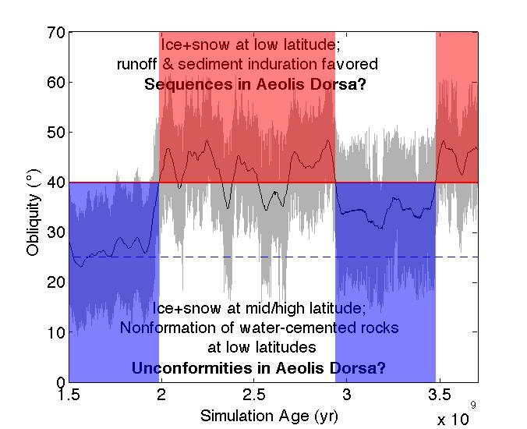
Figure 23. Example of alternations between low and high mean obliquity for one possible Mars obliquity history. Simulation by J.C. Armstrong, using a model based on Armstrong et al. (2004). Gray swath shows full simulated range of obliquity. Black line shows 50 Myr running-average of obliquity. Dashed blue line corresponds to present-day obliquity of Mars (25°). Red line corresponds to threshold for equatorial ice and snow. This threshold can be slightly lower in some models (but no lower than 30°). Note that it is impossible to recover the single true 4+ Gyr history of Mars’ obliquity solely by reverse-integrating the solar system from inexact observations of its present state (Laskar et al. 2004).
On the other hand, there is a straightforward mechanism allowing for wet-dry cycles in Aeolis. Liquid water at the equator requires a different climate from today – the minimum climate requirements for equatorial rivers are atmospheric pressure ~10² mbar (to suppress evaporitic cooling) and obliquity ≳40° (to drive ice and snow to the equator) (e.g. Jakosky & Carr 1985, Mischna et al. 2003, Forget et al. 2013, Kite et al. 2013b, Hecht 2002). At low obliquities, similar to today’s 25°, ice and snow is cold-trapped at mid-to-high latitudes and at depth and the equator’s surface quickly becomes dry (Mellon & Jakosky 1995, Hudson & Aharonson 2008). Without near-surface water, rivers and alluvial fans cannot form even if temperatures are high enough for melting.
Our simulations of Mars long-term obliquity change (Fig.23) (Armstrong et al. 2004) show chaotic, long-term alternations between high mean obliquity and low mean obliquity, with Mars spending comparable amounts of time at obliquity >40° and obliquity <40°. Intervals with >10⁸ yr continuously low mean obliquity are common.
This suggests a hypothesis for the sequence-scale stratigraphy of Aeolis Dorsa: at high obliquity, liquid water was intermittently available to move and indurate sediment, and at low obliquity, net wind erosion led to the development of unconformities. In this hypothesis, other global factors (e.g. loss of the atmosphere via carbonate formation and via escape to space) led to the drying-out recorded by successive intervals of deposition at high obliquity – from large rivers, to alluvial fans, to indurated rhythmite. Because in this hypothesis the drivers of Aeolis Dorsa stratigraphy have global effects, we predict that the history of sediment accumulation shown in Fig. 22 should be reproducible across the Martian equatorial latitudes.
6. Conclusions
In this study we have proposed a macrostratigraphic framework for Aeolis Dorsa, which is a wind-eroded cratered volume of sedimentary rock containing river deposits. Our purpose is to clear the ground for future work using Aeolis Dorsa as a natural laboratory for studying competition between cratering and fluvial mass transport (Howard 2007), competition between fluvial and aeolian processes (e.g. Haberlah et al. 2010), crater degradation (Forsberg-Taylor et al. 2004, Fassett & Head 2008b), reworking and re-alteration of aqueously cemented sediments (Milliken et al. 2009, Zolotov & Mironenko 2014, McLennan et al. 2005), continental sequence stratigraphy (Sloss 1963, Shanley & McCabe 1994, Peters 2006, Holt et al. 2010), geologic constraints on solar system history (Olsen & Kent 1999, Pälike et al. 2004), hyporheic weathering (Gooseff et al. 2002), river meandering in the absence of vegetation (Davies et al. 2011, Matsubara and Howard in press), alluvial architecture and stacking patterns (Mohrig et al. 2000, Hajek et al. 2010, Reijeinstein et al. 2011), and paleohydrology and climate versus time (Hajek & Wolinsky 2012, Amundson et al. 2012, Foreman et al. 2012, Foreman 2014, Zachos et al. 2001).
From this study we conclude that the sedimentary rocks of Aeolis Dorsa can be divided into four unconformity-bounded sequences.
- A >700m-thick sequence of layered pre-river deposits was erosionally dissected prior to embayment by river deposits.
- River deposits can be subdivided into at least three apparently-concordant units, which stratigraphically encapsulate a time series of river-deposit dimensions and channel-deposit proportions. The total thickness of river deposits is >400m.
- Alluvial fans are deflected by thrust faults that crosscut the river deposits. The alluvial fan source regions cut back into high-standing deposits.
- All three earlier sequences were unconformably draped by yardang-forming layered materials that contain rhythmite. The time gap on this unconformity is >10⁸ yr.
- Following deposition of yardang-forming layered materials, erosion resumed and is currently active.
Acknowledgements
We thank Devon Burr, Lynn Carter, Laura Kerber, Robert Jacobsen, and Bethany Ehlmann, for sharing their ideas about Aeolis Dorsa in many discussions that have made this a stronger manuscript. We thank Noah Finnegan, Jonathan Stock and Ross Irwin for discussions on paleohydrology, and Gary Kocurek, Dick Heermance and Paul Olsen for discussions on aeolian-fluvial interactions. We thank all the participants in the Caltech Mars Geomorphology Reading Group, especially Kirsten Siebach, Katie Stack, Roman DiBiase, Ajay Limaye, Joel Scheingross, Woody Fischer, Lauren Edgar, and Jeff Prancevic. Kevin Lewis, Frederik Simons, and Or Bialik provided useful feedback on an early draft. Brian Hynek shared a useful pre-publication map of Meridiani. Jenny Blue coordinated the naming of Obock, Neves, Kalba, Asau and Gunjur craters. We thank Ross Beyer, Sarah Mattson, Audrie Fennema, Annie Howington-Kraus, and especially Cynthia Phillips for help with DTM generation. We are grateful to the HiRISE team for maintaining the HiWish program, which provided multiple images that were essential to this study.

References.

Amundson, R., et al. 2012, Geomorphologic evidence for the late Pliocene onset of hyperaridity in the Atacama desert, Geol. Soc. Am. Bulletin 124, 1048-1070.

Anderson, R. B., Bell, J. F., III 2010. Geologic mapping and characterization of Gale Crater and implications for its potential as a Mars Science Laboratory landing site. International Journal of Mars Science and Exploration (Mars Journal) 5, 76-128.

Andrews-Hanna, J. C. 2012. The formation of Valles Marineris: 2. Stress focusing along the buried dichotomy boundary. Journal of Geophysical Research (Planets) 117, 4009.
Andrews-Hanna, J. C., Lewis, K. W. 2011. Early Mars hydrology: 2. Hydrological evolution in the Noachian and Hesperian epochs. Journal of Geophysical Research (Planets), 116, 2007.
Andrews-Hanna, J. C., Zuber, M. T., Hauck, S. A. 2008a. Strike-slip faults on Mars: Observations and implications for global tectonics and geodynamics. Journal of Geophysical Research (Planets) 113, 8002.
Andrews-Hanna, J. C., Zuber, M. T., Banerdt, W. B. 2008b. The Borealis basin and the origin of the martian crustal dichotomy. Nature 453, 1212-1215.
Armitage, J. J., Duller, R. A., Whittaker, A. C., Allen, P. A. 2011. Transformation of tectonic and climatic signals from source to sedimentary archive. Nature Geoscience 4, 231-235.
Armstrong, J.C., Leovy, C.B., and Quinn, T., 2004, A 1 Gyr climate model for Mars: new orbital statistics and the importance of seasonally resolved polar processes, Icarus 171, 255-271.
Bibring, J.-P., et al. 2006. Global Mineralogical and Aqueous Mars History Derived from OMEGA/Mars Express Data. Science 312, 400-404.
Boyce, J. M., Wilson, L., Mouginis-Mark, P. J., Hamilton, C. W., Tornabene, L. L. 2012. Origin of small pits in martian impact craters. Icarus 221, 262-275.
Bridge, J.S., 2003, Rivers and floodplains: Forms, processes, and sedimentary record, Wiley-Blackwell.

Bridges, N.T. & D.R. Muhs, 2012, Duststones on Mars: source, transport, deposition, and erosion, pp. 169-182 in Grotzinger, J.P., & R.E. Milliken (eds.) Sedimentary Geology of Mars, SEPM Special Publication No. 102.

Brothers, T. C., & Holt, J. W, 2013, Korolev Crater, Mars: Growth of a 2-km Thick Ice-Rich Dome Independent of, but Possibly Linked to, the North Polar Layered Deposits, 44th Lunar and Planetary Science Conference, held March 18-22, 2013 in The Woodlands, Texas. LPI Contribution No. 1719, p.3022.
Brothers, T. C., Holt, J. W., Spiga, A. 2013. Orbital radar, imagery, and atmospheric modeling reveal an aeolian origin for Abalos Mensa, Mars. Geophysical Research Letters 40, 1334-1339.
Buczkowski, D.L., et al. 2012, Giant polygons and circular graben in western Utopia basin, Mars: Exploring possible formation mechanisms, J. Geophys. Res. 117, E08010, doi:10.1029/2011JE003934.

Burbank, D.W. & R.S. Anderson, 2011, Tectonic geomorphology 2nd edition. John Wiley & Sons.

Burr, D. M., Enga, M.-T., Williams, R. M. E., Zimbelman, J. R., Howard, A. D., Brennand, T. A. 2009. Pervasive aqueous paleoflow features in the Aeolis/Zephyria Plana region, Mars. Icarus 200, 52-76.
Burr, D. M., Williams, R. M. E., Wendell, K. D., Chojnacki, M., Emery, J. P. 2010. Inverted fluvial features in the Aeolis/Zephyria Plana region, Mars: Formation mechanism and initial paleodischarge estimates. Journal of Geophysical Research (Planets) 115, 7011.
Byrne S, Murray BC. 2002. North polar stratigraphy and the paleo-erg of Mars. J. Geophys. Res. 107:5044.
Carter, L., et al., 2009, Shallow radar (SHARAD) sounding observations of the Medusae Fossae Formation, Mars, Icarus 199, 295-302.
Christie-Blick, N., von der Borch, C.C., DiBona, P.A., 1990, Working hypotheses for the origin of the Wonoka canyons (Neoproterozoic), South Australia: American Journal of Science, 290-A (Cloud volume), 295-332.
Clow, G. D. 1987. Generation of liquid water on Mars through the melting of a dusty snowpack. Icarus 72, 95-127.
Davies, N.S., Gibling, M.R., Rygel, M.C., 2011, Alluvial facies during the Palaeozoic greening of the land: case studies, conceptual models and modern analogues. Sedimentology (Special Decadal Issue), 58, 220-258.
Edgett, K. S., Malin, M. C. 2001. Rock Stratigraphy in Gale Crater, Mars. Lunar and Planetary Science Conference 32, 1005.
Edgett, K. S. 2005. The sedimentary rocks of Sinus Meridiani: Five key observations from data acquired by the Mars Global Surveyor and Mars Odyssey orbiters. International Journal of Mars Science and Exploration 1, 5-58.
Ehlmann, B. L., Mustard, J. F., Murchie, S. L., Bibring, J.-P., Meunier, A., Fraeman, A. A., Langevin, Y. 2011. Subsurface water and clay mineral formation during the early history of Mars. Nature 479, 53-60.
Ehlmann, B.L. & C.E. Edwards, 2014, Mineralogy of the Martian surface, Annual Reviews of Earth and Planetary Science, volume 42, Review in Advance.
Ewing, S. A., Sutter, B., Amundson, R., Owen, J., Nishiizumi, K., Sharp, W., Cliff, S. S., Perry, K., Dietrich, W. E. and McKay, C. P., 2006, A threshold in soil formation at Earth’s arid-hyperarid transition. Geochimica et Cosmochimica Acta 70(21), 5293-5322, doi: 10.1016/j.gca.2006.08.020.

Farley, K.A., et al., 2014, In Situ Radiometric and Exposure Age Dating of the Martian Surface, Science 343 (6169): DOI: 10.1126/science.1247166

Fassett, C. I., Head, J. W. 2008. The timing of martian valley network activity: Constraints from buffered crater counting. Icarus 195, 61-89.
Fassett, C.I., Head, J.W. 2011, Sequence and timing of conditions on early Mars, Icarus 211, 1204-1214.
Foreman, B. Z., Heller, P. L., Clementz, M. T. 2012. Fluvial response to abrupt global warming at the Palaeocene/Eocene boundary. Nature 491, 92-95.
Foreman, B.Z., 2014. Climate-driven generation of a fluvial sheet sand body at the Paleocene–Eocene boundary in north-west Wyoming (USA), Basin Research 26, 225-241.
Forget, F., Wordsworth, R., Millour, E., Madeleine, J.-B., Kerber, L., Leconte, J., Marcq, E., Haberle, R. M. 2013. 3D modelling of the early martian climate under a denser CO₂ atmosphere: Temperatures and CO₂ ice clouds. Icarus 222, 81-99.
Forsberg-Taylor, N. K., Howard, A. D., Craddock, R. A. 2004. Crater degradation in the Martian highlands: Morphometric analysis of the Sinus Sabaeus region and simulation modeling suggest fluvial processes. Journal of Geophysical Research (Planets) 109, 5002.
Golombek, M.P., 2001, Martian wrinkle ridge topography: Evidence for subsurface faults from MOLA, J. Geophys. Res. – Planets, 106(E10), 23811-23821.

Golombek, M. P., 2012, Timescale of Small Crater Modification on Meridiani Planum, Mars,
43rd Lunar and Planetary Science Conference, held March 19-23, 2012 at The Woodlands, Texas. LPI Contribution No. 1659, id.2267

Gooseff MN, McKnight DM, Lyons WB, Blum AE, 2002, Weathering reactions and hyporheic exchange controls on stream water chemistry in a glacial meltwater stream in the McMurdo Dry Valleys. Water Resour. Res. 38:WR000834.

Grant, J.A., & Wilson, S.A., 2012, A possible synoptic source of water for alluvial fan formation in southern Margaritifer Terra, Mars, 72, 44-52.

Grotzinger, J.P. & R.E Milliken 2012a, The Sedimentary Rock Record of Mars: Distribution, origins, and global stratigraphy, pp. 1-48 in Grotzinger, J.P., & R.E. Milliken (eds.) Sedimentary Geology of Mars, SEPM Special Publication No. 102.

Grotzinger, J.P., & R.E. Milliken (eds.) 2012b, Sedimentary Geology of Mars, SEPM Special Publication No. 102.

Grotzinger, J.P. et al., 2014, A habitable fluvio-lacustrine environment at Yellowknife Bay, Gale crater, Mars, Science 343(6169), doi: 10.1126/science.1242777

Haberlah, D., Williams, M. A. J., Halverson, G., McTainsh, G. H., Hill, S. M., Hrstka, T., Jaime, P., Butcher, A. R., Glasby, P. 2010. Loess and floods: High-resolution multi- proxy data of Last Glacial Maximum (LGM) slackwater deposition in the Flinders Ranges, semi-arid South Australia. Quaternary Science Reviews 29, 2673-2693.
Hajek, E. A., Heller, P. L., Sheets, B. A. 2010. Significance of channel-belt clustering in alluvial basins. Geology 38, 535-538.
Hajek, E. A., Wolinsky, M. A. 2012. Simplified process modeling of river avulsion and alluvial architecture: Connecting models and field data. Sedimentary Geology 257, 1-30.
Harrison, S.K., et al., 2010. Mapping Medusae Fossae Formation materials in the southern highlands of Mars, Icarus 209, 405-415.
Harrison, S. K., Balme, M. R., Hagermann, A., Murray, J. B., Muller, J.-P., Wilson, A. 2013. A branching, positive relief network in the middle member of the Medusae Fossae Formation, equatorial Mars - Evidence for sapping? Planet. & Space Sci. 85, 142-163.
Head, J. W., Kreslavsky, M. A. 2001. Medusae Fossae Formation as volatile-rich sediments deposited during high obliquity: an hypothesis and tests. Conference on the Geophysical Detection of Subsurface Water on Mars 7053.
Hecht, M. H. 2002, Metastability of Liquid Water on Mars. Icarus 156, 373-386.
Holt, J.W., et al., 2010, The construction of Chasma Boreale on Mars, Nature 465, 446-449.
Hoke, M.R.T., Hynek, B.M., and Tucker, G.E., 2011, Formation timescales of large Martian valley networks, Earth & Planetary Science Letters 312, 1-12.
Howard, A. D. 2007. Simulating the development of Martian highland landscapes through the interaction of impact cratering, fluvial erosion, and variable hydrologic forcing. Geomorphology 91, 332-363.
Howard, A.D., 2009, How to make a meandering river. Proceedings of the National Academy of Sciences 106, 41, 17245-17246.
Hudson, T.L., & Aharonson, O. 2008, Diffusion barriers at Mars surface conditions: Salt crusts, particle size mixtures, and dust, J. Geophys. Res. – Planets, 113(E9), E09008.
Hutton, J., 1788. p. 458 in Theory of the Earth.
Irwin, R. P., Watters, T. R. 2010. Geology of the Martian crustal dichotomy boundary: Age, modifications, and implications for modeling efforts. Journal of Geophysical Research (Planets) 115, 11006.
Irwin, R. P., Watters, T. R., Howard, A. D., Zimbelman, J. R. 2004. Sedimentary resurfacing and fretted terrain development along the crustal dichotomy boundary, Aeolis Mensae, Mars. Journal of Geophysical Research (Planets) 109, 9011.
Irwin, Rossman P.; Tanaka, Kenneth L.; Robbins, Stuart J. 2013, Distribution of Early, Middle, and Late Noachian cratered surfaces in the Martian highlands: Implications for resurfacing events and processes, Journal of Geophysical Research: Planets 118, 278-291.

Jacobsen, R.P., and Burr, D., 2012, Paleo-Fluvial Features in the Western Medusae Fossae Formation, Aeolis and Zephyria Plana, Mars: Elevations and Implications, 43rd Lunar and Planetary Science Conference, held March 19-23, 2012 at The Woodlands, Texas. LPI Contribution No. 1659, id.2398.

Jakosky, B. M., Carr, M. H. 1985. Possible precipitation of ice at low latitudes of Mars during periods of high obliquity. Nature 315, 559-561.
Jerolmack, D. J., Paola, C. 2007. Complexity in a cellular model of river avulsion. Geomorphology 91, 259-270.
Jerolmack, D.J., Sadler, P., 2007, Transience and persistence in the depositional record of continental margins, J. Geophys. Res. – Earth Surface 112(F3), F03S13.
Kerber, L., Head, J. W. 2010. The age of the Medusae Fossae Formation: Evidence of Hesperian emplacement from crater morphology, stratigraphy, and ancient lava contacts. Icarus 206, 669-684.
Kerber, L., Forget, F., Madeleine, J.-B., Wordsworth, R., Head, J. W., Wilson, L. 2013. The effect of atmospheric pressure on the dispersal of pyroclasts from martian volcanoes. Icarus 223, 149-156.
Kite, E. S., Michaels, T. I., Rafkin, S., Manga, M., Dietrich, W. E. 2011. Localized precipitation and runoff on Mars. Journal of Geophysical Research (Planets) 116, 7002.
Kite, E.S., 2012, Evidence for Melt-Fed Meandering Rivers in the Gale-Aeolis-Zephyria Region, Mars, 43rd Lunar and Planetary Science Conference, held March 19-23, 2012 at The Woodlands, Texas. LPI Contribution No. 1659, id.2778.

Kite, E. S., Lucas, A., Fassett, C. I. 2013a. Pacing early Mars river activity: embedded craters in the Aeolis Dorsa region imply river activity spanned ≳(1–20) Myr, Icarus 225, 850-855.
Kite, E. S., Halevy, I., Kahre, M. A., Wolff, M. J., Manga, M. 2013b. Seasonal melting and the formation of sedimentary rocks on Mars, with predictions for the Gale Crater mound. Icarus 223, 181-210.
Kite, E. S., Lewis, K. W., Lamb, M. P., Newman, C. E., Richardson, M. I. 2013c. Growth and form of the mound in Gale Crater, Mars: Slope wind enhanced erosion and transport. Geology 41, 543-546.
Kite, E. S., Williams, J.-P., Lucas, A., Aharonson, O. 2014. Low paleopressure of the martian atmosphere estimated from the size distribution of ancient craters, Nature Geoscience 7, 335-339. doi:10.1038/ngeo2137.
Laskar, J., Correia, A. C. M., Gastineau, M., Joutel, F., Levrard, B., Robutel, P., 2004,
Long term evolution and chaotic diffusion of the insolation quantities of Mars, Icarus 170, 343-364.

Le Deit, L., et al. 2013, Sequence of infilling events in Gale Crater, Mars: Results from morphology, stratigraphy, and mineralogy, J. Geophys. Res: Planets 118, 12, 2439-2473.

Lefort, A., Burr, D. M., Beyer, R. A., Howard, A. D. 2012. Inverted fluvial features in the Aeolis-Zephyria Plana, western Medusae Fossae Formation, Mars: Evidence for post-formation modification. Journal of Geophysical Research (Planets) 117, 3007.
Lewis, K.W., 2009, The rock record of Mars : structure, sedimentology and stratigraphy. Dissertation (Ph.D.), California Institute of Technology. http://resolver.caltech.edu/CaltechETD:etd-06062009-150120
Lewis, K. W., and O. Aharonson, Occurrence and Origin of Rhythmic Sedimentary Rocks on Mars. J. Geophys Res., in review.
Lewis, K. W., Aharonson, O., Grotzinger, J. P., Kirk, R. L., McEwen, A. S., Suer, T.-A. 2008. Quasi-Periodic Bedding in the Sedimentary Rock Record of Mars. Science 322, 1532.
Malin, M. C., Edgett, K. S. 2000. Sedimentary Rocks of Early Mars. Science 290, 1927-1937.
Mangold, N., et al., 2009, Estimate of aeolian dust thickness in Arabia Terra, Mars, Geomorphologie: relief, processus, environnement, url:http://geomorphologie.revues.org/7472 ; doi:10.4000/geomorphologie.7472.

Mangold, N., et al., 2012, The origin and timing of fluvial activity at Eberswalde crater, Mars, Icarus 220, 530-551.
Marinova, M. M., Aharonson, O., Asphaug, E. 2008. Mega-impact formation of the Mars hemispheric dichotomy. Nature 453, 1216-1219.
Matsubara, Y., & A.D. Howard, in press, Modeling planform evolution of a mud-dominated meandering river: Quinn River, Nevada, USA, Earth Surface Processes and Landforms, doi:10.1002/esp.3588.
McLennan, S. M., and 31 colleagues 2005. Provenance and diagenesis of the evaporite-bearing Burns formation, Meridiani Planum, Mars. Earth and Planetary Science Letters 240, 95-121.
Mellon, M.T., and Jakosky, B.M. 1995, The distribution and behavior of Martian ground ice during past and present epochs, J. Geophys. Res. 100(E6), 11781-11799.

Milliken, R. E., Fischer, W. W., Hurowitz, J. A. 2009. Missing salts on early Mars. Geophysical Research Letters 36, 11202.
Michael, G.G. 2013, Planetary surface dating from crater size-frequency distribution measurements: Multiple resurfacing episodes and differential isochron fitting, Icarus 226(1), 885-890.

Milliken, R. E.; Fischer, W. W.; Hurowitz, J. A., Missing salts on early Mars, Geophysical Research Letters 36, 11, CiteID L11202.

Mischna, M. A., Richardson, M. I., Wilson, R. J., McCleese, D. J. 2003. On the orbital forcing of Martian water and CO₂ cycles: A general circulation model study with simplified volatile schemes. Journal of Geophysical Research (Planets) 108, 5062.
Mohrig, D., Heller, P.L., Paola, C., Lyons, W.J., 2000, Interpreting avulsion process from ancient alluvial sequences: Guadalope-Matarranya system, northern Spain and Wasatch Formation, western Colorado: Geological Society of America Bulletin 112, 1787-1803.

Moore, J. M. 1990. Nature of the mantling deposit in the heavily cratered terrain of northeastern Arabia, Mars. Journal of Geophysical Research 95, 14279-14289.
Moore, J. M., Howard, A. D. 2005. Large alluvial fans on Mars. Journal of Geophysical Research (Planets) 110, 4005.
Morgan, G. A., Head, J. W., Forget, F., Madeleine, J.-B., Spiga, A. 2010. Gully formation on Mars: Two recent phases of formation suggested by links between morphology, slope orientation and insolation history. Icarus 208, 658-666.
Morgan, A.M., et al., 2014. Sedimentology and climatic environment of alluvial fans in the martian Saheki crater and a comparison with terrestrial fans in the Atacama Desert, Icarus 229, 131-156.

Nahm, A. L., Schultz, R. A. 2011. Magnitude of global contraction on Mars from analysis of surface faults: Implications for martian thermal history. Icarus 211, 389-400.
Nickling, W. G. 1984. The stabilizing role of bonding agents on the entrainment of sediment by wind. Sedimentology 31, 111-117.
Nimmo, F. 2005. Tectonic consequences of Martian dichotomy modification by lower- crustal flow and erosion. Geology 33, 533.
Nimmo, F., Hart, S. D., Korycansky, D. G., Agnor, C. B. 2008. Implications of an impact origin for the martian hemispheric dichotomy. Nature 453, 1220-1223.
Olsen, P.E. and Kent, D.V., 1999, Long-period Milankovitch cycles from the Late Triassic and Early Jurassic of eastern North America and their implications for the calibration of the early Mesozoic time scale and the long-term behavior of the planets. Philosophical Transactions of the Royal Society of London (series A) 357, 1761-1787.
Pälike, H., Laskar, J. and Shackleton, N.J. (2004) Geologic constraints on the chaotic diffusion of the Solar System. Geology 32, 929-932, doi:10.1130/G20750.1.
Palucis, M.C. et al., 2014, The origin and evolution of the Peace Vallis fan system that drains to the Curiosity landing area, Gale Crater, Mars, J. Geophys. Res. doi:10.1002/2013JE004583.
Pederson, G.B.M., & Head, J.W. 2011, Chaos formation by sublimation of volatile-rich substrate: Evidence from Galaxias Chaos, Mars, Icarus 211, 316-329.
Peters, S.E., 2006, Macrostratigraphy of North America, Journal of Geology 114, 391-412.

Phillips, R.J., et al. 2001, Ancient geodynamics and global-scale hydrology on Mars, Science 291, 2587-2591.

Reijeinstein, H.M., Posamentier, H.W., and Bhattacharaya, J.P., 2011, Seismic geomorphology and high-resolution seismic stratigraphy of inner-shelf fluvial, estuarine, deltaic and marine sequences, Gulf of Thailand, American Association of Petroleum Geologists Bulletin 95(11), doi:10.1306/03151110134.

Rose, K.C., F. Ferraccioli, S.S.R. Jamieson, R.E. Bell, H. Corr, T.T. Creyts, D. Braaten, T.A. Jordan, P. Fretwell, D. Damaske, in press. Growth and stability of the East Antarctic Ice Sheet recorded in the landscape of the Gamburtsev subglacial mountains. Earth and Planetary Science Letters.

Schiller, M. et al. 2014, Rapid soil accumulation in a frozen landscape, Geology, doi: 10.1130/G35450.1

Segura, T.L., Zahnle, K., Toon, O.B., & McKay, C.P. 2013, The effects of impacts on the climates of terrestrial planets, p. 417-438 in Mackwell, S.J., et al., eds., Comparative Climatology of Terrestrial Planets, U. Arizona Press.

Shanley, K.W., & McCabe, P.J. 1994, Perspectives on the sequence stratigraphy of continental strata, American Association of Petroleum Geologists Bulletin 78(4), 544-568.
Slingerland, R., Smith, N. D. 1998. Necessary conditions for a meandering-river avulsion. Geology 26, 435-438.
Sloss, L.L., 1963, Sequences in the cratonic interior of North America, Geol. Soc. Am. Bull. 74, 93-114.
Smith, M. R., Gillespie, A. R., Montgomery, D. R., Batbaatar, J. 2009. Crater-fault interactions: A metric for dating fault zones on planetary surfaces. Earth and Planetary Science Letters 284, 151-156.
Solomon, S. C., et al., 2005. New perspectives on ancient Mars. Science 307, 1214-1220.
Sun, V.Z., & R.E. Milliken, The geology and mineralogy of Ritchey crater, Mars: evidence for post-Noachian clay formation, J. Geophys. Res. – Planets, doi: 10.1002/2013JE004602.
Thomson, B. J., Bridges, N. T., Milliken, R., Baldridge, A., Hook, S. J., Crowley, J. K., Marion, G. M., de Souza Filho, C. R., Brown, A. J., Weitz, C. M. 2011. Constraints on the origin and evolution of the layered mound in Gale Crater, Mars using Mars Reconnaissance Orbiter data. Icarus 214, 413-432.
Tornabene, L., et al., A Revised Global Depth-Diameter Scaling Relationship for Mars Based on Pitted Impact Melt-Bearing Craters, 44th Lunar and Planetary Science Conference, held March 18-22, 2013 in The Woodlands, Texas. LPI Contribution No. 1719, abstract #2592.
Ward, A.W., 1979, Yardangs on Mars: Evidence of recent wind erosion, J. Geophys. Res. 84(B14), 8147-8166.

Watters, T.R., McGovern, P.J., and Irwin, R.P., Hemispheres apart: the crustal dichotomy on Mars, Annual Reviews of Earth and Planetary Sciences 35, 621-652.

Wesnousky, S.G., 2008, Displacement and geometrical characteristics of earthquake surface
ruptures, Bulletin of the Seismological Society of America, 98, 1609–1632, doi: 10.1785/0120070111.

Williams, R.M.E.; Malin, Michael C., 2008, Sub-kilometer fans in Mojave Crater, Mars. Icarus 198, 365-383.

Williams, R.M.E., et al., 2011, Evidence for episodic alluvial fan formation in far western Terra Tyrrhena, Mars, Icarus 211, 222-237.

Williams, R.M.E., Irwin, R. P., Burr, D. M., Harrison, T., McClelland, P. 2013. Variability in martian sinuous ridge form: Case study of Aeolis Serpens in the Aeolis Dorsa, Mars, and insight from the Mirackina paleoriver, South Australia. Icarus 225, 308-324.
Wordsworth, R., et al., 2014, Surface ice migration and transient melting events on early Mars, Fifth international workshop on the Mars atmosphere: Modelling and observations, Oxford, UK.
Wray, J. J. 2013. Gale crater: the Mars Science Laboratory/Curiosity Rover Landing Site. International Journal of Astrobiology 12, 25-38.
Zachos, J., Pagani, M., Sloan, L., Thomas, E., Billups, K. 2001. Trends, Rhythms, and Aberrations in Global Climate 65 Ma to Present. Science 292, 686-693.
Zimbelman, J. R., Scheidt, S. P. 2012. Hesperian Age for Western Medusae Fossae Formation, Mars. Science 336, 1683.
Zolotov, M. Y., Mironenko, M. V. 2014. Massive sulfate deposits on Mars could be remobilized Noachian salts. Lunar and Planetary Science Conference 45, 2876.
Supplementary Methods:
We mosaiced publicly available CTX images and mapped the boundaries of lithofacies defined using HiRISE and CTX images. Where multiple CTX images of the same terrain were available, we chose the CTX image with the smallest emission angle. Terrain data were obtained from MOLA MEGDR, MOLA PEDR, an inverse-distance weighted raster interpolating between PEDR points, and our own CTX stereo DTMs and HiRISE stereo DTMs. These additional stereo DTMs which were constructed in SOCET SET (BAE Systems).

Supplementary Figures:
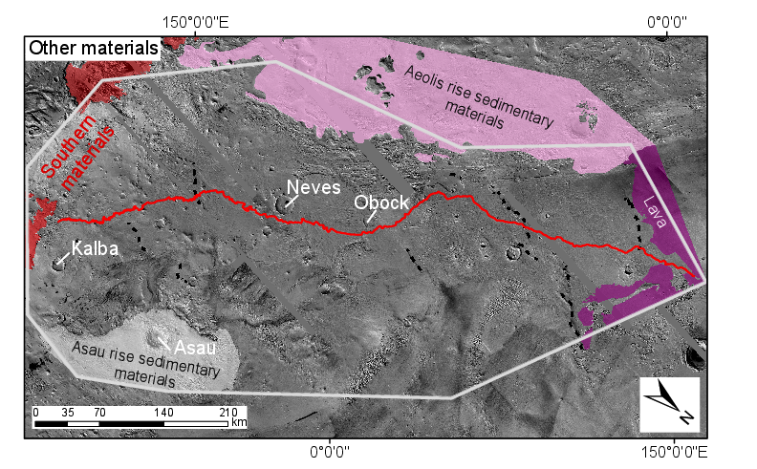
Figure S1. Materials outcropping in our study area, but not assigned to one of the sedimentary sequences in Figure 2. Aeolis rise sedimentary materials and Asau rise sedimentary materials probably postdate river deposits (Zimbelman & Scheidt 2012), but may unconformably predate them. Figure 20 shows these alternatives. Lava in the N of the study region embays Aeolis Serpens river deposits (Kerber & Head, 2010).

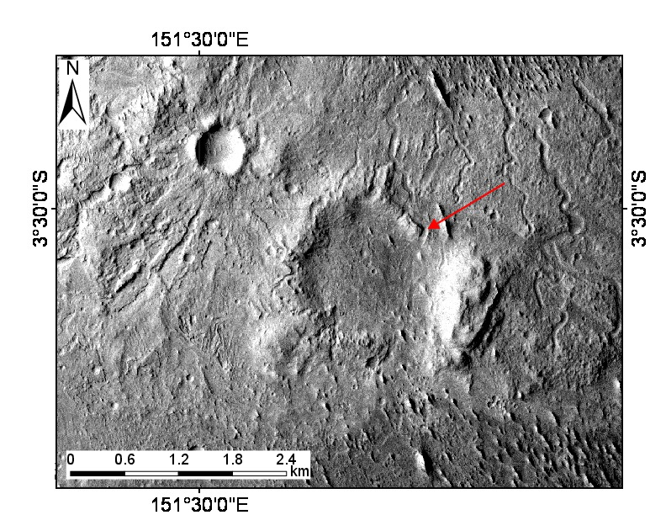
Figure S2. Channels crosscut a 1.5km-diameter crater on the Neves ejecta blanket, suggesting ≳3 x 10⁸ yr elapsed between the Neves impact and channel incision. Example shown by red arrow. Image is CTX P15_006894_1744_XI_05S208W.

a)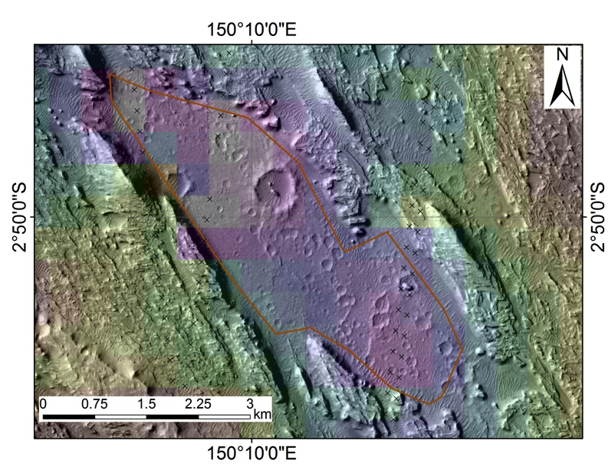
b)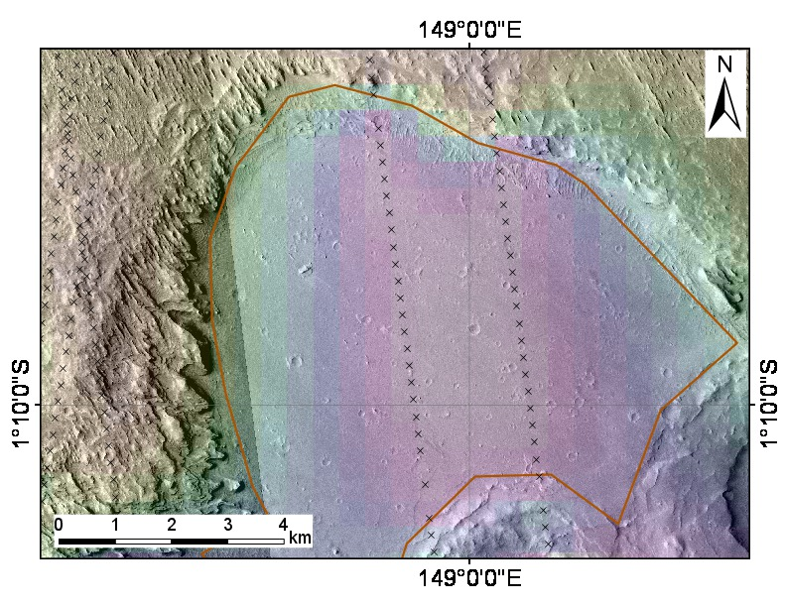
c)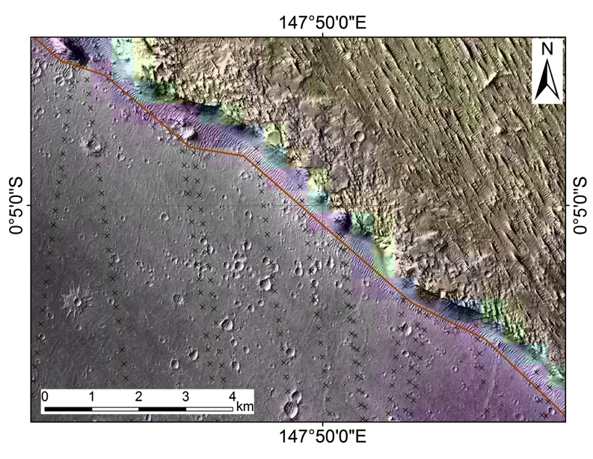
Figure S3. (a) Southernmost inlier of B (low-lying, heavily cratered material). Boundary scarp is ~100m high. Lowermost floor elevation is ~-2760m (from PEDR). Note wide spacing of PEDR tracks (columns of black crosses). (b) Part of central large inlier of B. Boundary scarp is ~150 m high. Lowermost floor elevation is ~-2700m. (c) Part of northernmost inlier of B. Floor elevation is -2840m. Boundary scarp is ~200m high.

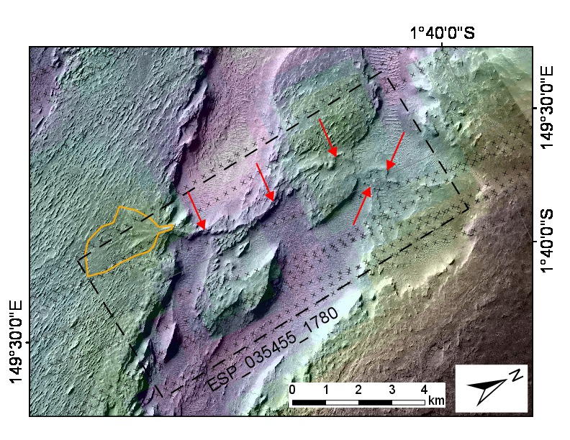
Figure S4. Source-to-sink sediment routing system preserved in inverted relief: erosion of L (high ground to E) to form an alluvial fan. Alcove formed by erosion of L contributes sediment to inverted channel (highlighted by red arrows) which terminates in alluvial fan (orange outline). Some PEDR points within alcove are now lower than the fan apex, which may correspond to undermining or differential compaction after the network was active. Black crosses show the location of PEDR tracks, which form the basis for the MOLA gridded terrain (color ramp). P18_008107_1800_XI_00N210W; outline of HiRISE ESP_035455_1780 shown by dashed black line.
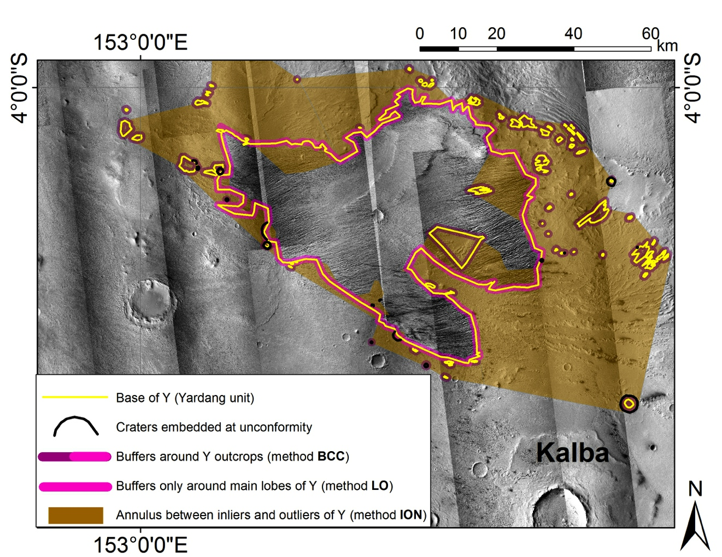
Figure S5. To show approaches to area normalization for measuring the time gap at the unconformity. A 1km-wide buffer is shown, although for each crater diameter we define a new buffer area (Fassett & Head 2008).

Supplementary Tables
Table S1. Craters embedded at sub-Y unconformity.
Lat (°N) Lon (°E) Diameter (km)
-5.0991 154.1100 2.6285
-5.2259 154.2500 0.8347
-4.7613 154.7600 0.6617
-4.9525 154.0180 0.6148
-4.9307 154.0470 0.5800
-4.6283 153.5320 5.0381
-4.7057 153.5600 1.7643
-4.4948 153.3830 0.6532
-4.3553 153.2560 0.7742
-4.3687 153.3610 1.5476
-3.3765 152.4080 1.4273
-3.6797 152.2870 0.5368
-3.6130 152.9730 0.3698
-3.6852 153.2380 0.3356
-0.3627 150.5120 0.7952
0.9737 149.9010 1.9173
1.0932 149.7340 1.4083
1.1893 149.5440 1.2603
0.9756 150.9850 0.7267
1.3456 150.7110 7.8509
1.0042 150.5550 3.1022
-1.4017 151.1420 2.1951
-1.7425 151.9850 11.0128
-1.5224 151.3640 1.9810
-1.4436 151.3770 0.3774
-1.7594 151.5250 7.3684
-1.8192 151.4370 1.1161
-4.4296 155.0640 2.1270
-4.7027 155.1750 0.2155
-2.8468 153.9150 1.0086
-3.5645 153.4430 0.3646
-0.1336 150.5150 0.1899
-0.0903 150.4850 0.2702
0.9947 150.9330 0.2583
1.2813 150.5880 0.7453
-4.3211 153.2400 1.3965
-4.7258 154.8540 0.2038
-5.1205 154.0110 0.3770
-3.4277 151.9080 10.0546
1.3583 151.4520 2.6600
1.2319 151.2890 1.8946
-0.0937 150.1590 0.7551
-5.4208 155.1540 4.4448
1.3342 151.8600 0.9861

Polygonal ridges in L near 150.7°E 1.1°N resemble the ridge-forming unit reported in Meridiani stratigraphy by Edgett (2005) (his Figs. 25-29).
In this paper, we use “river deposits” as a contraction to refer to “sedimentary units containing numerous river deposits.” This shorthand is neccessary because we do not know whether material between the deposits of channels that can be individually resolved from orbital images was moved by rivers. At some stratigraphic levels, the channel-deposit proportion approaches 100% by volume, and so this distinction is not important. However at other stratigraphic levels the channel-deposit proportion appears from orbit to be small. The remaining material could be unresolved channel deposits or overbank (floodplain) deposits (Bridge 2003), but significant input of atmospherically transported material is also possible (Haberlah et al. 2010, Schiller et al. 2014, Ewing et al. 2006).
Proof of quasi-periodic deposition – which requires painstaking analysis of HiRISE DTMs – has been achieved for only 9 locations on Mars so far (Lewis 2009, Lewis & Aharonson submitted).
This river-channel-containing material is here itself superposed by hummocks of smooth, concave-margined material of poorly constrained age.
Aeolis Serpens also postdates the dissection of the crater ejecta: for example, Aeolis Serpens approaches within 6 km of the Neves rim without visible deflection even though Neves ejecta extends up to 24 km from the rim.
Wesnousky (2008) estimates geologic slip of ~1-5m for single earthquakes on reverse faults with surface rupture length 25-100 km. The width of the alluvial-fan sinuous ridges (interpreted as inverted channels) is typically 30-60m. Taking the Hajek & Wolinsky (2012) (deposit width):(channel depth) ratio of 57 as a fiducial, the depth-of-flow on the alluvial fans would have been <1m, which could have been diverted by the rupture caused by a single earthquake.
The fault at the toe of the alluvial fans could not by itself have caused the change in fluvial style from rivers to alluvial fans – this must have been driven by some other external forcing.
These assumptions are consistent with embedded-crater counts (Kite et al. 2013), absence of major planetwide surface weathering at this time (Ehlmann et al. 2011), erosion modeling (Hoke et al. 2011), lithospheric stress-evolution modeling (Andrews-Hanna et al. 2008a), and a global geologic synthesis (Fassett & Head 2011).
The probability distribution of the time gap between runoff events conditional on the change in faulting style occurring between the runoff episodes is a quadratic function of the time gap, such that the 2σ lower limit is ~13% of the duration of the Hesperian (nominally (3.3±0.1) x 10⁸ yr; Michael, 2013).
The remaining ambiguity is unsurprising: ruling out unconformities has proven difficult even with rover-scale data (Grotzinger et al. 2014).
Preferential formation of layered deposits within craters has also been suggested (Brothers & Holt 2013; Figure DR3 in Kite et al. 2013c). The craters considered in those studies are larger than the craters considered in this study.
There are obvious limits to lithostratigraphic correlations across gaps where no layers can be traced. For example, the Old Red Sandstone of Britain (Hutton 1785) formed ~150 Myr prior to the New Red Sandstone and at a paleolatitude differing by ~40° – but both are desert red-beds with river and dune deposits. Incorrect stratigraphic correlation has a directional bias: it is particularly easy to misread an unsteady or oscillatory time evolution as a monotonic change (for example, compare Bibring et al. 2006 with Wray et al. 2009, Ehlmann & Edwards 2014, Sun & Milliken 2014). This difficulty and this bias is one of the reasons why the superposition relationships that ordinate the Aeolis Dorsa river deposits are so valuable.
Hypothetical ancient climates that were much warmer or wetter could have liquid water at the equator at obliquity <40° (Wordsworth 2014, Andrews-Hanna & Lewis 2011). Therefore, if the atmosphere was much warmer or wetter, then the importance of orbital forcing as a driver of climate change would be reduced.

