**MARS ALLUVIAL FAN FORMATION DURING THE AMAZONIAN AND LATE HESPERIAN SPANNED >10 MYR.** Edwin S. Kite1, Jonathan Sneed1, David P. Mayer1, Sharon Wilson2. 1University of Chicago (kite@uchicago.edu) 2Smithsonian Institution.

**Summary:** Large alluvial fan deposits on Mars record the most recent undisputed window of Mars surface habitability (the end of this interval has previously been dated to ~2.5 Ga) [1]. We find net sedimentation rate <10 μm/yr in the alluvial-fan deposits, using the frequency of craters that are visibly interbedded with alluvial-fan deposits. Assuming steady aggradation, this sets a lower bound of >100 Myr on the total interval spanned by alluvial-fan aggradation. This estimate would rise further if the Sadler effect operates on Mars. Even if there are no additional interbedded craters buried within the alluvial fan deposits, such that the only interbedded craters are the ones that are visibly outcropping today (which is very improbable), fan formation still spanned >10 Myr. Several factors not included in our calculations would further increase the lower bound. Our lower bound rules out fan-formation by a single catastrophic episode, such as a single impact-induced water–vapor greenhouse [2], or localized impact-triggered warming [3]. During the Late Hesperian/Amazonian, persistent or repeated processes permitted habitable surface conditions.

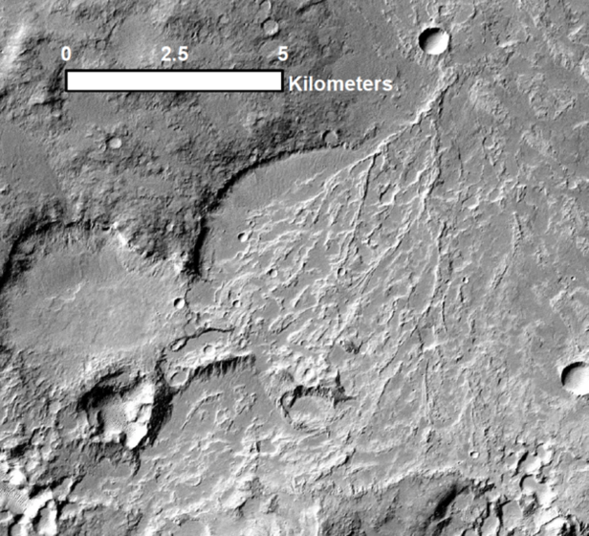

**Fig. 1.** A large synfluvial impact crater within Holden crater (previously noted by R.P. Irwin). Alluvial fan deposits sourced from the NW were cratered; the largest crater was then overlain by additional alluvial fan deposits sourced from the NE.

**Introduction:** Large alluvial fans on Mars correspond to the youngest undisputed evidence for a global river-supporting climate on Mars. This climate permitted runoff production of >0.1 mm/hr that fed rivers with discharge up to 60 m3/s [4]. Because of the large fluxes of fluid required to form the broad rivers that fed these alluvial fans, these streams probably had a water activity that would permit life. The duration of the habitable conditions recorded by the alluvial fans is not known.

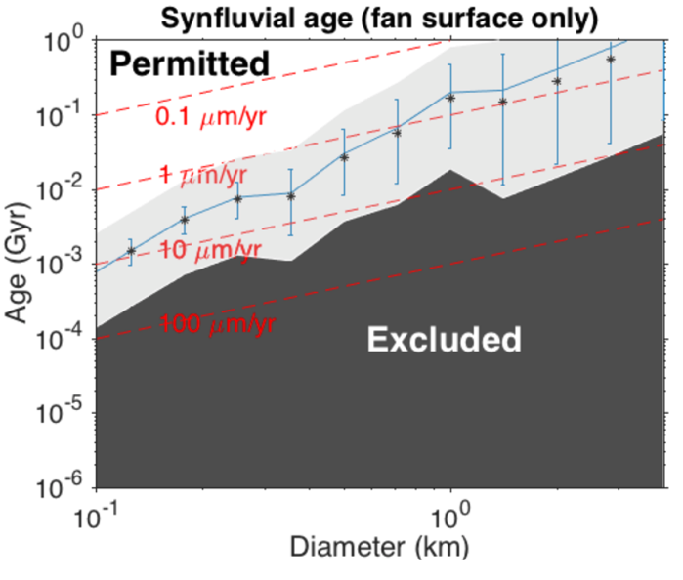

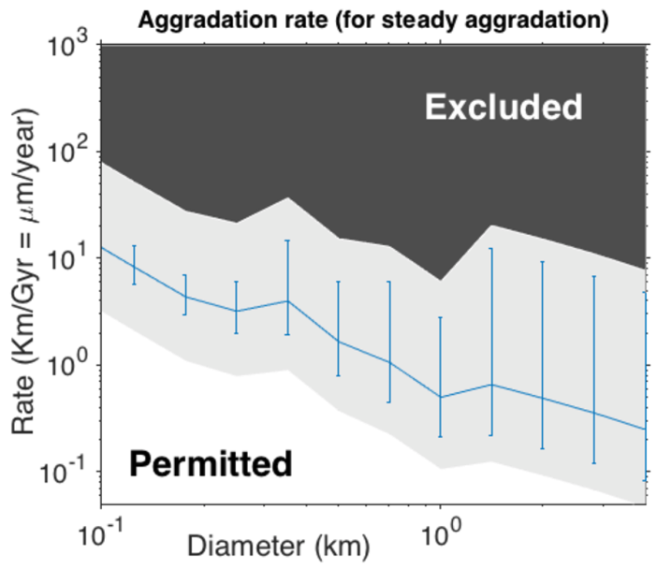

**Figure 1.** *Top:* Time span of alluvial fan formation, considering only the observed embedded-crater population. Crater counts are cumulative. Blue line shows best fit; blue error bars show the corresponding Poisson-statistics error. The gray area shows the 5%-95% uncertainty range in the lower limit from a Monte Carlo method including uncertainty in fan age, cratering rate, and paleoatmospheric pressure. The ‘Excluded’ region is excluded at the 95% level. The asterisks correspond to the median output of the Monte Carlo method. *Bottom*: As above, but for best-fit fan aggradation rate. The gray area shows the 5%-95% uncertainty range in the upper limit.

Previous estimates used geomorphic methods, which produce estimates of the time over which sediment transport occurred (e.g., Ref. 5). However, these methods rely heavily on Earth analogy both in terms of seasonal sediment transport and any time gaps (intermittency) in fan build-up (aggradation). In particular, they assume either zero intermittency, or Earth-like intermittency, neither of which should necessarily hold for Mars. To get a more accurate estimate of the interval over which alluvial fans formed, we used interbedded craters [6].

Crater density on a quiescent planetary surface is proportional to exposure duration. This method may be extrapolated to three dimensions: the total number of craters interbedded within a deposit depends on the time spanned by active sedimentation as well as interdepositional periods [6]. Naturally, this approach is complicated by the fact that interbedded craters may be completely buried; a comprehensive count via orbital photography is not feasible. However, if an impact occurs near the end of active sedimentation (by volume), then its crater may be only partially buried. Smaller craters are more readily buried, and larger craters require more sediment to be completely obscured. If the distribution of crater diameters in visibly interbedded craters is compared to some known impact frequency, then the past burial rate can be inferred. These “synfluvial” craters are distinguishable from pre-fan “prefluvial” craters that are overlain by alluvial fan deposits, but which formed before the start of fluvial activity [7]. The principle is straightforward and was first implemented by Hartmann (Ref. 8). See Ref. 6 for a detailed discussion.

**Methods:** In order to establish a lower bound on the length of time over which alluvial fans formed, we manually investigated the deposits catalogued by Ref. 9. 6m-per-pixel CTX images were used to produce an initial list of candidate craters showing possible evidence of interbedding with paleochannels or other fluvial features. Each candidate was then reviewed by a three-person panel for final classification, where 25cm-per-pixel HiRISE images and stereopairs were used (when available) to supplement the initial CTX search. We constrain the sedimentation rate of surveyed alluvial fans following the method of [6]. Importantly, different crater diameters probe different depth ranges and thus aggradation rate over different timescales. From Earth data (e.g. Ref. 10), we might expect aggradation rate to decrease over larger timescales, and this is in fact consistent with our data. All craters were classed as “synfluvial,” “prefluvial”, or “uncertain.” This distinction is needed because alluvial fan activity might have started well after the formation of the larger craters (e.g. Holden, Saheki, Ostrov) that host the alluvial fans [7].

The contribution of false positives to our catalog is likely negligible. Although polygonal faulting in Earth marine sediments can produce crater-like concentric layering structures [11], this is unlikely for Mars alluvial-fan deposits and many of our craters retain rims. On the other hand, there are certainly false negatives in our survey area: re-survey of a crater of interest found several additional embedded craters not found on the first pass. Therefore, our counts represent lower limits.

**Monte Carlo analysis.** The usual procedure for assaying crater-counting error is to use Poisson statistics [12]. The results of this procedure are shown by the blue error bars in Fig. 2. However, this ignores (1) uncertainty in the true crater flux, (2) filtering by a potentially thicker past atmosphere, and (3) variations in target strength. To determine past alluvial fan aggradation rates we must also consider (4) the time of formation of the alluvial fans, and (5) the amount of burial or erosion – expressed as a fraction of the crater’s diameter – that is needed to prevent the crater from being detected at CTX resolution. We adopted conservative priors on parameters (1), (2), (4), and (5) in a Monte Carlo simulation of our lower bound that also includes Poisson error. Specifically, we assumed a log-uniform uncertainty between 0.5× and 2× the Hartmann crater flux; a log-uniform prior between 6 mbar and 1000 mbar for atmospheric filtering (the “Popova correction” of Ref. 13); a uniform uncertainty between fan formation 2.0 Ga (low-end fan crater retention age) and 3.6 Ga (age of the large craters which host alluvial fans); and a log-uniform prior between 0.05 (rim burial; Ref. 14) and 0.2 (original crater depth; Ref. 15) for the obliteration depth fraction (relative diameter). Results are shown by the gray error bars in Fig. 2. The effects of varying target strength (parameter 3) will be discussed at the conference. The results are lower limits because of survey incompleteness.

**>100 Myr span of fan formation assuming steady aggradation:** We measured alluvial fan thicknesses by comparing CTX DTM profiles across fans to analogous profiles across parts of the same craters that lacked fans. We found maximum fan thickness 1.1 km, with thicknesses ~1 km common. If steady agggradation is assumed, then our <10 μm/yr aggradation rate bound corresponds to a >100 Myr span of (perhaps intermittent) surface habitability.

**Acknowledgements.** Particular thanks to J.-P. Williams.We thank A. Howard, R.P. Irwin III, W.E. Dietrich, and M. Palucis. We acknowledge NASA funding through a subcontract to U. Virginia (PI Howard, NNX15AM49G).

**References.** [1] Grant and Wilson, Geophys. Res. Lett. 2011. [2] Toon et al., Annual Reviews 2010 [3] Kite et al., JGR-E 2011 [4] Morgan et al., Icarus 2014 [5] Armitage et al., Geophys. Res. Lett. 2011. [6] Kite et al., Icaurs 2013. [7] Irwin et al., Geomorphology 2015 [8] Hartmann, JGR 1974. [9] Wilson et al., LPSC 2013 #2462 [10] Jerolmack & Sadler JGR-F 2007. [11] Egypt Tewksbury et al., Geology 2014. [12] Michael et al., Icarus 2016 [13] Hartmann, Icarus 2005. [14] Melosh, *Impact cratering: a geologic process*, 1989. [15] Watters et al., JGR-E 2015.