GEOS 32060 / GEOS 22060 / ASTR 45900

**What makes a planet habitable?**

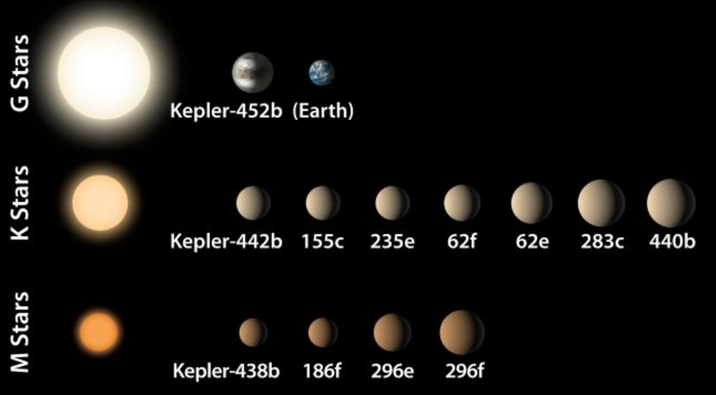

**Instructor:** Edwin Kite,kite@uchicago.edu

**Website:** geosci.uchicago.edu/~kite/geos32060 (required reading, homework)

**Homework:** Issued once per week, due 1 week after being issued.

**Grades:** 70% homework, 15% paper presentation, 15% final. There will not be a midterm. Final will be closed-book, but you will be provided with a list of basic quantities (mass of Earth, molar mass of CO2, e.t.c.), and in addition you can bring one sheet of paper with your own notes.

**Reading:** Required reading 1-2 papers per week (+ supplemental reading).

**Textbook:** None. PDFs of chapters from *Fundamentals of Geobiology* and *Principles of Planetary Climate* will be made available.

**Paper presentations:** You will be assigned a paper to present by the instructor. You are encouraged to make a powerpoint presentation (chalkboard presentations are allowed). Students will make 20 minute presentations, followed by class discussion.

**Office hours:** Mondays, 9am-10am. Hinds 467.

**Collaboration policy:** You are allowed to discuss course material and homework assignments with each other, but you must work out and write up each problem solution by yourself without assistance. Exchanging solutions to homework problems or sharing solutions is strictly prohibited. It is a violation of this policy to submit a homework solution that you cannot explain orally to the instructor/TA. Copied solutions obtained from a written source, from the internet, or from another person will receive zero credit.

**Dates when I will be unavailable:** Wed 2/17 – Fri 2/19.