GEOS 32060 / GEOS 22060 / ASTR 45900

Homework 5

*Due in class on Monday 15 Feb 4pm.*

*No credit will be given for answers without working. It is OK to use e.g. Mathematica, but if you do, please print out the work.*

**Q1. Ejecta weathering.** In addition to tectonic uplift, impacts can eject fresh-minerals for weathering. Assume the mass distribution of impactors follows the power law N(>m) = (m/mmax)-*b*, where mmax is the mass of the largest impactor, N(>m) is the cumulative number of impactors greater than mass m, and *b* = ¾.

1. Is impacting mass concentrated in the largest impactors or the smallest

impactors?

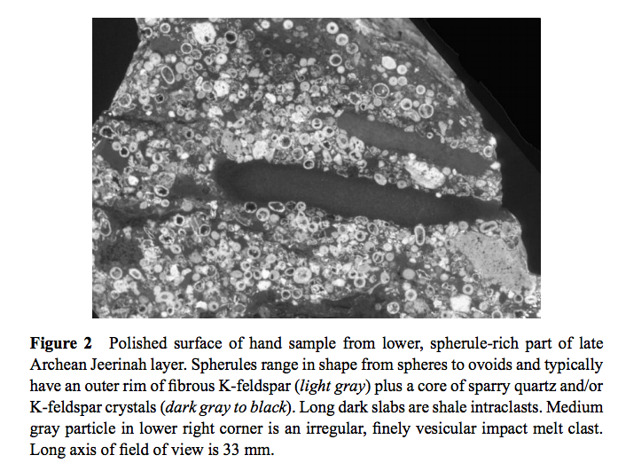

*Simonson & Glass, Annual Reviews of Earth and Planetary Science, 2004.*

1. Ancient impactors on Earth are recorded by spherule beds (ancient craters have subducted). Spherules condense from rock vapor in impact plumes during the minutes after impact, then fall to Earth as fresh, initially unweathered material that forms a near-uniform, thin blanket on the surface. Assume a weathering rate for spherules of 3 mm/106 yr with rapid infiltration of water into the space between the spherules, what is the duration of the weathering pulse associated with the above layer?
2. Assuming a (Ca+Mg) content of 10 wt %, a (spherule layer):impactor mass ratio of 102, and an Archean atmosphere+ocean C inventory and recycling time equal to that of the modern Earth as given in lecture, what is the impactor radius needed in order for the Jeerinah layer to have transiently doubled Earth’s weathering rate?
3. Suppose that a planet has ongoing volcanism but no plate tectonics and no mountain uplift (modern Mars is an example). Suppose that the rate of volcanism is sufficient to increase CO2 pressure by 100 mbar every 10 Myr. Assume the gravity and surface area of Mars. Determine the flux of 10 km-diameter (dinosaur-killing) impactors needed to generate enough weathering to consume as much CO2 as is released and thus prevent runaway warming.
4. Comment, given your answer to (a), on whether this set-up can lead to a stable climate in practice. (Disregard the immediate climate effects of the impact and consider only the longer-term balance between weathering and volcanism.) For what value of *b* would your answer change?
5. Now consider a Super-Earth (r = 2x Earth, g = 25 m/s2). How does your answer to part (d) change? Why?

**Q2. Buffering capacity of seawater.** Climate responds to atmospheric pCO2, but the majority of the C in the ocean/atmosphere system is stored in the ocean, primarily as [HCO3-]. Therefore the partitioning of C between the atmosphere and ocean affects the climate sensitivity of the ocean/atmosphere system (the amount of warming per unit C added to the system). Following Zeebe and Wolf-Gladrow (2001),

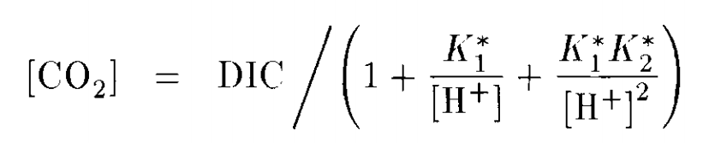

where square brackets denote concentration, DIC stands for Dissolved Inorganic Carbon (the sum of [CO2], [HCO3-], and [CO32-]), and the equilibrium constants K1* and K2* correspond to

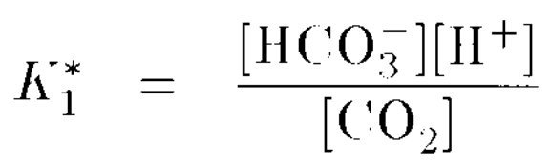 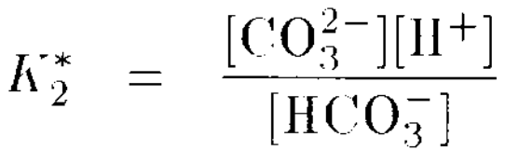

Note that pK1* = -log10(K1*), e.t.c. Let pK1* = 5.86, pK2* = 8.92. Assume the equilibrium between [CO2] in the ocean and pCO2 in the atmosphere is given by Henry’s law with a solubility constant of 0.034 mol/(L x atm).

1. For pH = 8 and DIC = 2 mmol kg-1, what is the [CO2] in the ocean? What is the atmospheric pCO2?
2. Suppose DIC the ocean volume is 10x greater, the DIC inventory is constant (i.e. proportionally diluted), but the pH is unchanged, what is the atmospheric pCO2 on this waterworld?
3. It is an ice age and the ocean considered in part (a) cools by 20K, shifting the equilibrium constants. The new pK1* is 6.11 and the new pK2* is 9.38 and you may assume DIC is unchanged. Does the ocean take up or release CO2? Is this a positive or a negative feedback on climate? Assuming a climate sensitivity of 2K to a CO2 doubling, what is the magnitude of surface temperature change due to the uptake or release of CO2? Comment on the importance of this feedback on surface temperature (relative to the initial ocean cooling).
4. (Revelle factor). Due to buffering in the carbonate system, it is found that

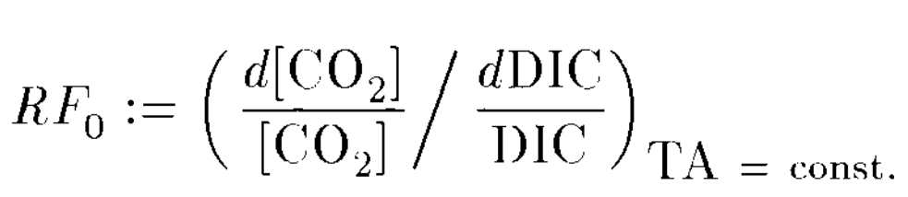 ~ 101 for Earth. With reference to the equations given above part, (a) explain the implications for both climate stability (against changes in volcanic outgassing rate) and for the ease of ocean acidification if the Revelle factor was 1 (i.e. no buffering).