GEOS 32060 / GEOS 22060 / ASTR 45900

Homework 4

*Due in class on Monday 8 Feb 4pm.*

*No credit will be given for answers without working. It is OK to use e.g. Mathematica, but if you do, please print out the work.*

**Q1. Tidally Locked Planet.** Many, perhaps most, of the rocky habitable-zone planets in the Universe orbit M-dwarf stars; these are also the easiest habitable-zone rocky planets to detect and characterize. However, because M-dwarfs are faint, the habitable zone is located close to the star (i.e. the ratio of planet radius *r* to orbital radius *a* is much smaller than on Earth). Because tidal locking timescales scale as *a*-5 for constant *r*, such planets are very vulnerable to tidal locking.

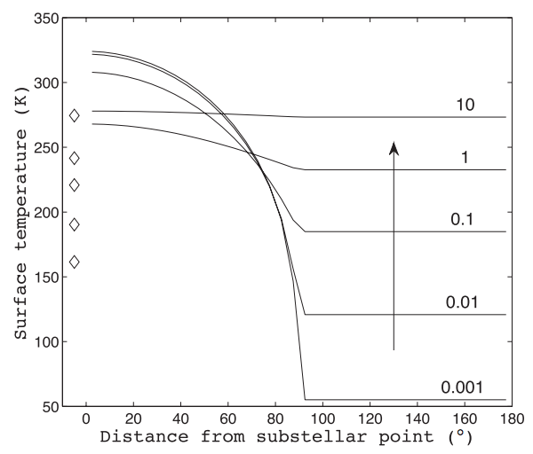

*Surface temperature on a tidally locked planet, calculated using an idealized 1D climate model. The numbers 0.001🡪10 correspond to atmospheric pressure in bars. Local temperature is controlled by the greenhouse effect, but also by the tendency of thicker atmospheres to redistribute energy from the lightside to the darkside.*

Consider the tidally locked planet from the figure.

1. Assume weathering rate scales as 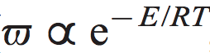

where *E* is activation energy and *R* is the gas constant. Assume an effective activation energy for weathering (“effective” including the effect of temperature on rainfall) of 1 kJ/mol. If the temperature goes up everywhere from 279K to 280K, what is the approximate fractional increase in weathering rate? For the 0.01 bar tidally locked planet case, what is the ratio of weathering rate at the substellar point to weathering rate at 60° from the substellar point?[1]

1. Assuming mountain belts / tectonic uplift zones are randomly distributed with distance from the substellar point, comment on where on the planet most weathering occurs. Consider the likely effect of ice cover.
2. Now assume that the gas that is the principal constituent of the atmosphere is also the principal greenhouse gas. (This assumption was used to calculate the temperatures shown in the plot. This assumption is not true for the Earth, but is true for Mars, Venus, Triton, and arguably also Titan). Explain how the planet-integrated weathering rate changes as we increase pressure from 0.001 🡪 10 bars.
3. Is this hypothetical planet stable to a sudden two-fold step increase in the volcanic outgassing rate? Why?
4. Now assume that everything is the same as in (e), but the effective activation energy is now 1000 kJ/mol. Is this hypothetical planet stable to a sudden two-fold step increase in the volcanic outgassing rate? Why? ***Hint:*** Recall that the threshold surface temperature for runaway greenhouse on a planet with water oceans is ~330K.

(This idealized planet is discussed further in Kite et al., ApJ 2011.)

**Q2. Effect of Supercontinent Formation.** We saw in lecture that mountains are important to the global weathering budget; the purpose of this question is to work through the order-of-magnitude effect on climate of forming new mountain belts.

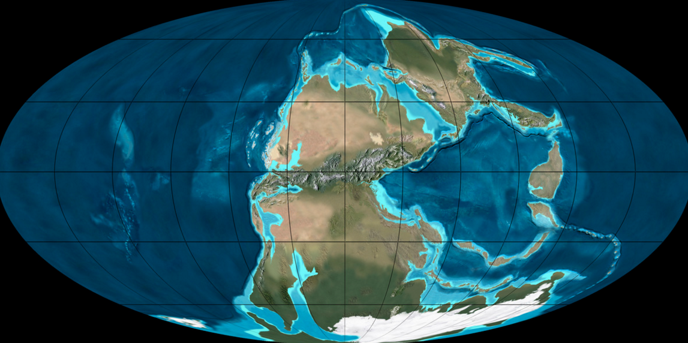

*Earth 280 Ma. Credit: Ron Blakey (NAU).*

The most recent global supercontinent, Pangea, was completed ~280 Ma by collision of North America with Africa. The collision (the Alleghenian orogeny) created a mountain chain, the Central Pangean Mountains. The Appalachian Mountains approximately correspond to a remnant of this mountain belt. In this question, use the paleogeographic reconstruction above (grid spacing 30 degrees) and Earth radius = 6x106 m.

1. Suppose paleomagnetic data[2] indicate Africa travelled N at 5 cm/yr and collided with a stationary North America. Assume continental crust is 35 km thick. Because continents are buoyant relative to the mantle, neither continent subducts. At steady state, continental crust is moving up to the surface at mountain belts, undergoing weathering and erosion, and the mass is being redistributed away from the mountain-belt, all at equal rates. What is the mass flux? Suppose the pre-collision eroded flux was equal to Earth’s modern sediment flux of 8 km3/yr; what is the fractional change in eroded flux (i.e., mass/volume available for weathering)?
2. Assume an activation energy for the temperature effect on weathering of 74 kJ/mol (West et al., Earth & Planetary Science Letters 2005). What is the sign and magnitude of planetary temperature change?
3. Suppose that the ice sheet in the S Hemisphere grows. Is this a positive or negative feedback on the change you calculated in part (b)? Why?
4. It is often said of warming climates that “wet areas get wetter, dry areas get drier.” [3] Given that weathering rate depends on both temperature and rainfall, explain qualitatively how changes in rainfall on the Central Pangean Mountains due to the warming you calculated in part (b) would feed back on (and thus modify) your answer to part (b).
5. Suppose that collision had occurred in the desert belt at 25° N instead of at the humid equator. Explain how you answer to part (d) would differ.

1. We saw in lecture that the evidence for a direct dependence of spatial variations in weathering rate on local T is mixed at best. However, for this question, assume that there is an overall dependence of spatial variation in weathering rate on local T.
2. Paleomagnetic data provide great constraints on latitudinal drift rates, but constraining paleo-longitudinal drift requires less direct methods such as matching up geologic provinces on either side of a rift zone, or looking for evidence of hotspot volcanism (hotspots are underlain by mantle plumes, which move slowly relative to plates and so define a “hotspot reference frame”).
3. Whole research groups in the Hinds Building are devoted to showing the many ways in which this is not exactly true. For example, an expanding Hadley cell under warming (discussed in lecture) can turn the low-latitude edge of the desert belt into a wet zone.