GEOS 32060 / GEOS 22060 / ASTR 45900

Homework 3

*Due in class on Monday 1 Feb 4pm.*

*No credit will be given for answers without working. It is OK to use e.g. Mathematica, but if you do, please print out the work.*

In class we discussed the point that at habitable temperatures, chemical diffusion in rocks is very slow.

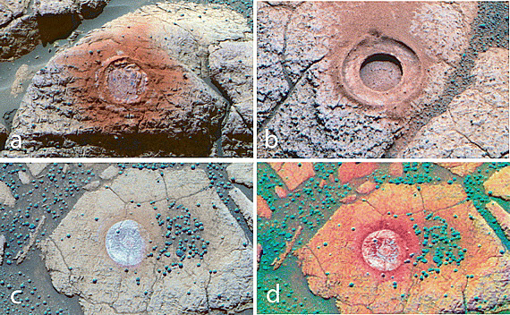

*After >3 Ga of cold-climate weathering, Mars rinds are very thin. Drill diameter 2cm.*

The purpose of this homework is to develop the idea that water-rock reactions (e.g. serpentinization, carbonation) at planetary scale are limited by the availability of surface area for reaction. This surface area can be produced by impacts, tectonism, erosion, or (for low-gravity worlds) by incomplete compaction during planet formation. Water-rock reactions are associated with gravity lows for two reasons: pore space is less dense than rock (even if liquid-filled); and hydrated minerals produced by water-rock reactions are usually less dense than anhydrous minerals.

**Q1. Relatively recent weathering on Mars.**

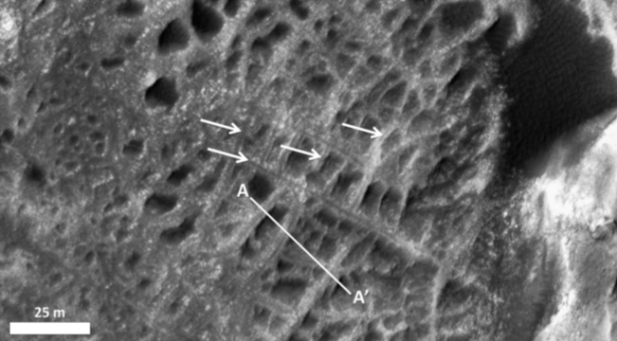

**Q1. The Moon from GRAIL.**

The resolution of satellite-derived gravity maps on planets with atmospheres is constrained by. On the Moon, the GRAIL mission was able to literally fly between the mountaintops, yielding a very high-resolution gravity map.

d) Scaling from the GRAIL observations, what is the porosity at the center of Enceladus? Assume permeability is given by . Does hydrothermal convection extend to the center of Enceladus?

**Q2. Gravity anomalies on Ganymede.**

Ganymede is a 0.4 Earth-radius moon of Jupiter with a probable “club sandwich” outer layer of multiple salty oceans and high-pressure-ice shells, a rocky mantle, and a liquid metal core with a strong dynamo. Moon density and J2 constrain the rock-metal boundary to be at ~0.25 Ganymede radii and the rock-water boundary to be at 0.65 Ganymede radii.

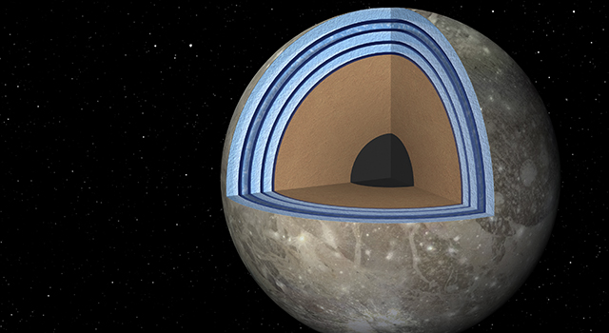

Ganymede is notable for its large gravity anomalies (detected during close flybys by the Galileo Jupiter orbiter). The anomalies are not correlated with surface geology. At closest approach (200 km), the anomalies produced an excess acceleration of 10-5 m s-2.

1. What is the approximate spatial resolution (the observational “footprint”) of a flyby gravity measurement at the surface? At the rock-ice boundary? At the rock-metal boundary? You may neglect planet curvature.
2. Density of metal = 7 g/cc; of rock = 3 g/cc; of high-pressure water substance, 1.5 g/cc. Assuming a “mountain” of metal (a perturbation of the rock-metal boundary) is responsible for the gravity anomalies, and the mountain radius is the footprint size from part (a), what is the height of the mountain? Repeat the calculation for a mountain of rock at the rock-ice boundary. You may neglect planet curvature.
3. Assume the viscosity of ice is 1013 Pa s, the viscosity of rock is 1018 Pa s, and the viscosity of liquid metal is 101 Pa s. Modeling the mountains as spheres, what is the time for the mountains to sink? Are the “mountains” a reasonable explanation for the data? ***Warning/hint:***