GEOS 32060 / GEOS 22060 / ASTR 45900

Homework 2

*Due in class on Monday 25 January 4pm.*

*No credit will be given for answers without working. It is OK to use e.g. Mathematica, but if you do, please print out the work.*

M = mass, R = planet radius, a = semimajor axis (typical distance of planet from star). Mass of Earth = 6 x 1024 kg, radius of Earth = 6 x 106 m, semimajor axis of Earth = 1.5 x 1011 m, solar flux at Earth = 1400 W/m2. Stefan’s constant = 5.67 x 10-8 W m-2 K-4.

**Q1. Alternative fates of Venus.**

1. In the case of Venus, a runaway greenhouse is believed to have been

followed by loss of almost all water from the planet. State and explain two circumstances under which a long-lived runaway greenhouse might *not* cause loss of much water from the planet.

1. The escape velocity from Venus is ~104 m/s, but in hydrodynamic escape models, both bulk and thermal velocities are <<104 m/s out to very large distances from the planet (example below). Explain qualitatively how gas can escape from the planet without reaching escape velocity.

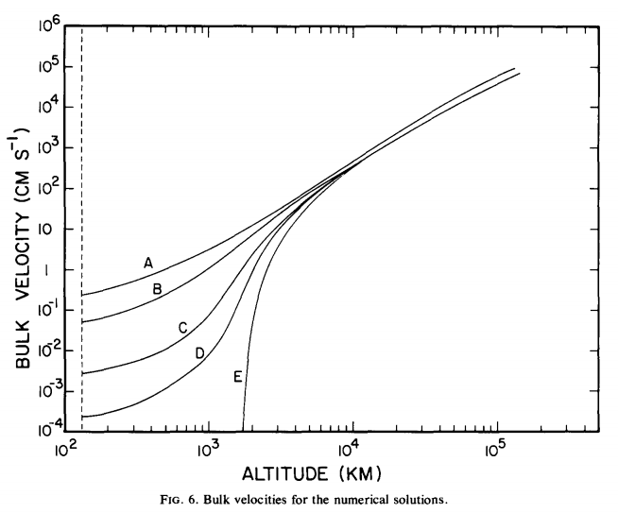

*from Watson et al. Icarus 1981*

c) In lecture, we saw that the basic equations for hydrodynamic escape have supersonic and sub-sonic solutions. Suppose that Venus was embedded in a gaseous nebula (e.g. during solar system formation). Explain, with reference to the basic equations for hydrodynamic escape as discussed in lecture, how this would affect the physical validity of the supersonic and/or sub-sonic solutions.

**Q2. What sets the rate of earthquakes?**

Earthquakes are caused by plate tectonic movements: if plates spread 10x faster, then earthquakes would be 10x more frequent. Resurfacing (which on Earth is driven by plate tectonics) is fundamental to planet habitability. In this question you will make an order-of-magnitude calculation of the rate of the rate of plate spreading (~resurfacing) on the Earth. Although it is not required to complete the question, you may wish to refer to Chapter 13 of Schubert et al. 2001 (optional reading from Week 1 at <http://geosci.uchicago.edu/~kite/geos32060/>). Heat flow from Earth’s interior = 0.07 W/m2, thermal diffusivity of Earth rocks kappa = 10-6 m2s-1, thermal conductivity of Earth rocks 3 W/m/K, melting point of rocks 1500K, Earth surface temperature 300K.

1. What is the temperature gradient in the shallow subsurface of Earth?
2. Extrapolating this temperature gradient, what is the depth at which Earth’s interior reaches the melting point?
3. From seismic data we know that the Earth’s rock mantle is almost entirely solid, so that temperatures do not in fact reach the melting point. Your answer to (b) is an upper limit on the depth of the conductively-cooled skin of the Earth (delta, thermal boundary layer, TBL). For cooling of a half-space, delta = 2.32 sqrt(kappa*tau), where tau is in seconds. What is tau for Earth?

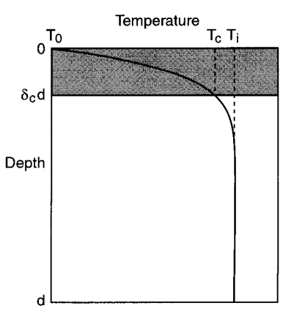

d) Plates grow at spreading ridges and cool conductively as they are transported to subduction zones where they are consumed. Assume plate length = 3000 km (typical length of journey from spreading ridge to subduction zone). What is the plate spreading rate for Earth? Assuming a subduction-zone total length of 40,000 km, what is the subduction flux per unit Earth surface area (cm/yr)?

e) Although plate spreading and subduction does not require magma and is a solid-state process, magma is formed at spreading-ridges as a consequence of plate spreading. Total spreading-ridge length is 40000 km, crystallized-magma thickness is 7 km. Calculate the crystallized-magma resurfacing rate of the Earth (cm/yr per unit surface area). Comment on the ratio of crystallized-magma resurfacing relative to the subduction flux.

f) Jupiter’s moon Io (radius = 0.3x Earth) has a surface-averaged lava resurfacing rate of 2 cm/yr. This is believed to also be the subduction rate on Io. Assume that the rate of quakes is set by the subduction rate[1], and that the size-frequency distribution of Io-quakes is identical to that of earthquakes. What is the ratio of Io-quakes to Earth-quakes?

1. A quite dubious approximation, because tides from Jupiter likely play a role in Io-quakes.