**GEOS 22060/32060 – Winter 2020 – Homework 6**

Due Wednesday 12 March

**Q1. Resurfacing mechanisms on Europa (how to get the oxygen to the ocean)**

In class, we discussed the geological evidence that Europa has been resurfaced by liquid water, but did not discuss driving forces for this resurfacing. In this question, you will investigate one hypothesis for resurfacing (optional reading: Manga & Wang, Geophysical Research Letters 2007).

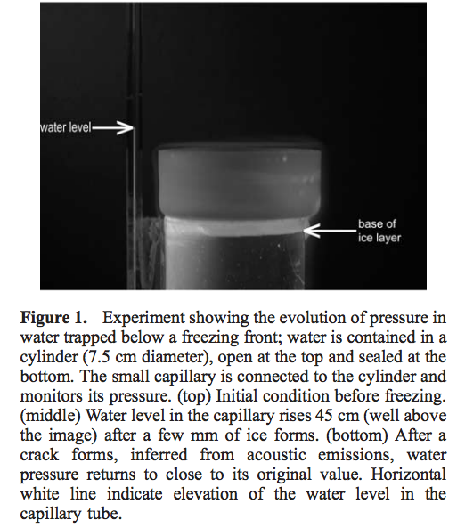Manga & Wang, GRL 2007

1. Assume that Enceladus undergoes heating-cooling cycles every 100 Myr due to the orbital-thermal feedbacks – let’s exaggerate and assume that the ice shell goes from almost completely frozen to almost completely unfrozen each cycle. Consider freezing of an initially very thin ice shell. Ocean pressure builds up according to

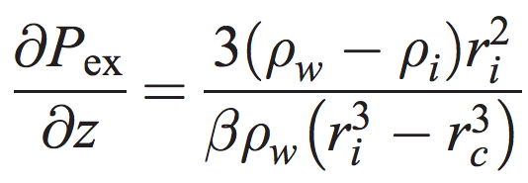

(neglecting ice-shell expansion), where z is the ice shell thickness, water density is 1000 kg/m3, ice density is 910 kg/m3, and water compressibility (beta) 4 x 10-10 Pa-1. rc is rocky-core radius (the rock is assumed incompressible), and ri is the radius at the top of the liquid-water ocean (i.e. ri = R – z, where R is moon radius). Let rc = R – 200 km and let R = 1600 km. How thick is the ice when the shell cracks?

(b) Assume that once the shell cracks the overpressured water can erupt onto the surface.[1] Taking into account the length of the heating-cooling cycle, for a typical water molecule, what is the typical wait time after being erupted before being erupted again?

**Q2. Gravity anomalies on Ganymede – buried topography?**

Ganymede is a 0.4 Earth-radius moon of Jupiter with a probable “club sandwich” outer layer of multiple salty oceans and high-pressure-ice shells, a rocky mantle, and a liquid metal core with a strong dynamo. Moon density and J2 constrain the rock-metal boundary to be at ~0.25 Ganymede radii and the rock-water boundary to be at 0.65 Ganymede radii.

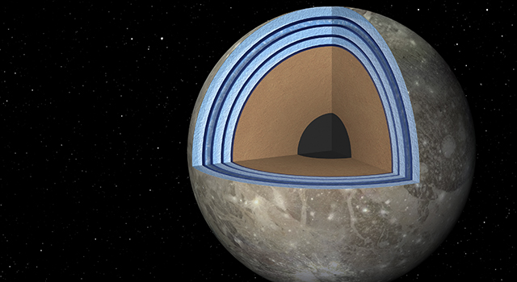

Ganymede is notable for its large gravity anomalies (detected during close flybys by the Galileo Jupiter orbiter). The anomalies are not correlated with surface geology. At closest approach (200 km), the anomalies produced an excess acceleration of 10-5 m s-2.

1. Assume that the approximate spatial resolution (the observational “footprint”) of a flyby gravity measurement is the distance of the spacecraft from the interface being probed. What is this footprint from a close flyby at the surface? At the rock-ice boundary? At the rock-metal boundary? You may neglect planet curvature.
2. Density of metal = 7 g/cc; of rock = 3 g/cc; of high-pressure water substance, 1.5 g/cc. Assuming a “mountain” of metal (a perturbation of the rock-metal boundary) is responsible for the gravity anomalies, and the mountain radius is the footprint size from part (a), what is the height of the mountain? Repeat the calculation for a mountain of rock at the rock-ice boundary. You may neglect planet curvature.

1. This is controversial; there is suggestive geologic evidence in favor, but theoretical arguments against.