**GEOS 32060 – Winter 2020 – Homework 2**

Due in class (or via email immediately after class) Tuesday 4 February. No credit will be given for answers without working. It is OK to use e.g. Mathematica, but if you do, please print out the work.

M = planet mass, R = planet radius, a = semimajor axis (typical distance of planet from star). Mass of Earth = 6 x 1024 kg, radius of Earth = 6 x 106 m, semimajor axis of Earth = 1.5 x 1011 m, solar flux at Earth = 1400 W/m2. Stefan’s constant = 5.67 x 10-8 W m-2 K-4. Stefan-Boltzmann law: total energy radiated = (Stefan’s constant) x T4. Assume all worlds are rapidly rotating such that πR2 of stellar flux is spread out evenly over 4 π R2 of surface area.

**Q1.** Twin studies. Pluto and Charon are at the same distance from the Sun (a = 40 x Earth). Assume that they formed at the same distance from the Sun at about the same time. Pluto has a mass of 2.2 x 10-3 x Earth and a radius of 0.18 x Earth. Charon has a mass of 2.6 x 10-4 x Earth and a radius of 0.09 x Earth.

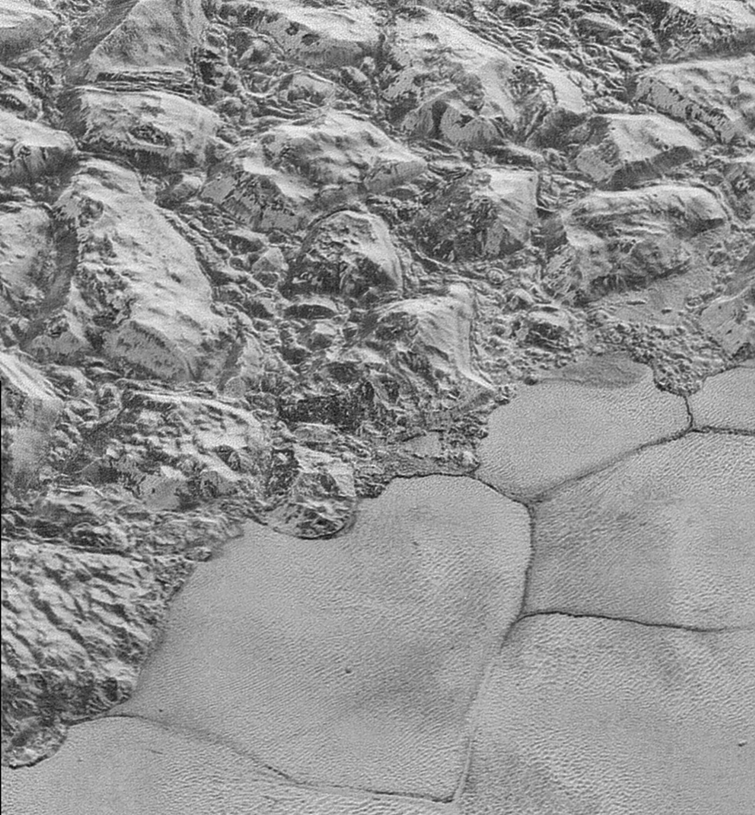

*Nitrogen ice sheet adjacent to mountains on Pluto. Oblique view from New Horizons spacecraft flyby. Nitrogen-ice convection cells are ~20 km across.*

a) Assume Pluto and Charon absorb 70% of incident sunlight. What is the surface temperature at Pluto? At Charon? b) From now on, assume an isothermal, pure nitrogen atmosphere. What is the scale height at Pluto? At Charon? c) Assume that the exobase is 10 scale heights above the surface1[1]. What is the gravity at the exobase for Pluto? For Charon?

The Jeans’ parameter, λesc, is proportional to the ratio of the gravitational binding energy to the thermal energy for molecules at the exobase. Larger values of λesc indicate that escape-to-space is unlikely. The Jeans’ parameter is usually calculated for exobase conditions (altitude, temperature). Hydrodynamic escape is most likely for λesc <~ 3. For λesc > 10, we are in a molecule-by-molecule thermal escape regime (confusingly, this molecule-by-molecule escape process is termed Jeans’ escape).

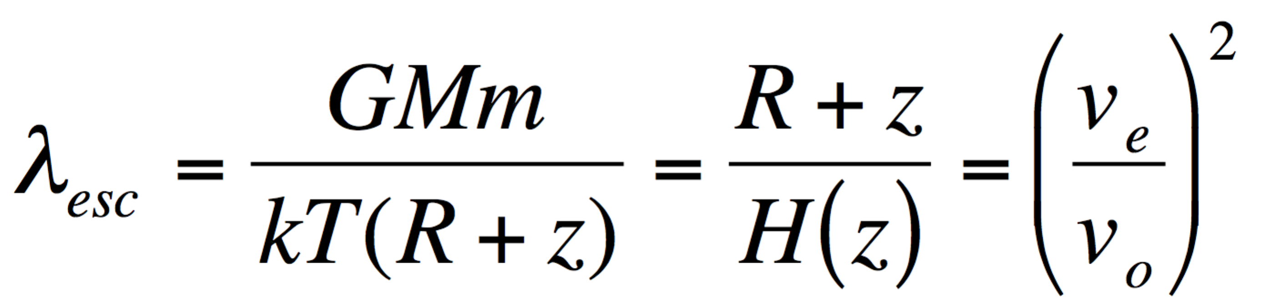

where G is gravitational constant, M is planet mass, m is molecule mass, k is Boltzmann’s constant, T is (local) atmosphere temperature, R is planet radius, and z is altitude above the planet’s surface.

d) What is the escape parameter (Jean’s parameter) for Pluto? For Charon? e) (For each world,) are we in a Jeans escape or hydrodynamic escape regime? f) How would your answer to (d) change if the isothermal assumption was not true, and the exobase temperature was in fact 200K (for example, due to UV absorption in the upper atmosphere)?

**Q2. Impact energies.**

Consider a large planet with a density consistent with that of rock (*M* = 17 × Earth, *R* = 2.35 × Earth, *a* = 0.25 × Earth): this is close to the upper limit for rocky-planet mass. Assume that this “Godzilla” world orbits an exactly Sun-like star.

1. What is the escape velocity at the surface of ‘Godzilla’?
2. Suppose that the last giant impact on Godzilla involved a 1.7× Earth mass object. To within a factor of 2, what is the *minimum* specific kinetic energy of the collision (J/kg)?
3. Assume all the energy was dissipated as heat, and that before the impact Godzilla was just below the melting point. Assume *Lmelt* = 5 × 105 J/kg for planetary materials. Did the impact melt Godzilla?
4. Assume *Lvap* = 5 × 106 J/kg. Was the energy of the impact sufficient to vaporize Godzilla?
5. Assume that Godzilla has a global magma (liquefied rock) ocean after the impact, with no atmosphere or ocean. The surface temperature is ~1500 K. Find the (blackbody) radiated flux. Assuming steady cooling at this flux, find the time it will take for the magma ocean to freeze.
6. Assume that Godzilla retains (or outgasses) steam immediately after the impact, so that it emits at the runaway greenhouse limit (steam atmosphere: ~320 W/m2). In a runaway greenhouse, surface temperature can be much higher than the effective emission temperature. Comment on ***net*** cooling rates and the likely time-to-freezing.
7. Comment on the direct detection of giant impacts on young rocky exoplanets. Describe qualitatively what a very sensitive wide-field survey would see (in the just-magma case, and in the steam-outgassing case). Describe qualitatively what a less sensitive wide-field survey would see (in the just-magma case, and in the steam-outgassing case).

No direct detections of giant impacts on exoplanets have yet occurred. However, Meng et al. (Science, 2014) report year-to-year variations in the 3-5 μm flux from a debris disk around a young Sunlike star, consistent with condensation and collisional grinding of debris from a recent giant impact.

**Q3. Energy balance, albedo, and moon destruction.**

Phobos, a dark moon, is accelerating towards Mars and will disintegrate in 20-70 Myr due to tidal forces[2].

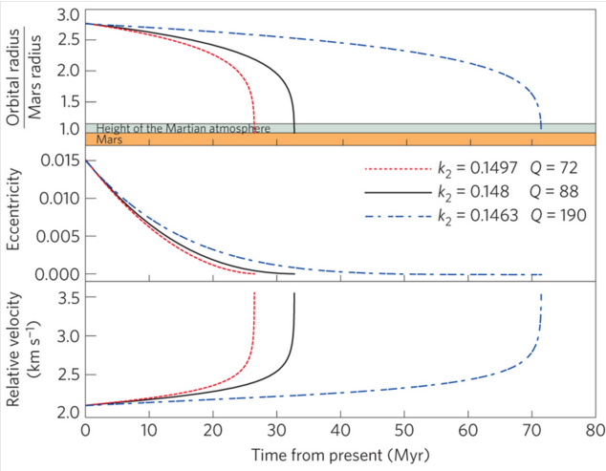

From Black & Mittal, Nature Geoscience 2015 (k2 and Q refer to tidal dissipation parameters for Mars).

This question is about the climatic consequences.

1. Calculate the global-equivalent depth of Phobos dust (Phobos diameter ~10 km) following disintegration of Phobos and reentry of the fragments. Assume all material arrives as dust. (The duration over which fragments reenter could be Myr, or even longer).
2. Assume Phobos dust (set Phobos dust albedo = 0) falls on the north polar water ice cap and Mars obliquity = 60°, Mars semimajor axis *a* is unchanged (1.52 AU)[3] and Mars eccentricity *e* is slightly higher than today (0.15)[4]. Noting that perihelion distance *q* = *a*(1 – *e*), what is the theoretical maximum polar melt rate (kg/m2/hr) when perihelion is aligned with northern summer solstice? (Assume all absorbed sunlight goes into melting water ice). You will have to use a textbook,
3. Correct your answer for upwelling longwave radiation at the melting point – what is the corrected melt rate? Assume dusty ice radiates in the thermal infrared as a blackbody.
4. Correct your answer to (c) for evaporitic cooling using the following table (from Ingersoll, Science, 1970), assuming an atmospheric pressure of 25 mb[5] – what is the melt rate including this second correction?

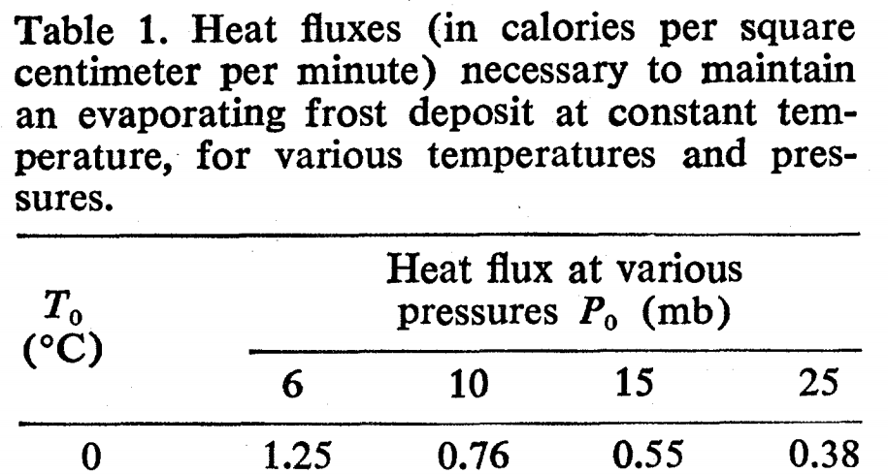

1. As the meltwater reacts with atmospheric CO2 and with the Phobos dust, carbonates will form, reducing CO2 pressure. Assuming Henry’s law solubility of CO2 in the meltwater - 3.4x10-2 mol/(liter × bar) – and that the polar cap covers 10% of the planet, what is the maximum (dissolution-limited) rate of CO2 consumption? How long would it take for the atmosphere to disappear at this rate?
2. In reality, CO2 consumption will stop when either when the carbonate-forming potential of Phobos dust is used up or when increased evaporitic cooling (due to the lower total atmospheric pressure) prevents further meltwater production – whichever comes first. Show, by quantitative use of Table 1, whether reactant-mass or water availability will limit the CO2 consumption. Assume Phobos dust has density 2 g/cc and is 10 wt% Mg (no Ca). Approximate interpolations are OK.

The one-sided negative feedback you have just worked through (minus the disintegrating moons, although it is quite possible that Phobos is merely the latest in a chain of inspiralling moons) is one hypothesis for what regulates atmospheric pressure on the real Mars. Optional reading: Kahn (Icarus, 1985) is credited with suggesting this one-sided negative feedback.

1. This is often a terrible approximation. It should only be made when one is pretty confident (from independent evidence) that the exobase altitude is much less than the planet’s radius and that the planet is not close to tidal disruption.
2. The details, which are not necessary for this homework, are in Black & Mittal, Nature Geoscience, 2015. The acceleration has been confirmed by (among other methods) Phobos-eclipse timing using the Mars rovers.
3. Semimajor axis change is negligible since >3 Gya.
4. Mars eccentricity goes through 105-107 yr cycles and ranges from 0-0.15.
5. This assumes that buried CO2 ice and adsorbed CO2 is released at high obliquity: this is likely, but unproven.