GEOS 22060/32060 – Spring 2019 – Homework 3

Due in Kite mailbox (which is in the mailroom on the 1st floor of the Hinds building) 4pm Friday 10th May. To get to the mailroom on the 1st floor of the Hinds building, turn left on entering Hinds through the main (East) entrance, walk past the sofas, and just after entering a windowless corridor, the mailroom will be the first room on your left. No credit will be given for answers without working. It is OK to use e.g. Mathematica, but if you do, please print out the work.

M = planet mass, R = planet radius, a = semimajor axis (typical distance of planet from star). Mass of Earth = 6 x 10²⁴ kg, radius of Earth = 6 x 10⁶ m, semimajor axis of Earth = 1.5 x 10¹¹ m, solar flux at Earth = 1400 W/m². Stefan’s constant = 5.67 x 10⁻⁸ W m⁻² K⁻⁴. Stefan-Boltzmann law: total energy radiated = (Stefan’s constant) x T⁴. Assume all worlds are rapidly rotating such that πR² of stellar flux is spread out evenly over 4 π R² of surface area.

Q1. Twin studies. Pluto and Charon are at the same distance from the Sun (a = 40 x Earth). Assume that they formed at the same distance from the Sun at about the same time. Pluto has a mass of 2.2 x 10⁻³ x Earth and a radius of 0.18 x Earth. Charon has a mass of 2.6 x 10⁻⁴ x Earth and a radius of 0.09 x Earth.
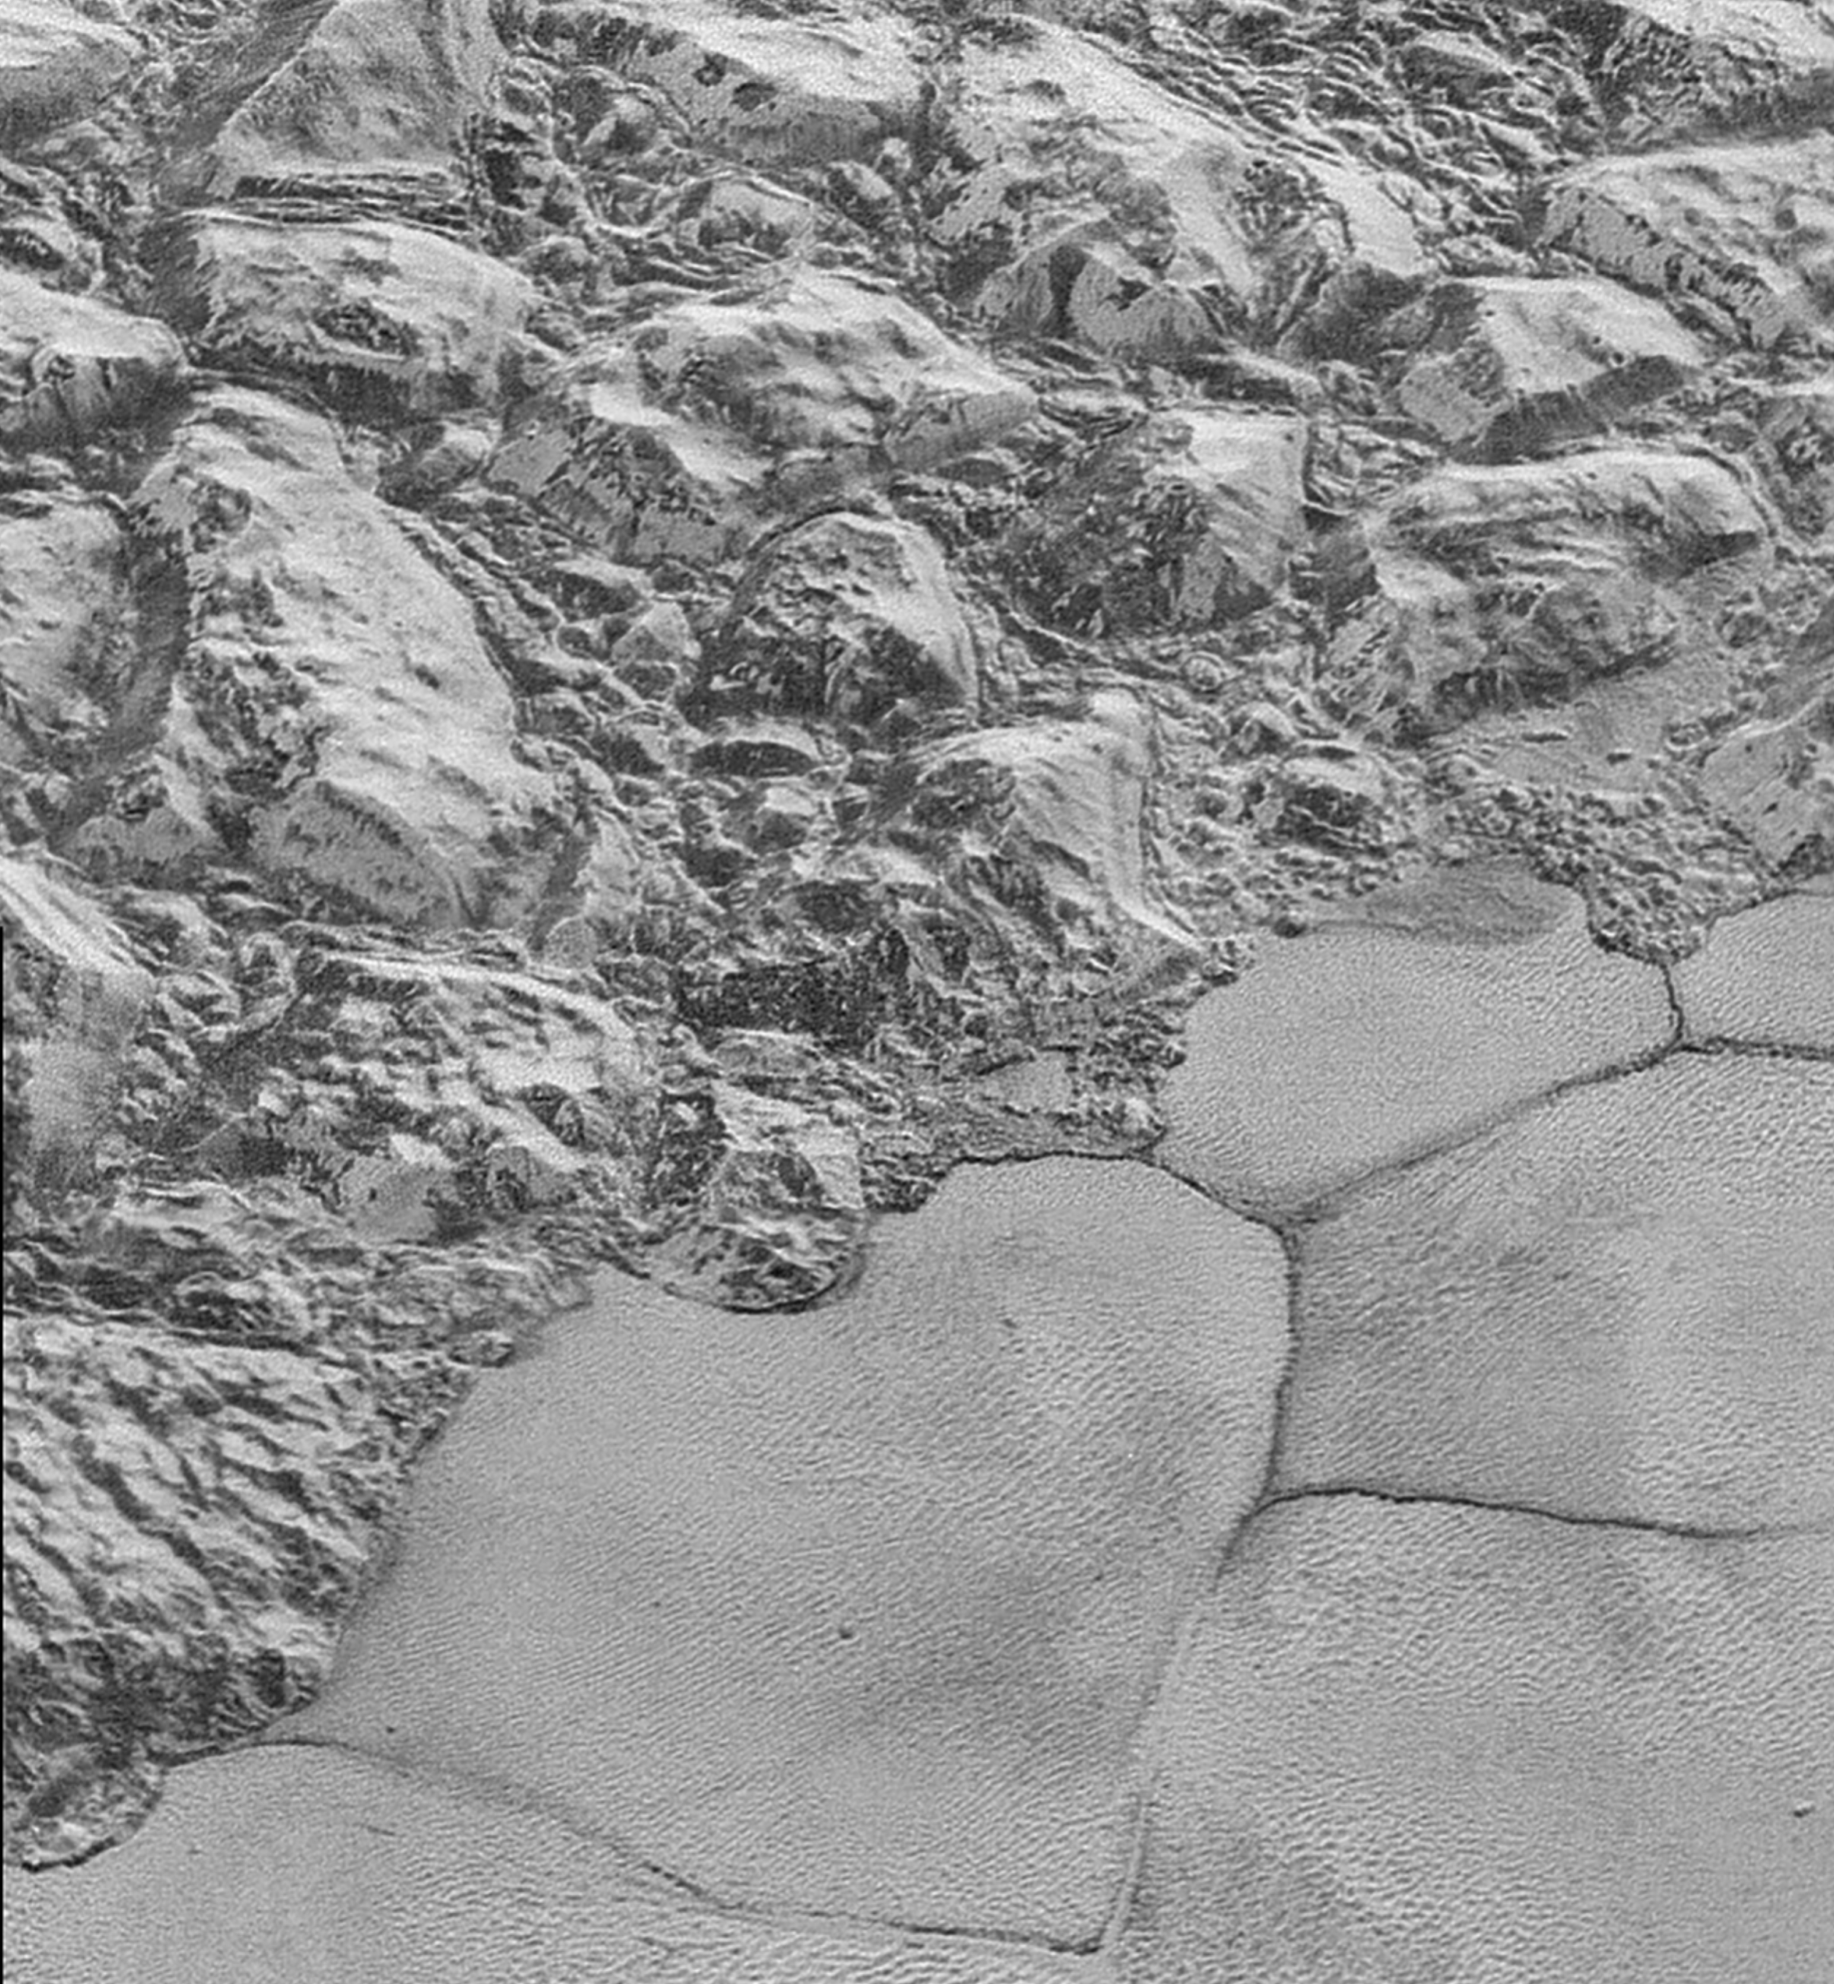
Nitrogen ice sheet adjacent to mountains on Pluto. Oblique view from New Horizons spacecraft flyby. Nitrogen-ice convection cells are ~20 km across.

a) Assume Pluto and Charon absorb 70% of incident sunlight. What is the surface temperature at Pluto? At Charon? b) From now on, assume an isothermal, pure nitrogen atmosphere. What is the scale height at Pluto? At Charon? c) Assume that the exobase is 10 scale heights above the surface1. What is the gravity at the exobase for Pluto? For Charon?

The Jeans’ parameter, λ_{esc}, is proportional to the ratio of the gravitational binding energy to the thermal energy for molecules at the exobase. Larger values of λ_{esc} indicate that escape-to-space is unlikely. The Jeans’ parameter is usually calculated for exobase conditions (altitude, temperature). Hydrodynamic escape is most likely for λ_{esc} <~ 3. For λ_{esc} > 10, we are in a molecule-by-molecule thermal escape regime (confusingly, this molecule-by-molecule escape process is termed Jeans’ escape).
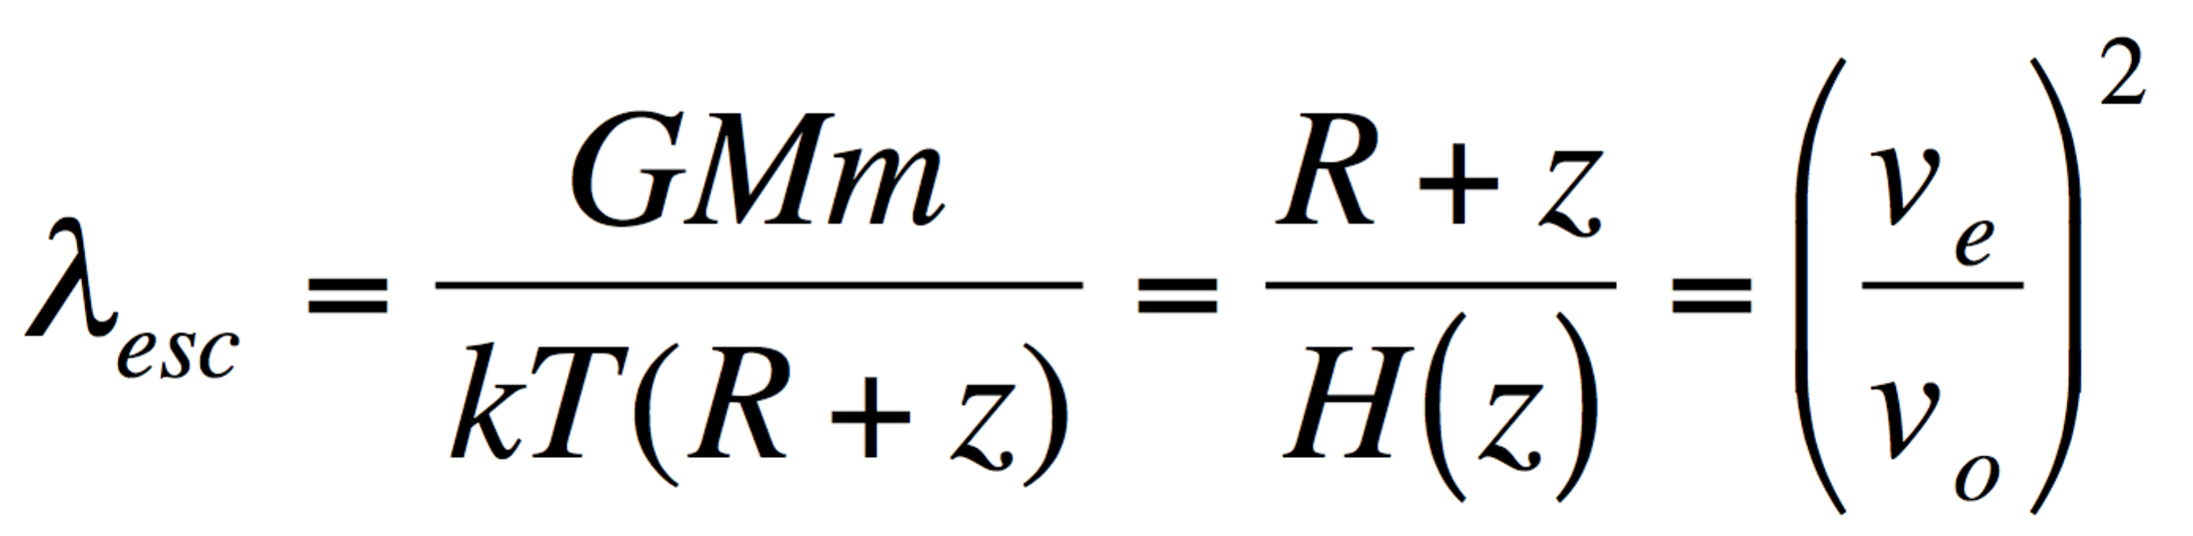
where G is gravitational constant, M is planet mass, m is molecule mass, k is Boltzmann’s constant, T is (local) atmosphere temperature, R is planet radius, and z is altitude above the planet’s surface.

d) What is the escape parameter (Jean’s parameter) for Pluto? For Charon? e) (For each world,) are we in a Jeans escape or hydrodynamic escape regime? f) How would your answer to (d) change if the isothermal assumption was not true, and the exobase temperature was in fact 200K (for example, due to UV absorption in the upper atmosphere)?

Q2. Alternative fates of Venus.
- The escape velocity from Venus is ~10⁴ m/s, but in hydrodynamic escape models, both bulk and thermal velocities are <<10⁴ m/s out to very large distances from the planet (example below). Explain qualitatively how gas might escape from the planet without ever reaching escape velocity.
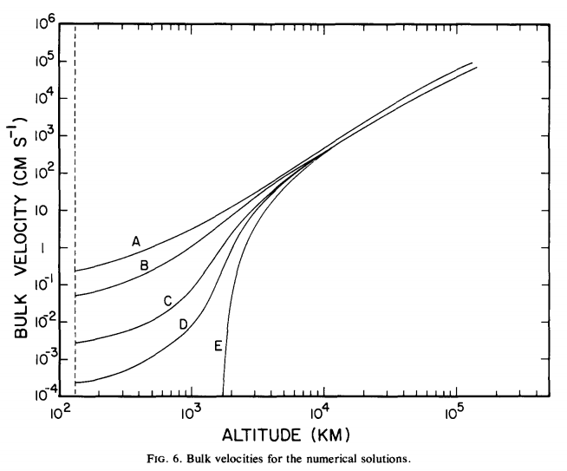
from Watson et al. Icarus 1981

- We have seen that the basic equations for hydrodynamic escape have supersonic and sub-sonic solutions. Suppose that Venus was embedded in a gaseous nebula (e.g. during solar system formation). Explain, with reference to the basic equations for hydrodynamic escape as discussed in lecture, how this would affect the physical validity of the supersonic and/or sub-sonic solutions.
- In the case of Venus, a runaway greenhouse is believed to have been
followed by loss of almost all water from the planet. State and explain two circumstances under which a long-lived runaway greenhouse might not cause loss of much water from the planet.

This is often a terrible approximation. It should only be made when one is pretty confident (from independent evidence) that the exobase altitude is much less than the planet’s radius and that the planet is not close to tidal disruption.

