**GEOS 32060 – Spring 2019 – Homework 2**

Due in Kite mailbox (which is in the mailroom on the 1st floor of the Hinds building) 4pm Friday 26th April. To get to the mailroom on the 1st floor of the Hinds building, turn left on entering Hinds through the main (East) entrance, walk past the sofas, and just after entering a windowless corridor, the mailroom will be the first room on your left. No credit will be given for answers without working. It is OK to use e.g. Mathematica, but if you do, please print out the work.

**Q1. Energy balance, albedo, and moon destruction.**

Phobos, a dark moon, is accelerating towards Mars and will disintegrate in 20-70 Myr due to tidal forces[1].

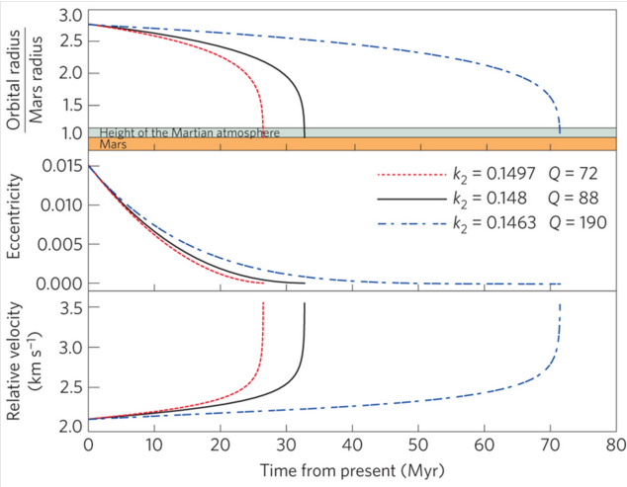

From Black & Mittal, Nature Geoscience 2015 (k2 and Q refer to tidal dissipation parameters for Mars).

This question is about the climatic consequences.

1. Calculate the global-equivalent depth of Phobos dust (Phobos diameter ~10 km) following disintegration of Phobos and reentry of the fragments. Assume all material arrives as dust. (The duration over which fragments reenter could be Myr, or even longer).
2. Assume Phobos dust (set Phobos dust albedo = 0) falls on the north polar water ice cap and Mars obliquity = 60°, Mars semimajor axis *a* is unchanged (1.52 AU)[2] and Mars eccentricity *e* is slightly higher than today (0.15)[3]. Noting that perihelion distance *q* = *a*(1 – *e*), what is the theoretical maximum polar melt rate (kg/m2/hr) when perihelion is aligned with northern summer solstice? (Assume all absorbed sunlight goes into melting water ice). You will have to use a textbook,
3. Correct your answer for upwelling longwave radiation at the melting point – what is the corrected melt rate? Assume dusty ice radiates in the thermal infrared as a blackbody.
4. Correct your answer to (c) for evaporitic cooling using the following table (from Ingersoll, Science, 1970), assuming an atmospheric pressure of 25 mb[4] – what is the melt rate including this second correction?

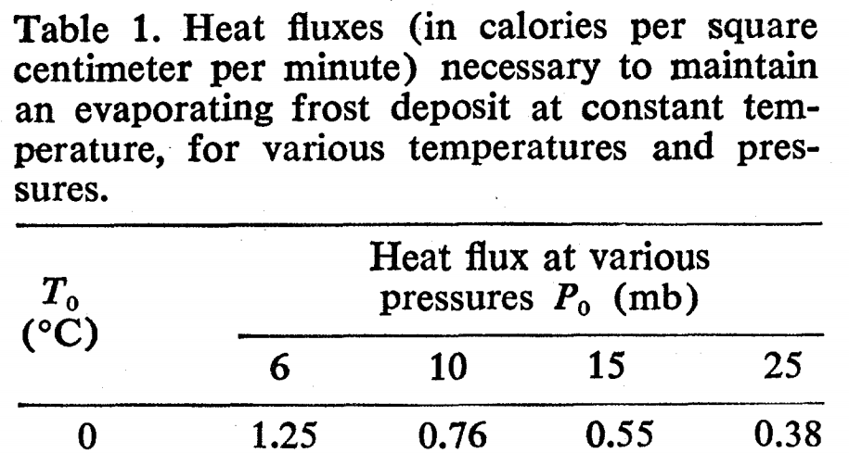

1. As the meltwater reacts with atmospheric CO2 and with the Phobos dust, carbonates will form, reducing CO2 pressure. Assuming Henry’s law solubility of CO2 in the meltwater - 3.4x10-2 mol/(liter × bar) – and that the polar cap covers 10% of the planet, what is the maximum (dissolution-limited) rate of CO2 consumption? How long would it take for the atmosphere to disappear at this rate?
2. In reality, CO2 consumption will stop when either when the carbonate-forming potential of Phobos dust is used up or when increased evaporitic cooling (due to the lower total atmospheric pressure) prevents further meltwater production – whichever comes first. Show, by quantitative use of Table 1, whether reactant-mass or water availability will limit the CO2 consumption. Assume Phobos dust has density 2 g/cc and is 10 wt% Mg (no Ca). Approximate interpolations are OK.

The one-sided negative feedback you have just worked through (minus the disintegrating moons, although it is quite possible that Phobos is merely the latest in a chain of inspiralling moons) is one hypothesis for what regulates atmospheric pressure on the real Mars. Optional reading: Kahn (Icarus, 1985) is credited with suggesting this one-sided negative feedback.

**Q2. Impact energies.**

Consider a large planet with a density consistent with that of rock (*M* = 17 × Earth, *R* = 2.35 × Earth, *a* = 0.25 × Earth): this is close to the upper limit for rocky-planet mass, before the. Assume that this “Godzilla” world orbits an exactly Sun-like star.

1. What is the escape velocity at the surface of ‘Godzilla’?
2. Suppose that the last giant impact on Godzilla involved a 1.7× Earth mass object. To within a factor of 2, what is the *minimum* specific kinetic energy of the collision (J/kg)?
3. Assume all the energy was dissipated as heat, and that before the impact Godzilla was just below the melting point. Assume *Lmelt* = 5 × 105 J/kg for planetary materials. Did the impact melt Godzilla?
4. Assume *Lvap* = 5 × 106 J/kg. Was the energy of the impact sufficient to vaporize Godzilla?
5. Assume that Godzilla has a global magma (liquefied rock) ocean after the impact, with no atmosphere or ocean. The surface temperature is ~1500 K. Find the (blackbody) radiated flux. Assuming steady cooling at this flux, find the time it will take for the magma ocean to freeze.
6. Assume that Godzilla retains (or outgasses) steam immediately after the impact, so that it emits at the runaway greenhouse limit (steam atmosphere: ~320 W/m2). In a runaway greenhouse, surface temperature can be much higher than the effective emission temperature. Comment on ***net*** cooling rates and the likely time-to-freezing.
7. Comment on the direct detection of giant impacts on young rocky exoplanets. Describe qualitatively what a very sensitive wide-field survey would see (in the just-magma case, and in the steam-outgassing case). Describe qualitatively what a less sensitive wide-field survey would see (in the just-magma case, and in the steam-outgassing case).

No direct detections of giant impacts on exoplanets have yet occurred. However, Meng et al. (Science, 2014) report year-to-year variations in the 3-5 μm flux from a debris disk around a young Sunlike star, consistent with condensation and collisional grinding of debris from a recent giant impact.

1. The details, which are not necessary for this homework, are in Black & Mittal, Nature Geoscience, 2015. The acceleration has been confirmed by (among other methods) Phobos-eclipse timing using the Mars rovers.
2. Semimajor axis change is negligible since >3 Gya.
3. Mars eccentricity goes through 105-107 yr cycles and ranges from 0-0.15.
4. This assumes that buried CO2 ice and adsorbed CO2 is released at high obliquity: this is likely, but unproven.