GEOS 32060 / GEOS 22060 / ASTR 45900

Homework 6

*Due in class, Tue 29 May. No credit will be given for answers without working. It is OK to use e.g. Mathematica, but if you do, please print out the work.*

**Q1. Terraforming Mars with nanorods.**

For this question, assume that the nanorod scattering cross-sections shown in the figure below (for Ag-metal spheroids in water) also apply to Fe spheroids in Mars air.

(a) CO2 absorbs weakly at 900 cm-1. The corresponding “gap” in Mars’ greenhouse effect makes the planet’s surface cooler than it would be if that gap were filled. Using the ratio of nanorod length to peak-absorption wavelength in the plot, determine the length and radius of nanorod for 50:1 aspect ratio that would be “tuned” to absorb light at wavenumber 900 cm-1. What is the ratio of absorption cross-section to geometric cross-section? What is the mass of a single “tuned” nanorod? Extrapolating from the spectra shown below, would your “tuned” nanorods absorb/scatter incoming sunlight, or only thermal emission?

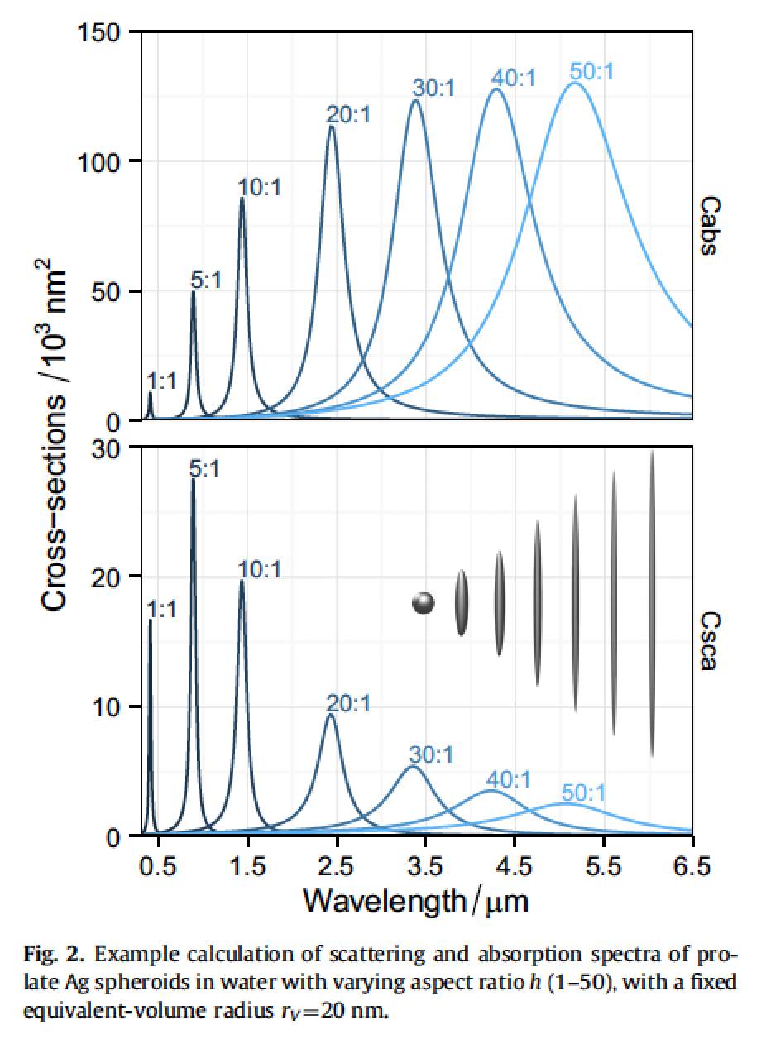

(b) Determine the atmospheric-column density of “tuned” nanorods (nanorods/m2) needed to reach optical depth 5 at wavenumber 900 cm-1.

(c) Determine the settling rate of an individual nanorod in calm, still air at 40 km altitude on present-day Mars. (You may assume Stokes flow, and that the nanorods fall with long axis perpendicular to gravity. Extra credit for taking into account the Cunningham slip correction).

(d) Determine the mass flux (kg/m^2/s) of nanorods injected at high altitude needed to balance the settling rate (and maintain optical depth 5).

(e) For Mars surface area 150 million km^2, determine the total mass flux needed to maintain global optical depth 5.

(f) Mars rover *Curiosity* is currently exploring Vera Rubin Ridge, with is ~10 wt% composed of the iron ore mineral hematite (Fe2O3) based on *Curiosity* X-Ray Diffraction (XRD) data. Vera Rubin Ridge is ~6.5 km long, ~200m wide, and ~100m tall. Assuming that in future Vera Rubin Ridge is mined for Fe from hematite, and the Fe is converted into nanorods, determine for how many years the warming scheme described above could be sustained from material from this one ridge.

(g) How would the warming differ if the nanorods were injected at 5 km altitude? Why?

(h) The scheme described in parts (a)-(f) above would not be sufficient to warm Mars to Earthlike temperatures. Why not? With reference to the figures in this question, suggest minor modifications to the warming scheme that could might lead to greater warming.

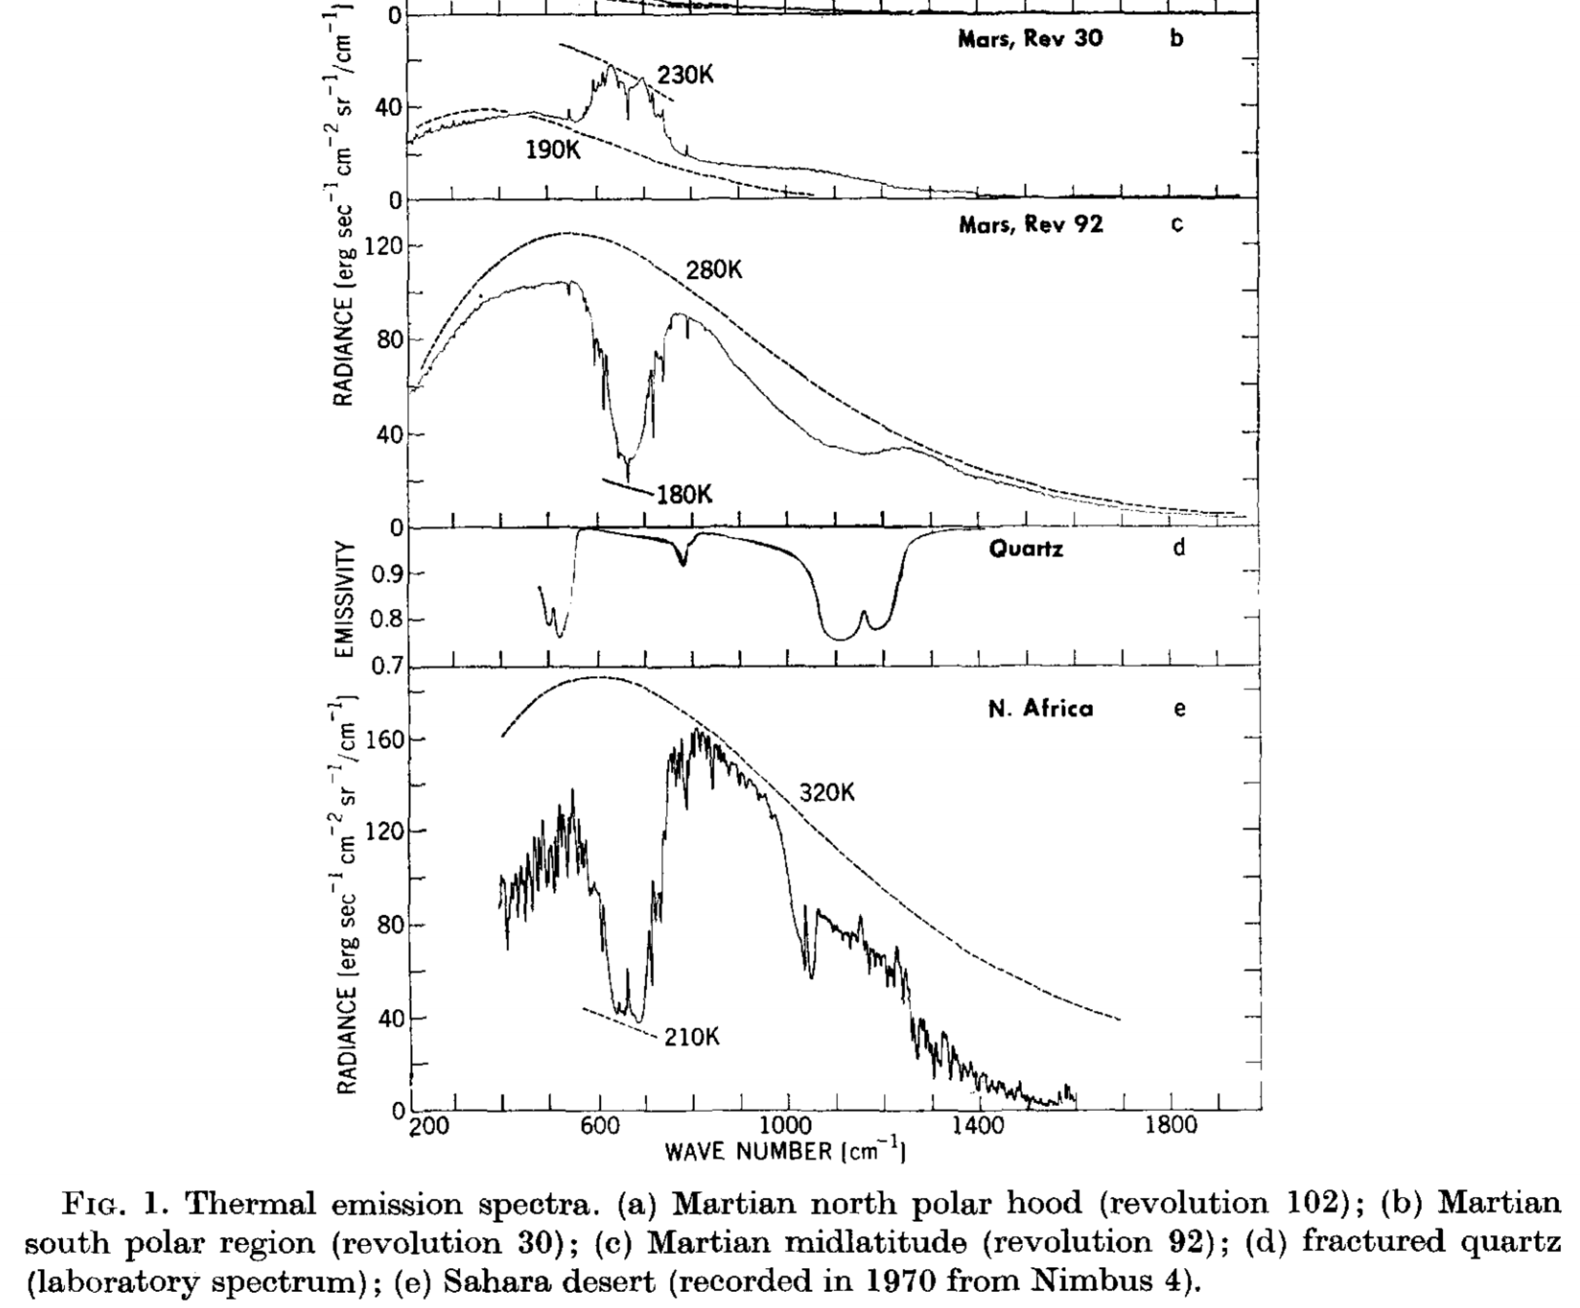

(i) (Extra credit) From a planetary atmospheres perspective, identify key factors/assumptions in the above workflow that (if modified) could greatly affect the viability of this warming scheme.

**Q2. Resurfacing mechanisms on Europa (how to get the oxygen to the ocean)**

In class, we discussed the geological evidence that Europa has been resurfaced by liquid water, but did not discuss driving forces for this resurfacing. In this question, you will investigate one hypothesis for resurfacing (for more information, you might want to read Manga & Wang, Geophysical Research Letters, 2007).

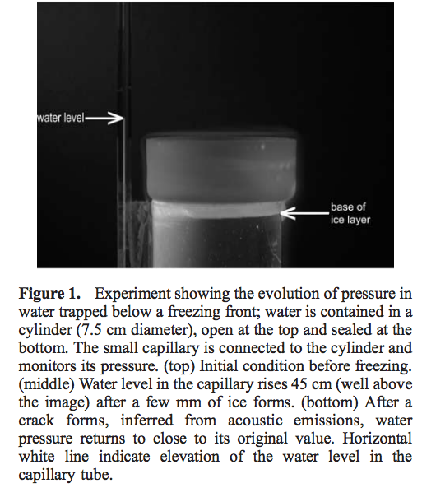Manga & Wang, GRL 2007

1. Assume that Enceladus undergoes heating-cooling cycles every 100 Myr due to the orbital-thermal feedbacks – let’s exaggerate and assume that the ice shell goes from almost completely frozen to almost completely unfrozen each cycle. Consider freezing of an initially very thin ice shell. Ocean pressure builds up according to

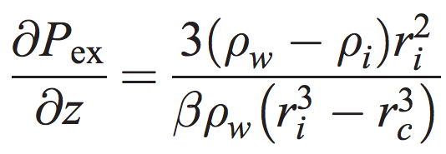

(neglecting ice-shell expansion), where z is the ice shell thickness, water density is 1000 kg/m3, ice density is 910 kg/m3, and water compressibility (beta) 4 x 10-10 Pa-1. rc is rocky-core radius (the rock is assumed incompressible), and ri is the radius at the top of the liquid-water ocean (i.e. ri = R – z, where R is moon radius). Let rc = R – 200 km and let R = 1600 km. Assume overpressure 1 MPa is sufficient for shell cracking. How thick is the ice when the shell cracks?

(b) Assume that as the water flows up through the cracks the pressure (units: energy density) goes into melt-back of the walls of the cracks. If all the water flows through a crack system of total length 1000 km, how much widening of the cracks by melt-back has occurred at the end of the eruption? (Latent heat of melting = 3 x 10^5 J/kg).

(c) Assume that once the shell cracks all of the overpressured water can erupt onto the surface.[1] Taking into account the length of the heating-cooling cycle, for a typical water molecule, what is the typical wait time after being erupted before being erupted again?

1. This is controversial; there is suggestive geologic evidence in favor, but theoretical arguments against.