GEOS 32060 / GEOS 22060 / ASTR 45900

Homework 5

*Due in class on Tuesday 22 Feb. No credit will be given for answers without working. It is OK to use e.g. Mathematica, but if you do, please print out the work.*

**Q1. The contribution of ocean-atmosphere exchange to climate (in?)stability.**

For background on this question, you may wish to refer to <http://geosci.uchicago.edu/~kite/doc/Zeebe_2012.pdf> and (for those who like extreme detail!) <http://geosci.uchicago.edu/~kite/doc/Zeebe_CO2_In_Seawater_Ch_1.pdf>

Climate responds to atmospheric pCO2, but the majority of the C in the ocean/atmosphere system is stored in the ocean, primarily as [HCO3-]. Therefore the partitioning of C between the atmosphere and ocean affects the climate sensitivity of the ocean/atmosphere system (the amount of warming per unit C added to the system). The atmosphere and ocean equilibrate on thousand-year timescales. Following Zeebe and Wolf-Gladrow (2001),

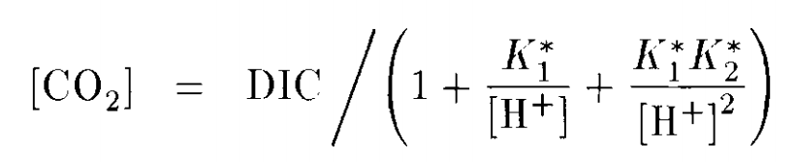

where square brackets denote concentration, DIC stands for Dissolved Inorganic Carbon (the sum of [CO2], [HCO3-], and [CO32-]), and the equilibrium constants K1* and K2* correspond to

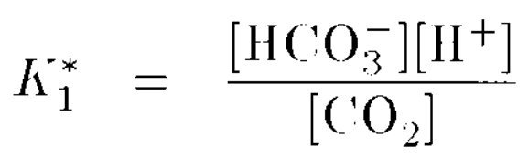 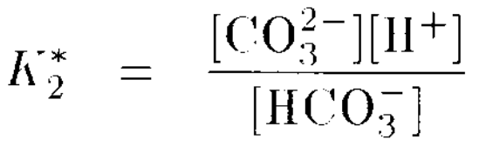

i.e., the equilibrium constants for the reactions

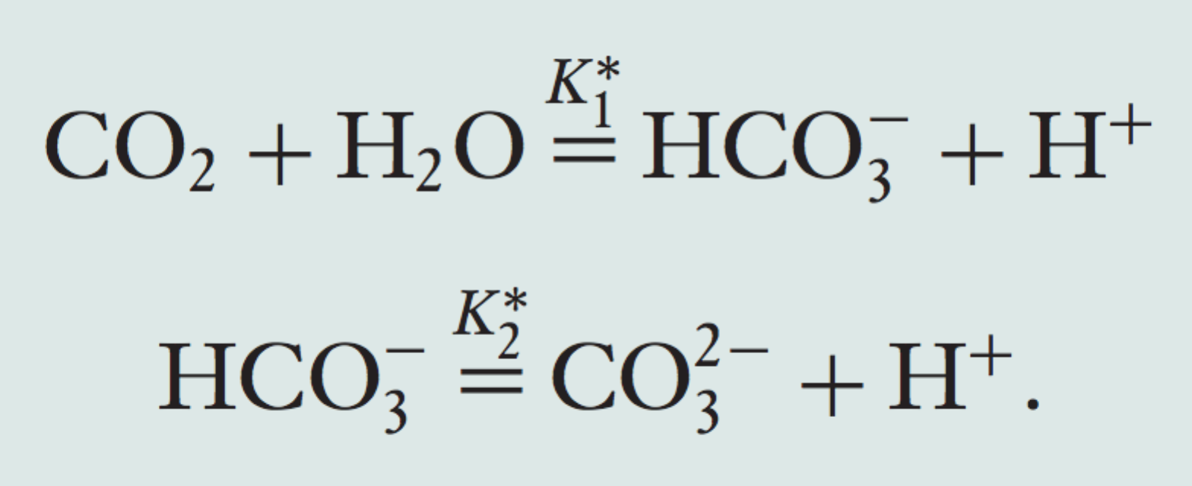

Note that pK1* = -log10(K1*), e.t.c. Let pK1* = 5.86, pK2* = 8.92. Assume the equilibrium between [CO2] in the ocean and pCO2 in the atmosphere is given by Henry’s law with a solubility constant of 0.034 mol/(L x atm).

1. For pH = 8 and DIC = 2 mmol kg-1, what is the [CO2] in the ocean? What is the atmospheric pCO2?
2. Suppose DIC the ocean volume is 10x greater, the DIC inventory is constant (i.e. proportionally diluted), but the pH is unchanged, what is the atmospheric pCO2 on this waterworld?
3. It is an ice age and the ocean considered in part (a) cools at all depths by 20K, shifting the equilibrium constants. The new pK1* is 6.11 and the new pK2* is 9.38 and you may assume DIC is unchanged. Does the ocean take up or release CO2? Is this a positive or a negative feedback on climate? Assuming a climate sensitivity of 2K to a CO2 doubling, what is the magnitude of surface temperature change due to the uptake or release of CO2? Comment on the importance of this feedback on surface temperature (relative to the initial ocean cooling).
4. (Revelle factor). Due to buffering in the carbonate system, it is found that

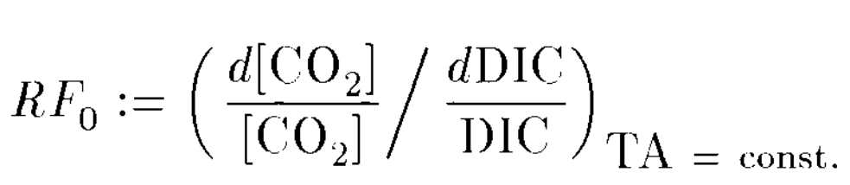 ~ 101 for Earth. With reference to the equations given above part, (a) explain the implications for both climate stability (against changes in volcanic outgassing rate) and for the ease of ocean acidification if the Revelle factor was 1 (i.e. no buffering).

1. Thought experiment: Starting with an ocean that is isothermal at 20C , suppose I cool the *deep* ocean everywhere to just above the freezing point, but leave the temperature of the ocean above 100m depth at 20C. I then allow the ocean currents to restart with the same fluxes as they had before the cooling, but maintain this vertical temperature structure everywhere in the ocean forever afterward. (This is not an oceanographically reasonable thing to do; it is a thought experiment). Will the climate warm, cool, or remain unchanged? Hint: Think about where the equilibration between the ocean and atmosphere occurs.
2. Thought experiment: Starting with an ocean that is isothermal at 20C , suppose I warm the *deep* ocean everywhere 90 degrees C, but leave the temperature of the ocean above 100m depth at 20C. I then allow the ocean currents to restart with the same fluxes as they had before the cooling, but maintain this vertical temperature structure everywhere in the ocean forever afterward. (This is not an oceanographically reasonable thing to do; it is a thought experiment). Will the climate warm, cool, or remain unchanged? Hint: Think about bubbles.

**Q2. The integrity of the ancient O-isotope record.**

The following figure is from Knauth (2005, Palaeogeography Palaeoclimatology Palaeoecology); see also Knauth & Lowe (GSA Bulletin, 2003). The horizontal bars at the bottom show supercontinent breakup and dispersal (not needed to answer the question). “Delta notation” refers to parts-per-thousand enrichment relative to a standard. The data are for chert.

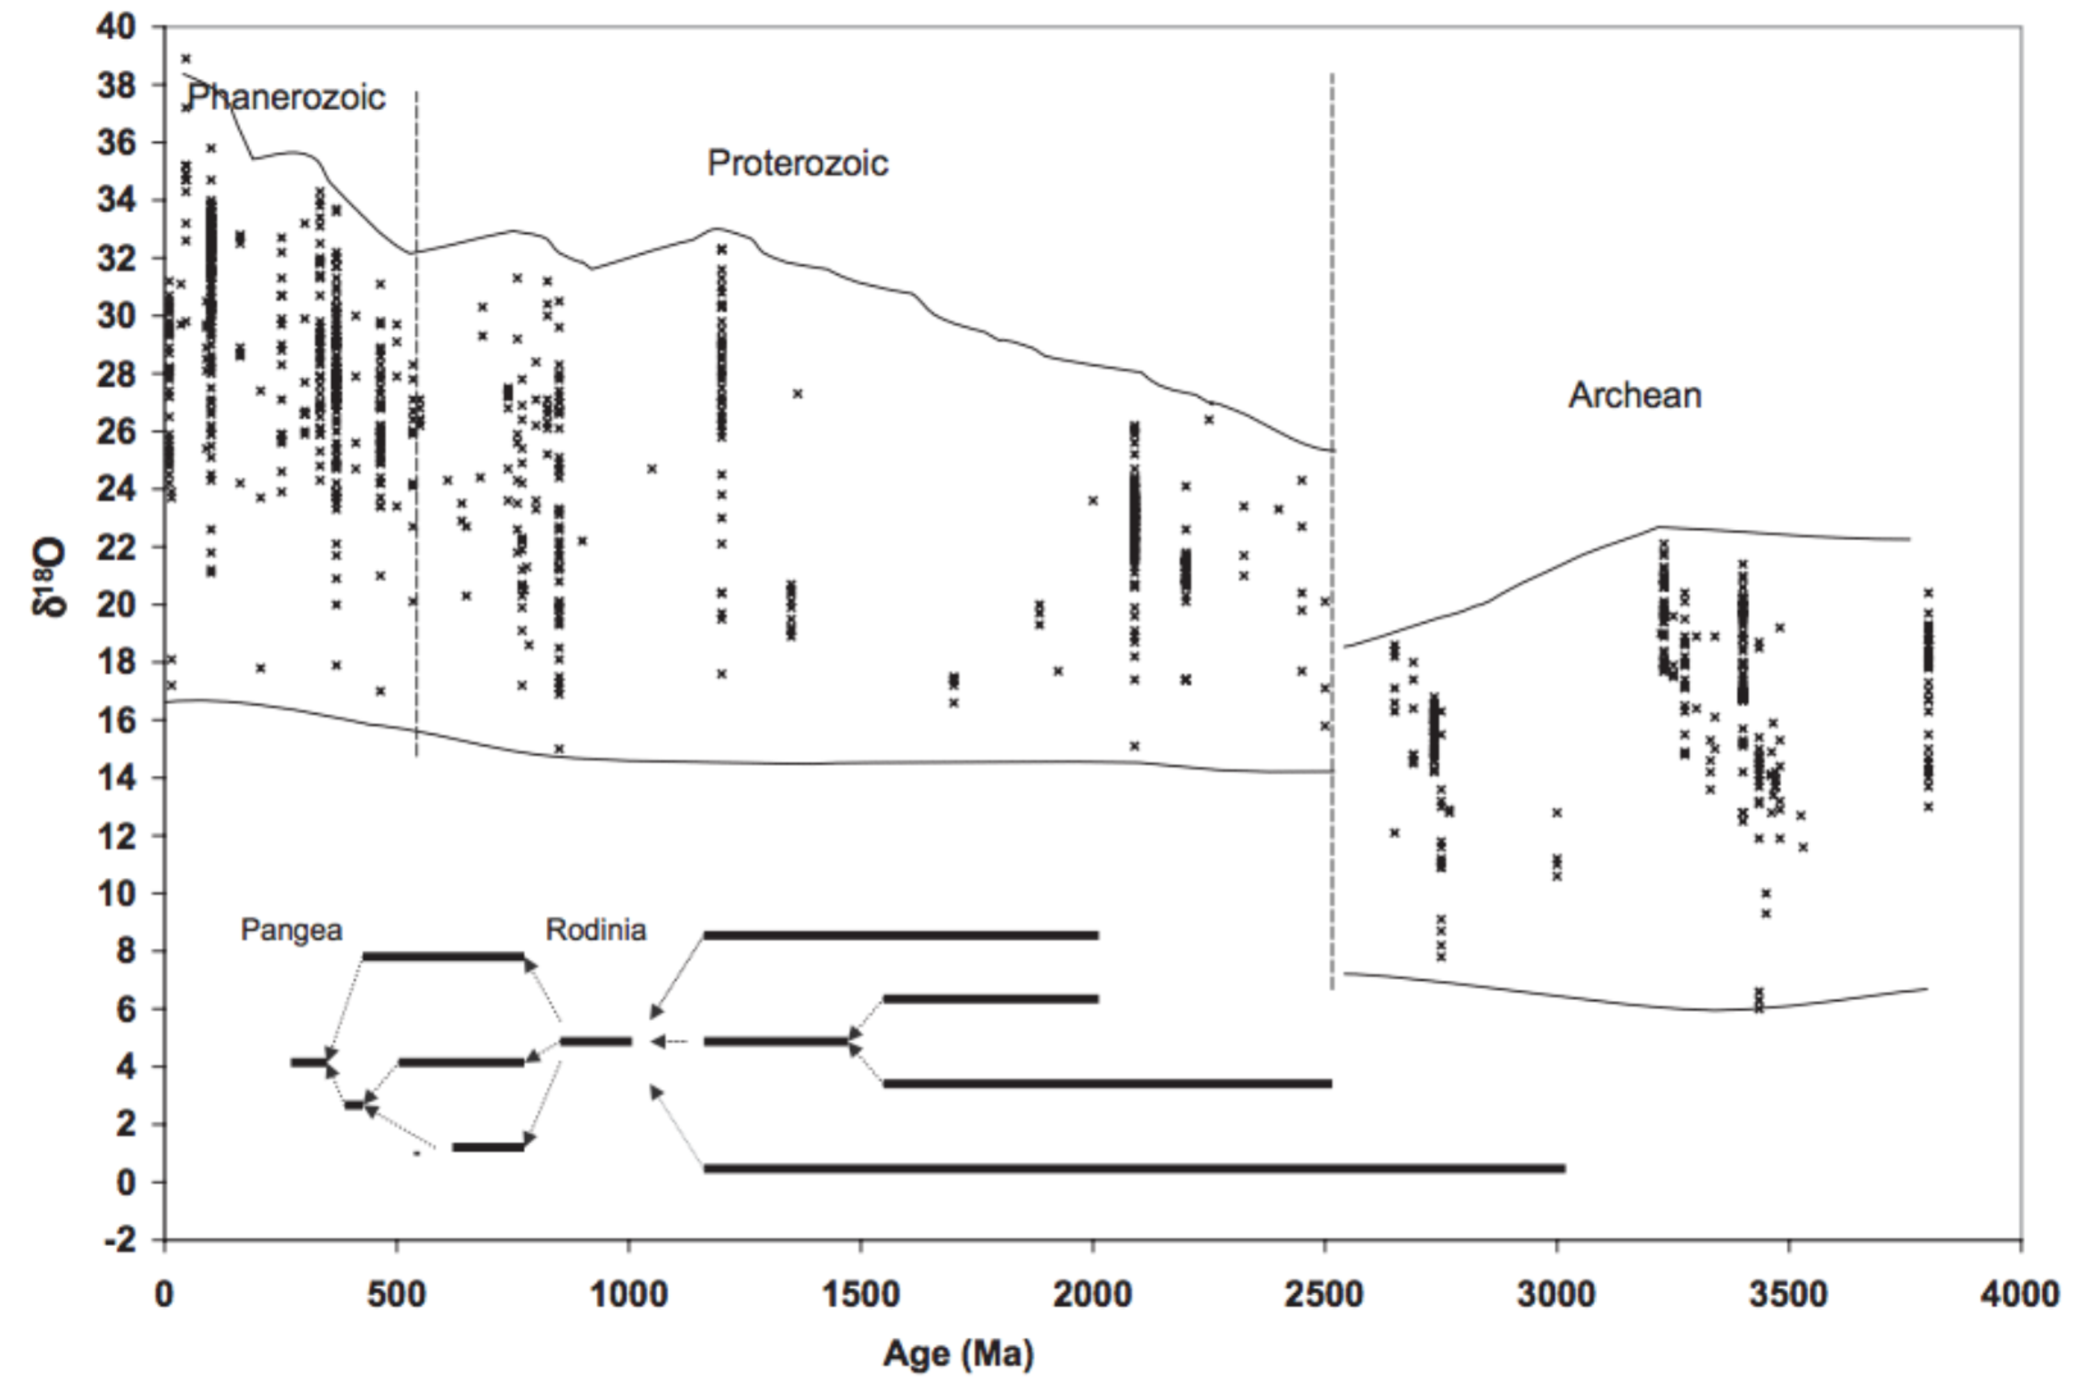

Assume that formation temperature of chert is given by

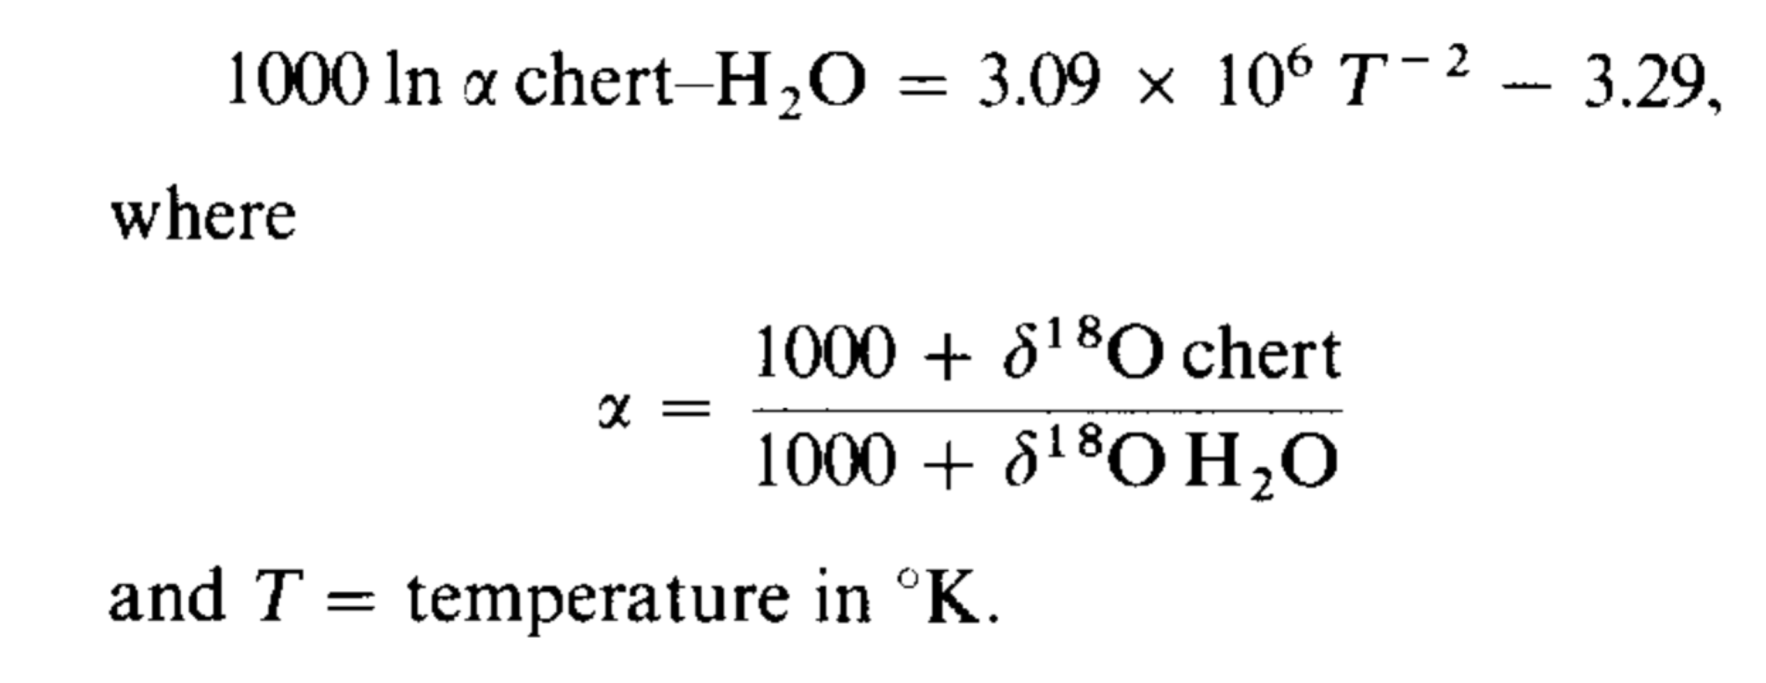

Assume the oxygen isotope compositon of seawater has been constant over time and is zero on the del-18-O scale. What is the sign and magnitude of Earth temperature change since 3.5 Ga recorded by chert?

(b) Assume that burial and exhumation is a random walk with step size 250m and step length 50 Myr. What is the typical peak burial depth of sediments initially at the seafloor, and now exposed at the surface, that are 500 Myr in age? What about 3 Gyr in age? (Remember that sediments cannot have a negative burial depth; this corresponds to sediment erosion and loss of the record).

(c) If geothermal heat flow is 0.1 W/m2, thermal conductivity is 2 W/m/K , and sediment oxygen-isotope composition is reset to the temperatures at peak burial depth, what would be the typical percentage correction to your answer to part (a)? Hint: Use Fourier’s law of heat conduction.

(d) Does the model assumed in part (b) provide a good explanation for the scatter in the figure (i.e. the vertical width of the “envelope” of data points)? Why or why not?