GEOS 32060 / GEOS 22060 – Spring 2018 – Homework 3

Due in class Tuesday 1 May. No credit will be given for answers without working. It is OK to use e.g. Mathematica, but if you do, please print out the work.

M = mass, R = planet radius, a = semimajor axis (typical distance of planet from star). Mass of Earth = 6 x 1024 kg, radius of Earth = 6 x 106 m, semimajor axis of Earth = 1.5 x 1011 m, solar flux at Earth = 1400 W/m2. Stefan’s constant = 5.67 x 10-8 W m-2 K-4.

**Q1. Giant impacts on a Super-Earth**

Kepler-20b is currently (4/2018) the most massive known planet with a density consistent with that of the Earth (M = 10x Earth, R = 1.9x Earth). (Kepler-20b displaces ‘Godzilla’, a.k.a. Kepler-10c, which was initially reported to be rocky but upon more careful analysis turns out to have a thick volatile envelope). Kepler-20b orbits a star very similar to the Sun; for this question, please assume that Kepler-20b orbits an exactly Sun-like star at a distance of 0.1 AU.

1. What is the escape velocity at the surface of Kepler-20b?
2. Suppose that the last giant impact on Kepler-20b involved impact of a 1 x Earth mass object. To within a factor of 2, what is the *minimum* specific kinetic energy of the collision (J/kg)? Compare this to the atmosphere-loss and ocean-loss energies from the required reading.
3. Assume all the energy was dissipated as heat, and that before the impact Kepler-20b was just below the melting point. Assume *Lmelt* = 5 x 105 J/kg for planetary materials. Did the impact melt Kepler-20b?
4. Assume *Lvap* = 5 x 106 J/kg. Was the energy of the impact sufficient to vaporize Kepler-20b?
5. Assume that Kepler-20b has a global magma ocean after the impact, with no atmosphere or ocean. The surface temperature is ~1500 K. Find the (blackbody) radiated flux. Assuming steady cooling at this flux, find the time it will take for the magma ocean to freeze.
6. Assume that Kepler-20b retains (or outgasses) steam immediately after the impact, so that it emits at the runaway greenhouse limit (steam atmosphere: ~320 W/m2). In a runaway greenhouse, surface temperature can be much higher than the effective emission temperature. Comment on ***net*** cooling rates and the likely time-to-freezing. Account for insolation from the star.
7. Comment on the direct detection of giant impacts on young rocky exoplanets. Describe qualitatively what a very sensitive wide-field survey would see (in the just-magma case, and in the steam-outgassing case). Describe qualitatively what a less sensitive wide-field survey would see (in the just-magma case, and in the steam-outgassing case).

No direct detections of giant impacts on exoplanets have yet occurred. However, Meng et al. (Science, 2014) report year-to-year variations in the 3-5 micron flux from a debris disk around a young Sunlike star, consistent with condensation and collisional grinding of debris from a recent giant impact.

**Q2. Alternative fates of Venus.**

1. The escape velocity from Venus is ~104 m/s, but in hydrodynamic escape models, both bulk and thermal velocities are <<104 m/s out to very large distances from the planet (example below). Explain qualitatively how gas might escape from the planet without ever reaching escape velocity.

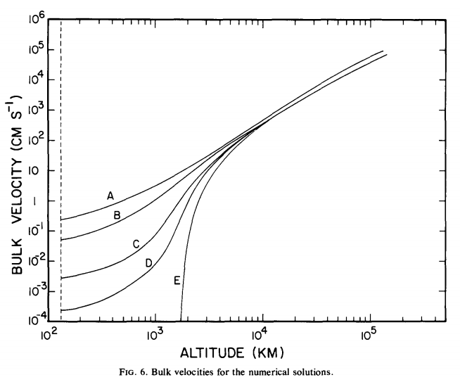

*from Watson et al. Icarus 1981*

1. We have seen that the basic equations for hydrodynamic escape have supersonic and sub-sonic solutions. Suppose that Venus was embedded in a gaseous nebula (e.g. during solar system formation). Explain, with reference to the basic equations for hydrodynamic escape as discussed in lecture, how this would affect the physical validity of the supersonic and/or sub-sonic solutions.
2. In the case of Venus, a runaway greenhouse is believed to have been

followed by loss of almost all water from the planet. State and explain two circumstances under which a long-lived runaway greenhouse might *not* cause loss of much water from the planet.