GEOS 32060 / GEOS 22060 – Spring 2018 – Homework 2

Due in class Tuesday 24 April. No credit will be given for answers without working. It is OK to use e.g. Mathematica, but if you do, please print out the work.

**Q1. Dusting by Phobos.**

Phobos, a dark moon, is accelerating towards Mars and will disintegrate in 20-70 Myr due to tidal forces[1].

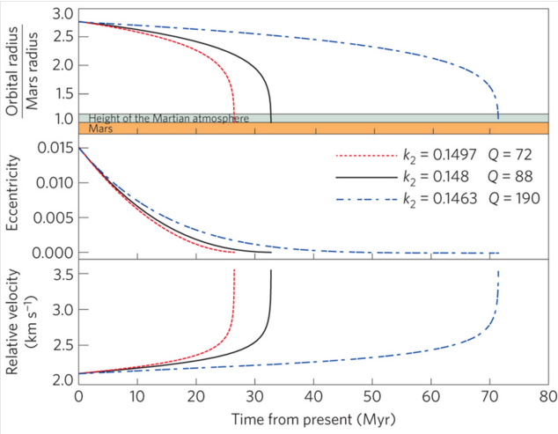

Black & Mittal, Nature Geoscience 2015 (k2 and Q refer to tidal dissipation parameters for Mars).

This question is about the climatic consequences.

1. Calculate the global-equivalent depth of Phobos dust (Phobos diameter ~10 km) following disintegration of Phobos and reentry of the fragments. Assume all material arrives as dust. (The duration over which fragments reenter could be Myr, or even longer).
2. Assume Phobos dust (albedo = 0.1) falls on the north polar water ice cap and Mars obliquity (tilt of spin axis relative to incoming sunlight) = 45 degrees, Mars semimajor axis *a* is unchanged (1.52 AU)[2] and Mars eccentricity *e* is zero. What is the theoretical maximum polar melt rate (kg/m2/hr)? (Assume all absorbed sunlight goes into melting water ice).
3. Correct your answer for upwelling longwave radiation at the melting point (Stefan-Boltzmann law) – taking into account energy lost to upwelling longwave radiation, what is the corrected melt rate? Assume dusty ice radiates in the thermal infrared as a blackbody, and neglect the Mars greenhouse effect (which is weak).
4. Correct your answer to (c) for evaporitic cooling using the following table (from Ingersoll, Science, 1970), assuming an atmospheric pressure of 25 mb[3] – what is the melt rate including this second correction?

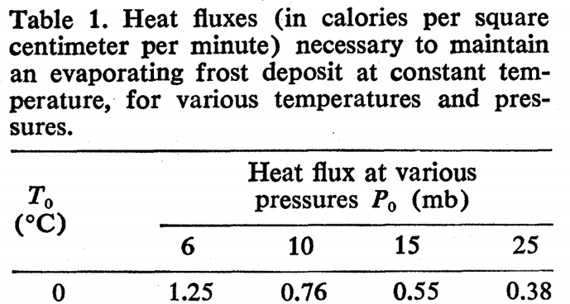

1. As the meltwater reacts with atmospheric CO2 and with the Phobos dust, carbonates will form, reducing CO2 pressure. Assuming Henry’s law solubility of CO2 in the meltwater - 3.4x10-2 mol/(liter x bar) – and that the polar cap covers 10% of the planet, what is the maximum (dissolution-limited) rate of CO2 consumption? How long would it take for the atmosphere to disappear at this rate?
2. In reality, CO2 consumption will stop when either when the carbonate-forming potential of Phobos dust is used up or when increased evaporitic cooling (due to the lower total atmospheric pressure) prevents further meltwater production – whichever comes first. Show, by quantitative use of Table 1, whether reactant-mass or water availability will limit the CO2 consumption. Assume Phobos dust has density 2 g/cc and is 10 wt% Mg (no Ca). Approximate interpolations are OK.

The one-sided negative feedback you have just worked through (minus the disintegrating moons, although it is quite possible that Phobos is merely the latest in a chain of inspiralling moons) is one hypothesis for what regulates atmospheric pressure on the real Mars. Kahn (Icarus, 1985) is credited with suggesting this one-sided negative feedback.

**Q2:** Venus surface temperature is ~750K, Mars surface temperature is ~210K.

1. Draw the brightness temperature versus wavelength for Venus and Mars if they both radiated to space as a black-body at their observed surface temperatures (no atmosphere on either planet). (1/5 of credit)
2. Below is brightness temperature versus wavelength for Venus and Mars. Why is the average brightness temperature for Venus and Mars similar? Explain in detail. (3/5 of credit)
3. Suppose that the brightness temperature of Venus was slightly less at all wavelengths than that of Mars. How might this be true, given that Venus is closer to the Sun? (1/5 of credit)

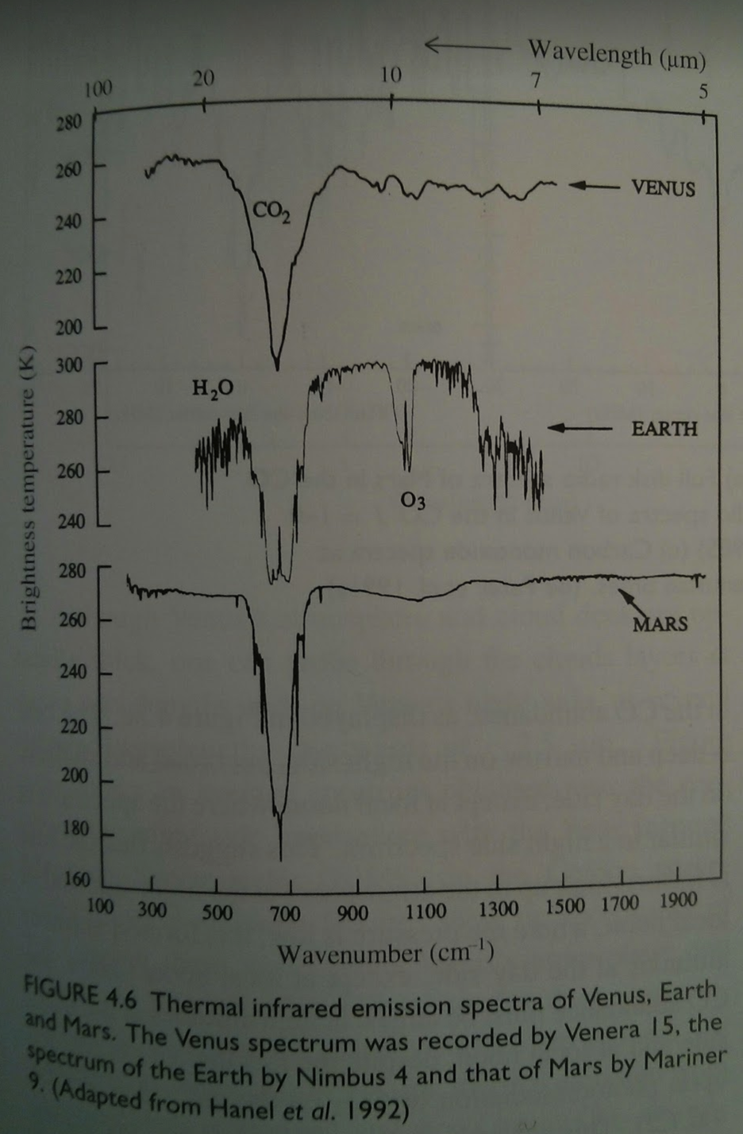

*from de Pater & Lissauer 2001*

1. The details, which are not necessary for this homework, are in Black & Mittal, Nature Geoscience, 2015. The acceleration has been confirmed by (among other methods) Phobos-eclipse timing using the Mars rovers.
2. Semimajor axis change is negligible since >3 Gya.
3. This assumes that buried CO2 ice and adsorbed CO2 is released at high obliquity: probable but unproven.