GEOS 32060 / GEOS 22060 – Spring 2018 – Homework 1

Due in my mailbox (HGS building, 1st floor) Wednesday 18 April 5pm. No credit will be given for answers without working. It is OK to use e.g. Mathematica, but if you do, please print out the work. M = planet mass, R = planet radius, a = semimajor axis (typical distance of planet from star). Mass of Earth = 6 x 1024 kg, radius of Earth = 6 x 106 m, semimajor axis of Earth = 1.5 x 1011 m, solar flux at Earth = 1400 W/m2. Stefan’s constant = 5.67 x 10-8 W m-2 K-4. Stefan-Boltzmann law: total energy radiated = (Stefan’s constant) x T4. Assume all worlds are rapidly rotating such that πR2 of stellar flux is spread out evenly over 4 π R2 of surface area.

**Q1.** Twin studies. Pluto and Charon are at the same distance from the Sun (a = 40 x Earth). Assume that they formed at the same distance from the Sun at about the same time. Pluto has a mass of 2.2 x 10-3 x Earth and a radius of 0.18 x Earth. Charon has a mass of 2.6 x 10-4 x Earth and a radius of 0.09 x Earth.

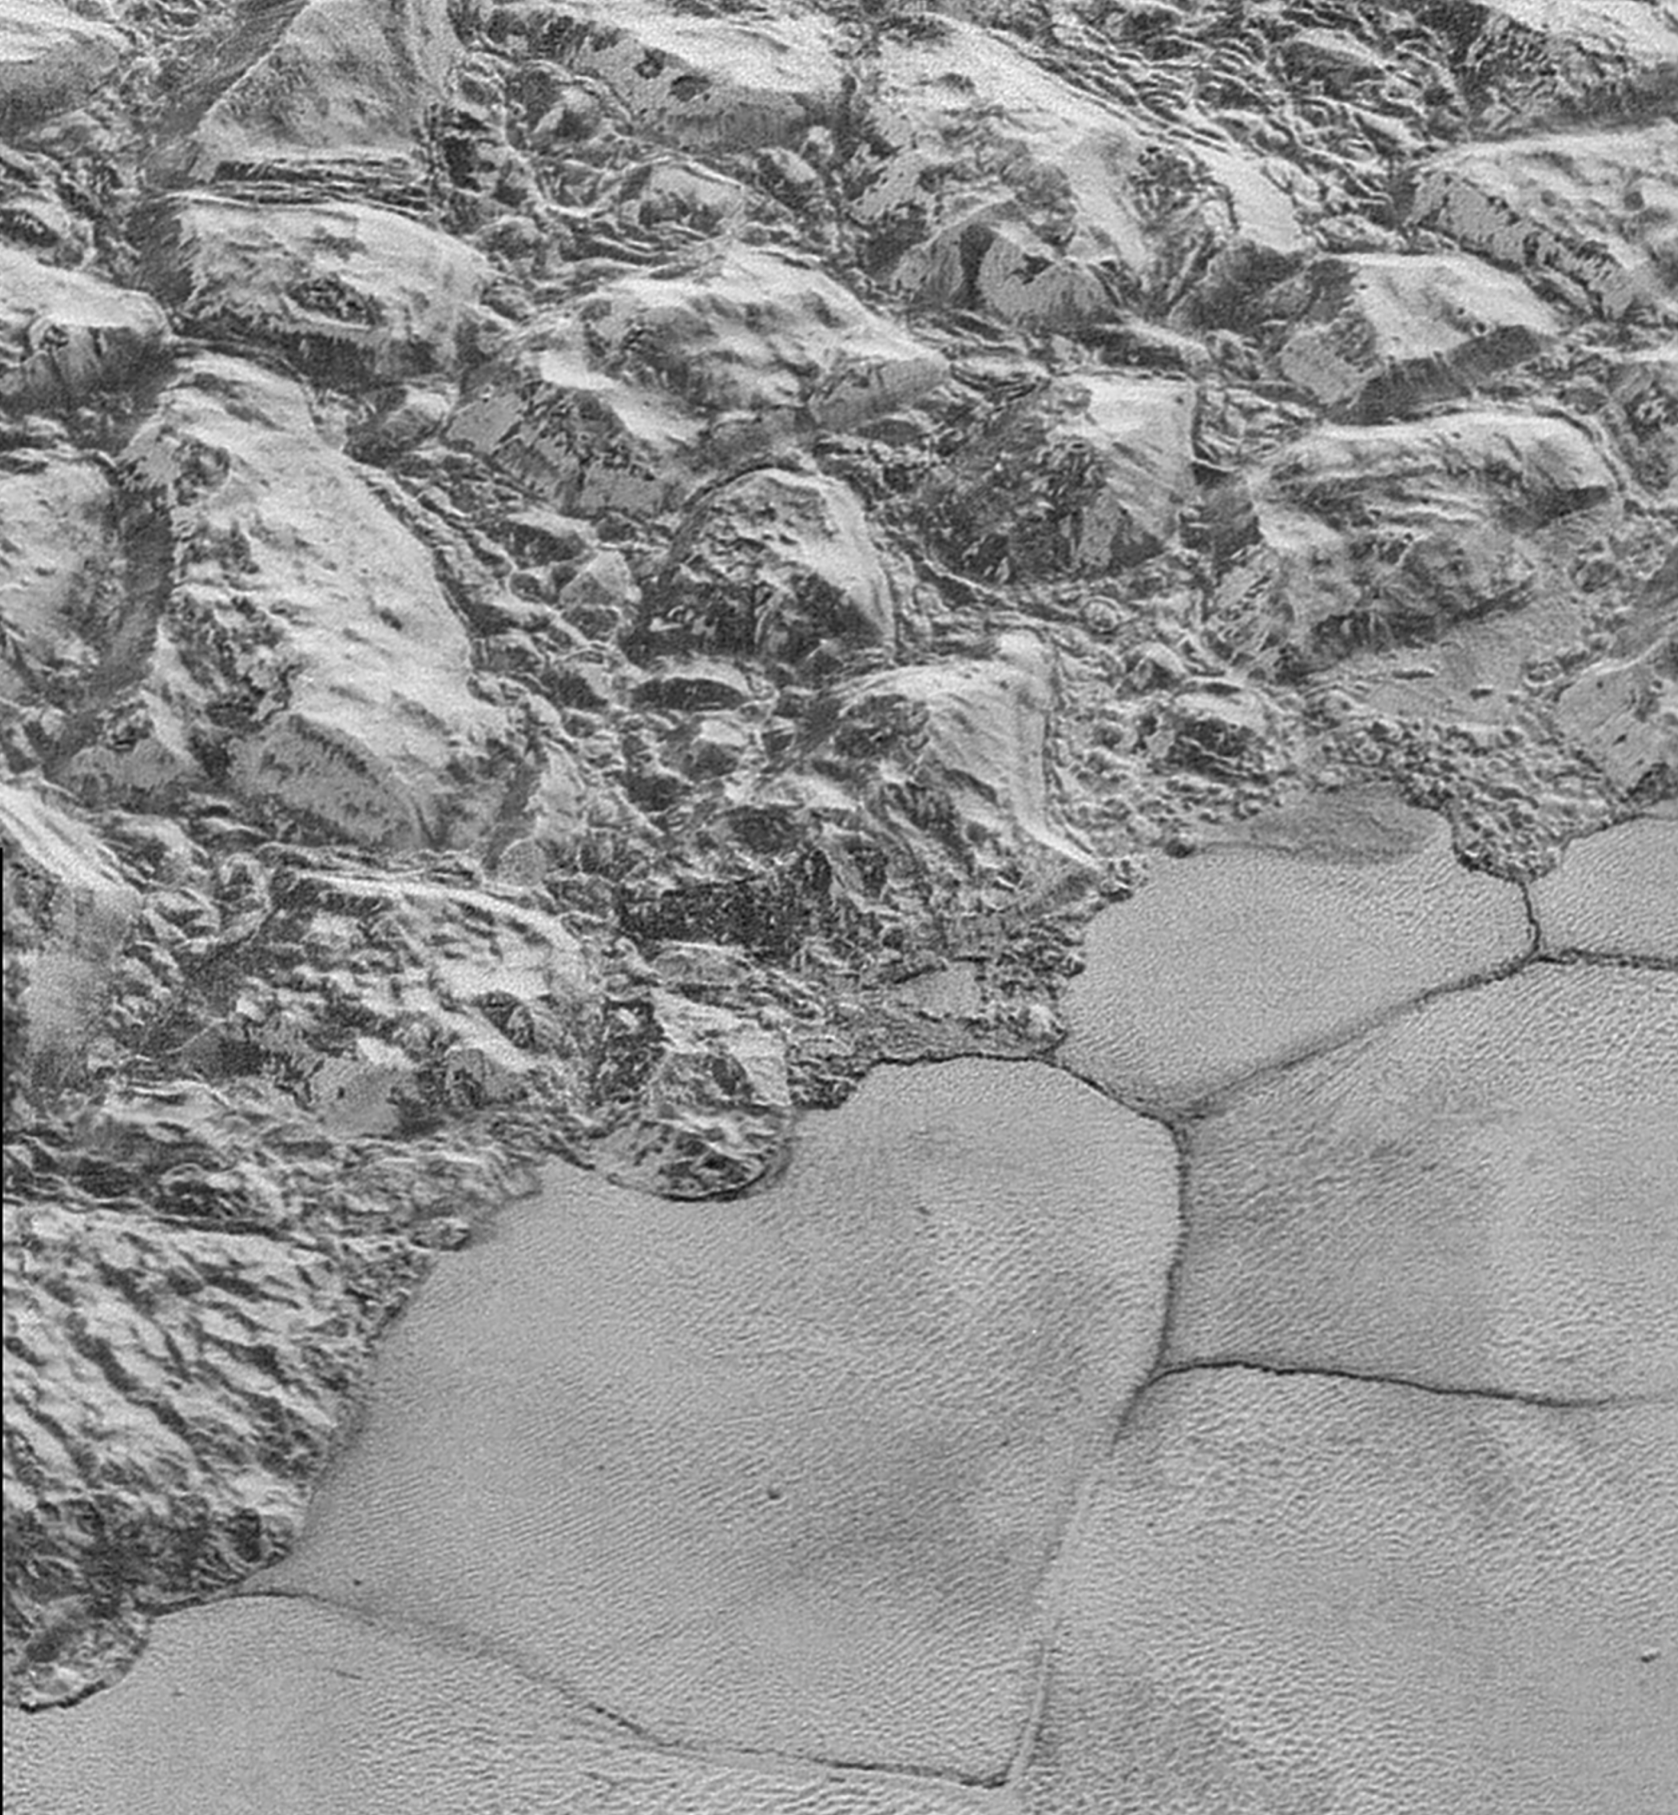

*Nitrogen ice sheet adjacent to mountains on Pluto. Oblique view from New Horizons spacecraft flyby. Nitrogen-ice convection cells are ~20 km across.*

a) Assume Pluto and Charon absorb 70% of incident sunlight. What is the surface temperature at Pluto? At Charon? b) From now on, assume an isothermal, pure nitrogen atmosphere. What is the scale height at Pluto? At Charon? c) Assume that the exobase is 10 scale heights above the surface1[1]. What is the gravity at the exobase for Pluto? For Charon?

The Jeans’ parameter, λesc, is proportional to the ratio of the gravitational binding energy to the thermal energy for molecules at the exobase. Larger values of λesc indicate that escape-to-space is unlikely. The Jeans’ parameter is usually calculated for exobase conditions (altitude, temperature). Hydrodynamic escape is most likely for λesc <~ 3. For λesc > 10, we are in a molecule-by-molecule thermal escape regime (confusingly, this molecule-by-molecule escape process is termed Jeans’ escape).

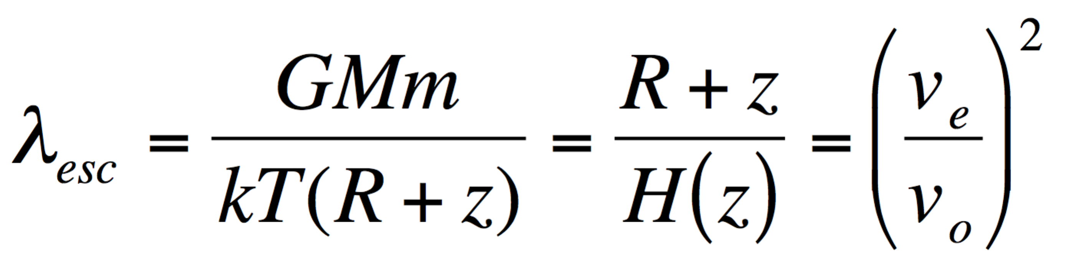

where G is gravitational constant, M is planet mass, m is molecule mass, k is Boltzmann’s constant, T is (local) atmosphere temperature, R is planet radius, and z is altitude above the planet’s surface.

d) What is the escape parameter (Jean’s parameter) for Pluto? For Charon? e) (For each world,) are we in a Jeans escape or hydrodynamic escape regime? f) How would your answer to (d) change if the isothermal assumption was not true, and the exobase temperature was in fact 100K (due to UV absorption in the upper atmosphere)?

**Q2. Effect of Supercontinent Formation.** Mountains are important to the global weathering budget. This is because mountain uplift increases the amount of material available for weathering per year (the sediment mass flux). Because the total planet-integrated weathering must be constant (averaged over >10^7 yr timescales) in order to avoid a climate runaway, the increase in material available for weathering must be compensated by a decrease in the amount of weathering per unit sediment. The easiest way to decrease the amount of weathering per unit sediment is to lower the planet temperature. (The lowering of temperature is accommodated by a transient pulse of increased weathering. This transient increase in weathering lowers the CO2 concentration, which lowers temperature. The planet is now less efficient at weathering each sediment parcel, and so the climate re-equilibrates at a new, lower temperature).

The purpose of this question is to work through the order-of-magnitude effect on planetary climate of forming new mountain belts.

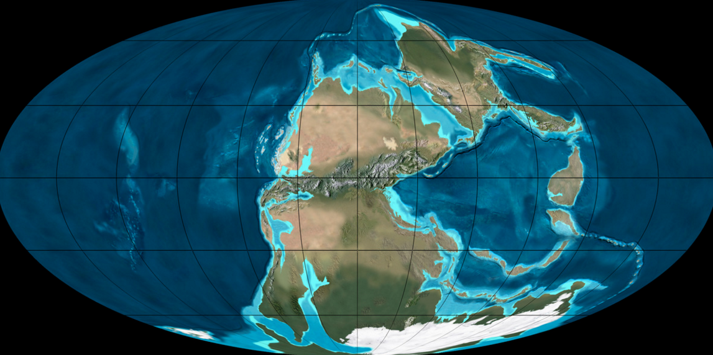

*Earth 280 Ma. Credit: Ron Blakey (NAU).*

The most recent global supercontinent, Pangea, was completed ~280 Ma by collision of North America with Africa. The collision (the Alleghenian orogeny) created a mountain chain, the Central Pangean Mountains. The Appalachian Mountains approximately correspond to a remnant of this mountain belt. In this question, use the paleogeographic reconstruction above (grid spacing 30 degrees) and Earth radius = 6x106 m.

Assume weathering efficiency (cations/yr/km^3 of sediment flux) scales as 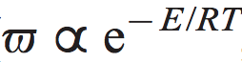

where *E* is activation energy and *R* is the gas constant, 8.314 J/mol/K, and surface temperature *T* is in K. Assume an effective activation energy for weathering (“effective” including the effect of temperature on rainfall) of *E* =74 kJ/mol (West et al., Earth & Planetary Science Letters, 2005).

1. Suppose paleomagnetic data[2] indicate Africa travelled N at 5 cm/yr and collided with a stationary North America. Assume continental crust is 35 km thick. Because continents are buoyant relative to the mantle, neither continent subducts. At steady state, continental crust is moving up to the surface at mountain belts, undergoing weathering and erosion, and the mass is being redistributed away from the mountain-belt, all at equal rates. What is the mass flux? Suppose the pre-collision eroded flux was equal to Earth’s modern sediment flux of 8 km3/yr; what is the fractional change in eroded flux (i.e., mass/volume available for weathering)?
2. Assume an activation energy for the temperature effect on weathering of 74 kJ/mol (West et al., Earth & Planetary Science Letters 2005). What is the sign and magnitude of planetary temperature change?
3. Suppose that the ice sheet in the S Hemisphere grows. Is this a positive or negative feedback on the change you calculated in part (b)? Why?
4. It is often said of warming climates that “wet areas get wetter, dry areas get drier.” [3] Given that weathering rate depends on both temperature and rainfall, explain qualitatively how changes in rainfall on the Central Pangean Mountains due to the warming you calculated in part (b) would feed back on (and thus modify) your answer to part (b).
5. Suppose that collision had occurred in the desert belt at 25° N instead of at the humid equator. Explain how you answer to part (d) would differ.

The formation of the Himalayas and Tibet is one leading hypothesis for the cooling of Earth that led to the onset of ice sheets on Antarctica ~35 Myr ago.

1. This is often a terrible approximation. It should only be made when one is pretty confident (from independent evidence) that the exobase altitude is much less than the planet’s radius and that the planet is not close to tidal disruption.
2. Paleomagnetic data provide great constraints on latitudinal drift rates, but constraining paleo-longitudinal drift requires less direct methods such as matching up geologic provinces on either side of a rift zone, or looking for evidence of hotspot volcanism (hotspots are underlain by mantle plumes, which move slowly relative to plates and so define a “hotspot reference frame”).
3. This is not always exactly true. For example, an expanding Hadley cell under warming (the Hadley cells are currently expanding due to anthropogenic global warming) can turn the low-latitude edge of the desert belt into a wet zone.