Earth and Planetary Surface Processes
Winter 2019 - Lab 5. “Shorelines” on Mars.
Hinds 440, 11a-noon
Grades are not assigned for lab, but attendance is required.
If you are unable to make a lab, email kite@uchicago.edu to set up an alternate time.

Introduction. In 1911, a meteorite struck Egypt (purportedly killing a dog). The meteorite, named Nakhla, was recognized as a piece of Mars during the 1980s – one proof came from comparing the isotopic composition of gas trapped within meteorite glass to the isotopic composition of Mars air measured by the Viking landers.
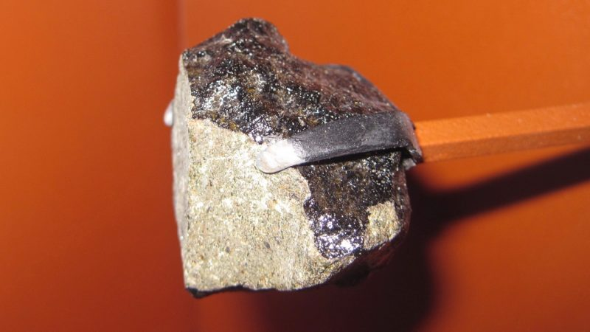
Nakhla (AMNH, D.C.)

Nakhla and related meteorites, the “Nakhlites”, are clinopyroxenites that crystallized 1.3 Ga either in a thick lava flows or in a shallow magma chamber, were ejected by spallation during a single cratering event on Mars ~10 Ma, and all have resided on Earth for <10 Ka. The launch crater for Nakhla is not known, but the youthful crystallization age narrows the source area to the red zone below:
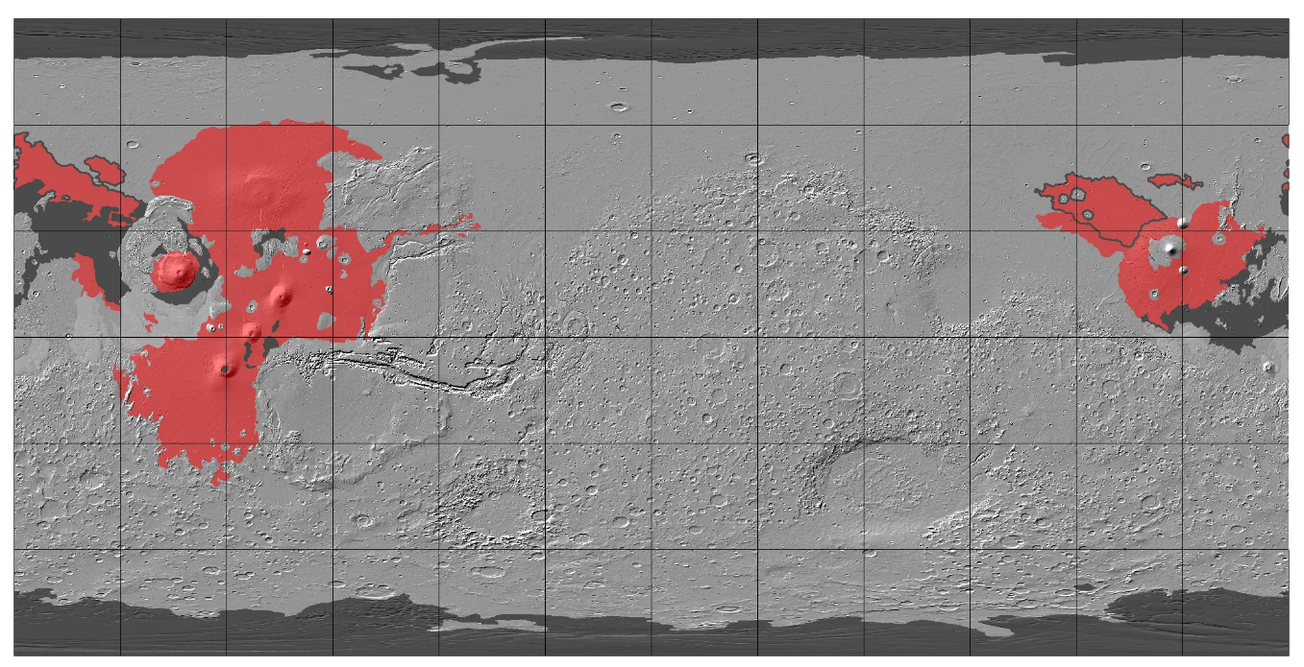
Red area corresponds to likely launch zone for the nakhlites based on geological mapping (Tanaka et al. 2014) and crater-based age dating (Platz et al. 2013). Red areas with gray outline corresponds to likely launch zone for the nakhlites assuming lava-pool drainage is responsible for the fast-cooling event recorded by NWA 817 and MIL 03346. Dark-gray tint corresponds to geologic units that are Upper Amazonian (likely too young to be the nakhlite source region); mid-gray tint (most of the planet) corresponds to geologic units that are likely too old to be the nakhlite source. A special case is the Medusae Fossae Formation (near equator; light gray tint), which has the right age to be the nakhlite launch site, but the wrong lithology. Backdrop is shaded relief based on Mars Orbiter Laser Altimeter topography. Grid spacing is 30˚. Source of geological data is Tanaka et al. (2014).

The cooling history of the Nakhlites suggest they cooled first slowly, then rapidly. A likely cause is that the Nakhlites formed near the bottom of a thick (and therefore slow-cooling) lava flow whose top drained rapidly (the fast-cooling phase; Richter, Chaussidon, Mendybaev, and Kite, Geochimica et Cosmochimica Acta, 2016).

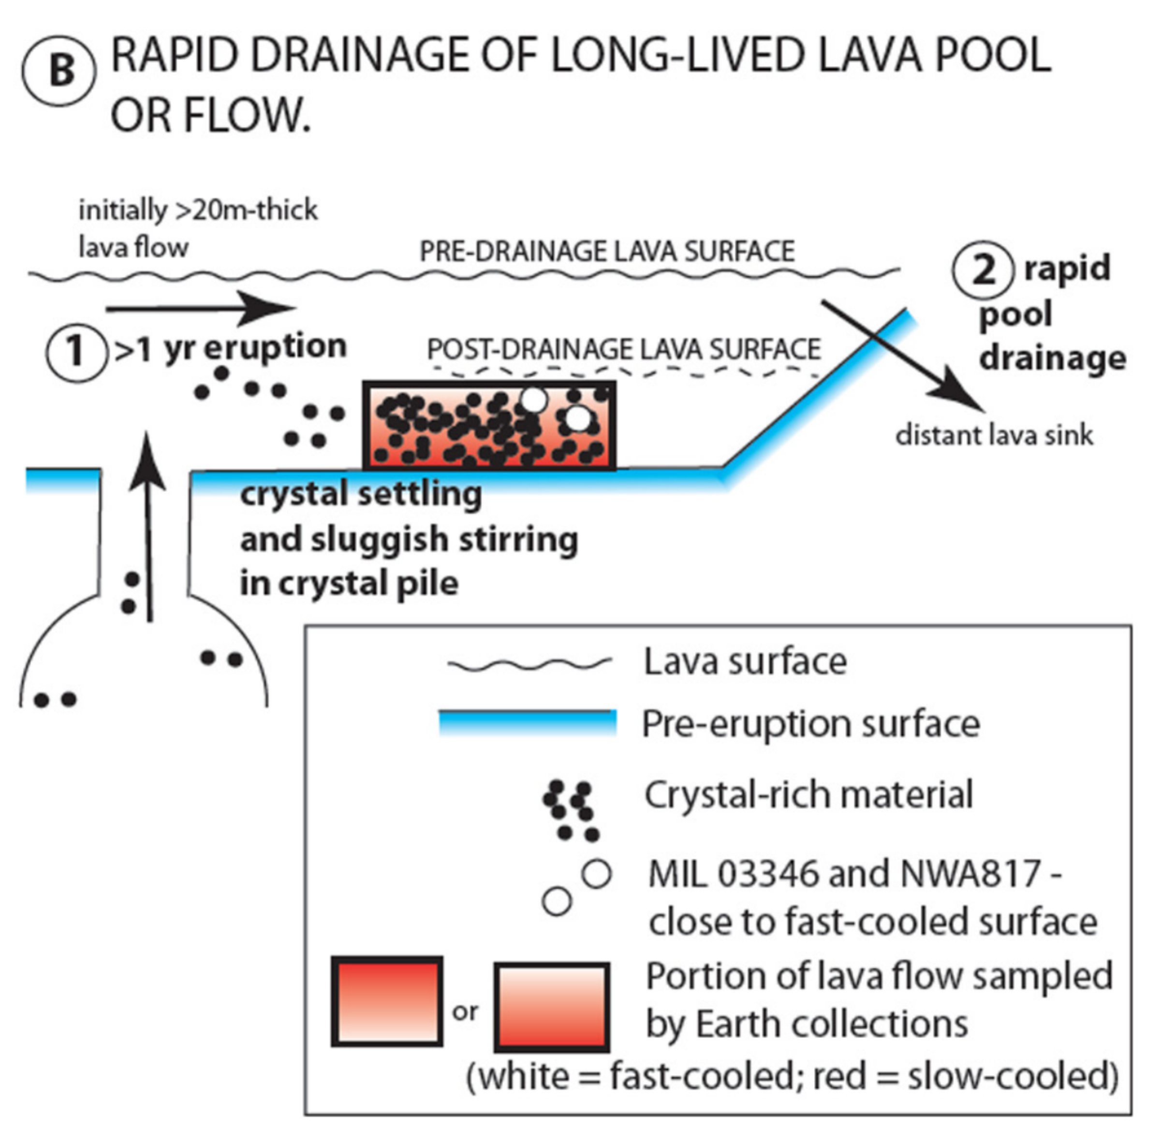

Go to http://geosci.uchicago.edu/~kite/geos28600_2019/ and download the files in “Lab 5 Files directory”.

Go to http://www.uahirise.org/ESP_025459_1895
click on anaglyph. Use red-blue glasses to browse the shoreline features (probably high-lava marks). Also view the “JPEG Black and white map projected” and make a
note of the scale bar.

An Earth example of the shoreline features is shown below – fringes of Kileau Iki lava lake, Hawaii Big Island, 110m deep: - filled with lava 1959, partially drained a few months later, solidifying crust drilled into by Rosalind Helz starting in April 1960; magma still present at depth as of 1981.
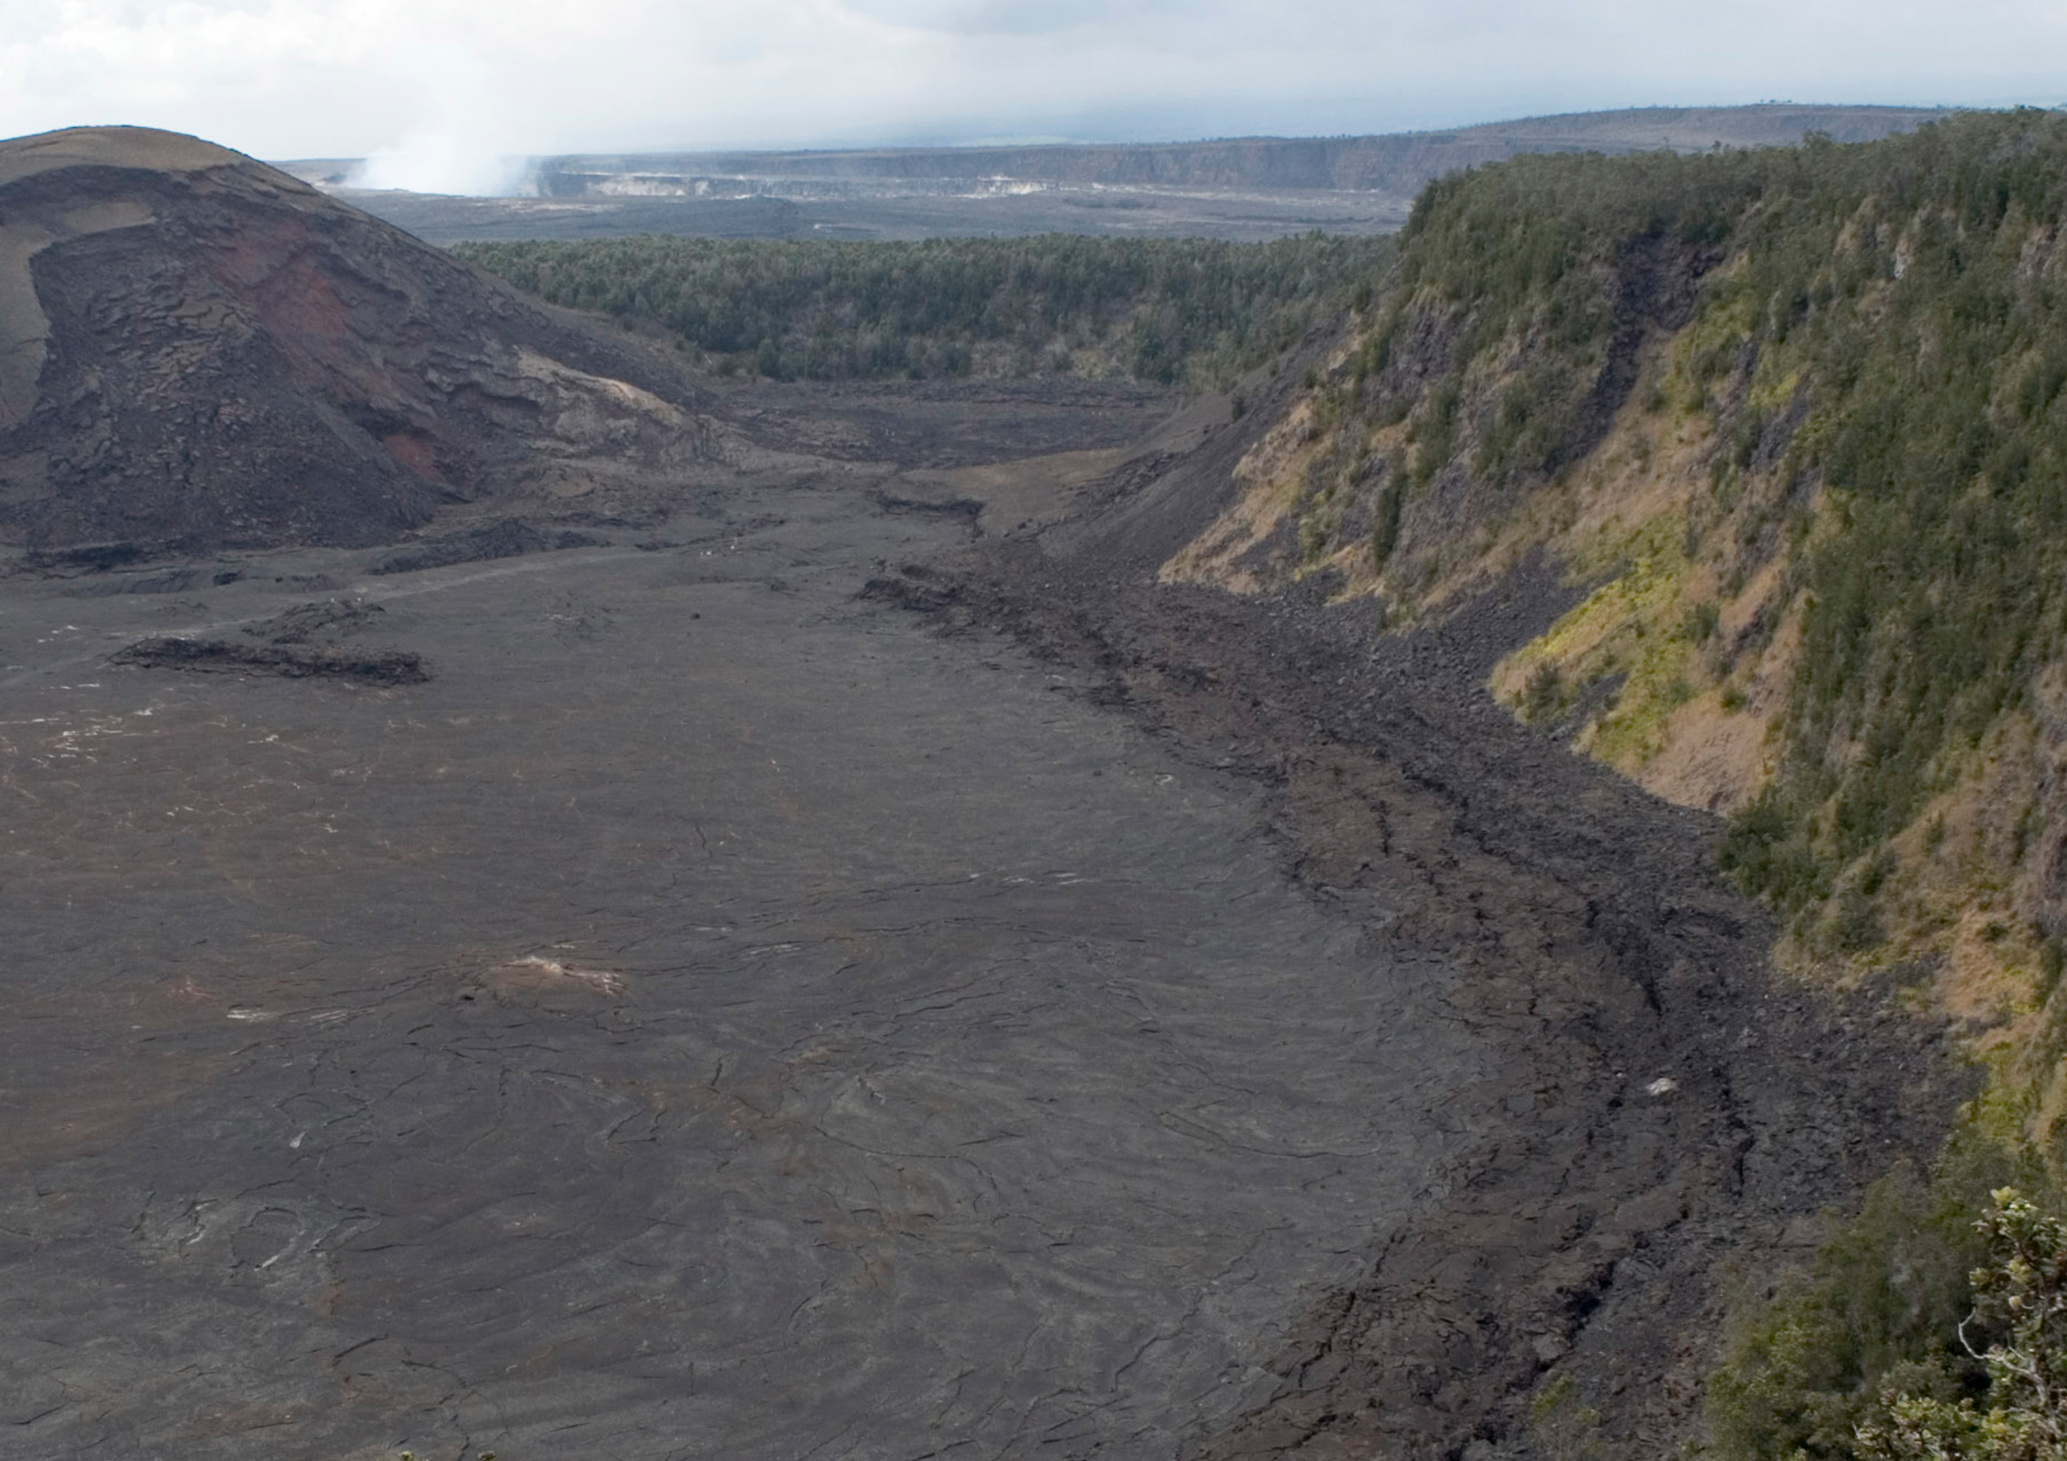

Instructions:Go to http://www.uahirise.org/dtm/dtm.php?ID=ESP_025459_1895
Click on the image at the top of the screen. Browse the topography.
i. Lava rheology.
For each of the profiles in the Lab files directory, use the data file and your preferred data software (e.g. Excel, Matlab) to determine the elevation of each shoreline feature. You may want to plot the first derivative of elevation to highlight breaks-in-slope. Use the image files corresponding to each profile to help identify the shorelines. Can any of the shoreline features be matched up between the profiles? Can all of them?

By using the context image, the gradient in elevation along the shorelines, and the fact that the colored part of the image is ~5km wide, what is the yield strength of the lava?

ii. Maybe these really are (water) shorelines?
Suppose that the shorelines you have been inspecting really did form on the edge of a water lake – in which case they would closely follow an equipotential. What would the subsequent tilting of the shoreline (which you have just measured, by pairing up shorelines between different profiles) have been? What processes might cause this amplitude of tilt over this length scale?

iii. Lava drainage.
The “wide angle view” in the “Lab 2 files” shows the context. Recall that the colored part of the image is ~5 km wide. What is the width of the throat separating the profiles you have drawn from the rift?

Assuming the lava drained into the rift, did the lava drain turbulently? Assume density 3000 kg/m³, lava viscosity 10 Pa s, and lava lake depth 60m, and assume that the lava drained into the rift to the south. To answer this question we need to calculate the Reynolds number. To do that, we must estimate u_{drain}.

North of the throat, roughly what volume of lava drained to create the shoreline features?

What is an upper limit on the timescale of drainage? (Remember that if the lava level stayed stable for too long, the lava would freeze fast to the substrate and would not produce “lip” features. So this timescale is a thermal conduction timescale).

What is the horizontal flow speed if the lava drained through the throat into the rift?

What is the Reynolds number of the flow?

Did the lava drain turbulently?

The cooling rate of the Nakhlites is constrained to ~1K/hr (from “quenched” ⁷Li/⁶Li isotopic diffusion profiles in individual crystals; Li diffuses readily, so non-equilibrated ⁷Li/⁶Li diffusion profiles ). Suppose that the nakhlites are a sample of the drained lava pool you have been examining (this is probably not true, but the depth of the current frozen-lava surface below the “high lava marks” is fairly common on Mars.)

What is the revised timescale of drainage, to order of magnitude?

What is the new velocity and Reynolds number? Did the lava drain turbulently?

