**The science of landscapes: Earth and planetary surface processes**

**Winter 2019**

**Problem set 5**

Due in class Wednesday 27 Feb, 10:30am. Office hours 11:30a-12:30p Mondays, or by arrangement ([kite@uchicago.edu](mailto:kite@uchicago.edu)).

Collaboration policy. You may discuss homework questions with each other, but you should not be in the same room as another student when you are writing up the answers. Questions in this problem set are “open book” and may draw on concepts in the required reading.

**Question 1.**

Consider a wide, shallow mountain belt whose bedrock fragments into 2cm-diameter clasts that cannot be further abraded. How will the height of this mountain belt differ from that of an otherwise identical mountain belt whose bedrock fragments into 1cm-diameter clasts that cannot be further abraded? Be quantitative (use the equations given in lecture).

**Question 2.** Eberswalde paleohydrology (following Irwin et al., Geomorphology 2015)

You may need a ruler for this question.

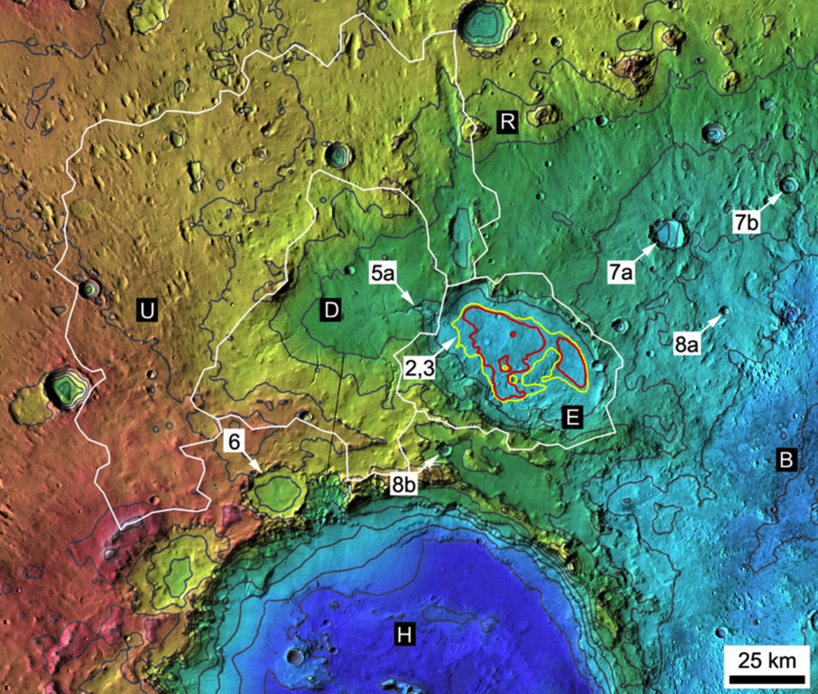

On Mars ~3.5 Gyr ago water from the white-outlined catchment area drained into the lake outlined in yellow, forming a delta at the point marked “2,3”. For this delta, we think only one trunk channel was active at any one time.

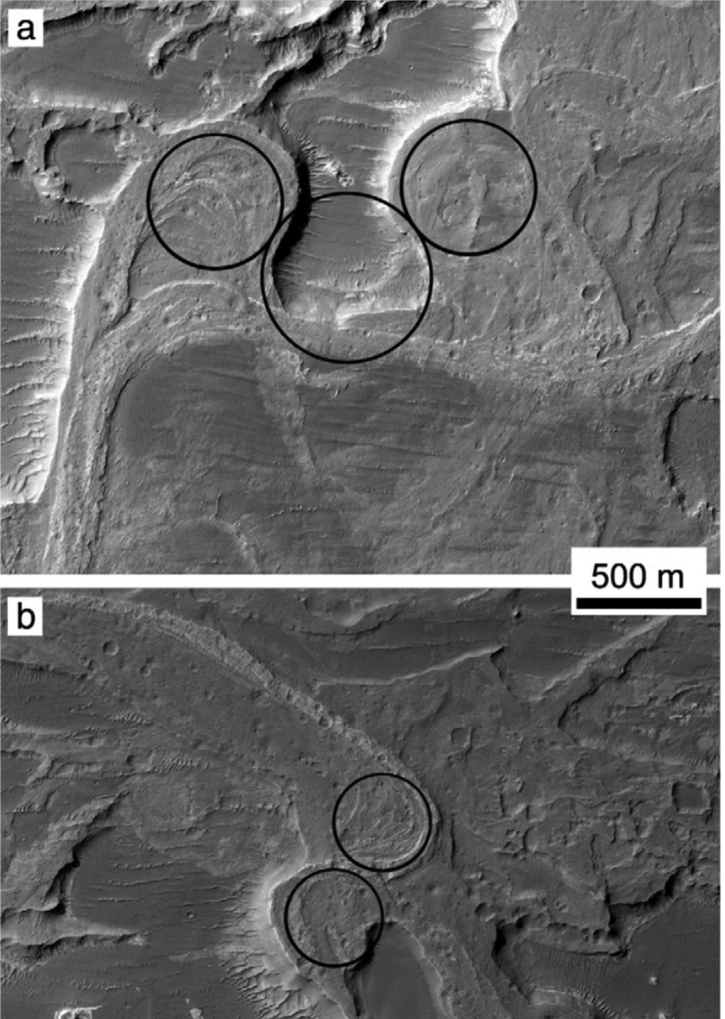

Use 

to find bankfull discharge from the two meandering trunk streams shown above. (Remember that wavelength = 2x half-wavelengths).

Assume a sediment:water ratio of 1:1000 (by volume) and a lake evaporation rate of 1 m/yr.

Assuming that the lake level stayed constant during construction of the delta:

What is the total evaporation / yr from the lake (in km3)?

For how many days/year could the trunk streams have been flowing at bankful discharge?

What is the amount of sediment transported per year?

What is the lake lifetime implied for the measured delta volume of 6 km3?

**Question 3.** From Whipple & Tucker, JGR Planets, 1999 (in the required reading): Show that Equations 10a-10d in that paper follow from Equations 1-7 in that paper.