**The science of landscapes: Earth and planetary surface processes**

**Winter 2019**

**Problem set 2**

Due in class Wed 30 Jan, 10:30am. Office hours 11:30a-12:30p Monday 28 Jan, or email me to set up a time (kite@uchicago.edu).

Collaboration policy. You may discuss homework questions with each other, but you should not be in the same room as another student when you are writing up the answers. Questions in this problem set are “open book” and may draw on concepts in the required reading.

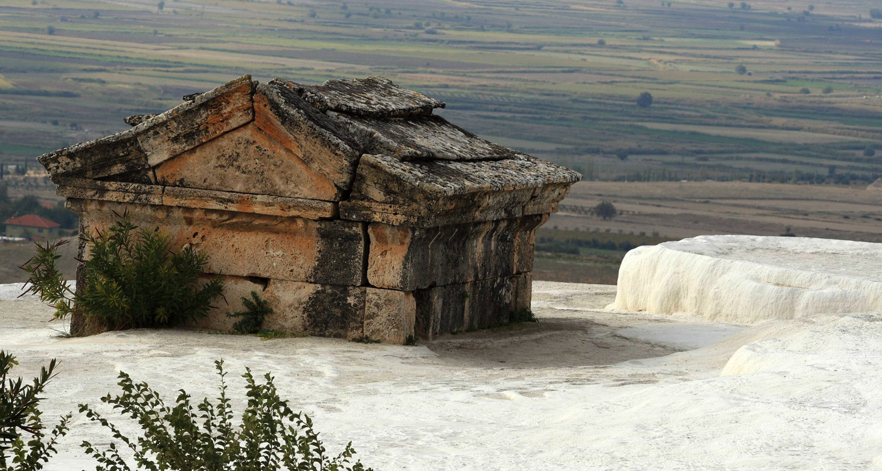

**Question 1.** What is the minimum timescale for a travertine (CaCO3) terrace to aggrade by 1 m? Assume travertine density 2 g/cc, initial total C content 8 millimolar, pool depth *d =* 3 cm, and terrace width 5 m. For flow velocity *v*, use *v* = *C* (*d s*)0.5, where *s* is a characteristic slope of the water surface, and C ~ 10 is the Chézy coefficient. Alternatively, use any other flow velocity equation you prefer (show your working). How does this growth timescale compare to the time-lapse movie we saw in lecture? How does this compare to the picture (1st Millennium AD temple entombed by travertine) shown above? Comment on which assumption or assumptions in the set-up of this idealized calculation might be most responsible for the discrepancy with real growth rates.

Background on the process of travertine-terrace build-up can be found in Veysey & Goldenfeld, “Watching rocks grow”, Nature Physics, 2008, and the accompanying News & Views article by Hammer. Both are included in: http://geosci.uchicago.edu/~kite/doc/Veysey_and_Goldenfeld_2008.pdf

**Question 2.** BuildingOlympus Mons. (This is question 5.6 in the Melosh text, included in the required reading pdf).

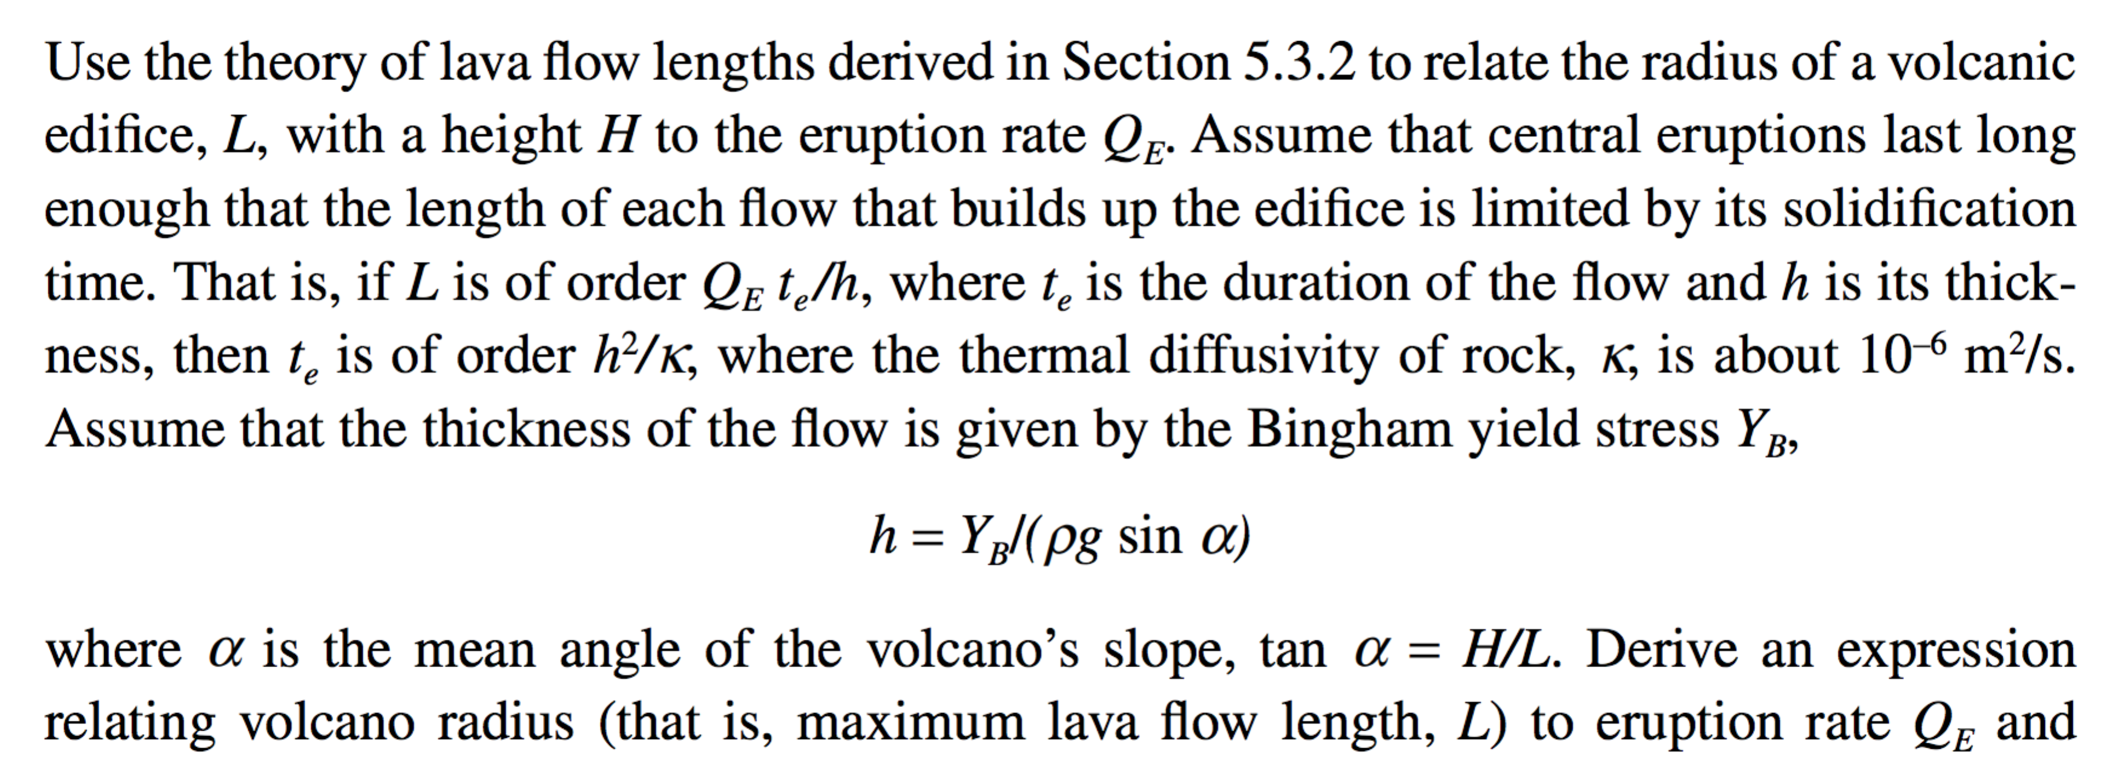

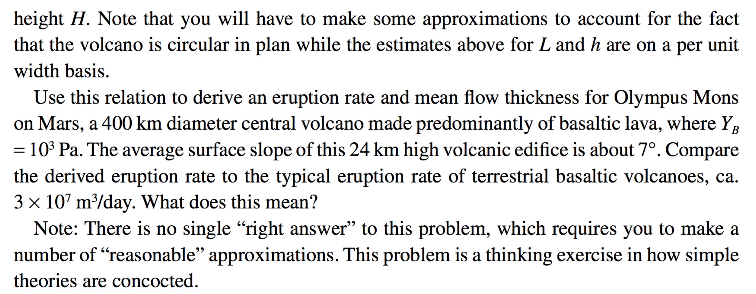

­ **Question 3.**

You may want to refer to the required reading (Chapter 5 in Melosh) for guidance on this question.

**(a)** Disintegrating magma planets. What is the maximum-sized world that can disintegrate via CO2-driven explosive volcanism? Assume constant density 5 g/cc. Show your working.

**(b)** The fire fountains at Tvashtar on Jupiter’s moon Io are 1.5 km tall. Assume the fountains are driven by exsolving SO2, what is the minimum SO2 content of the erupting magma? Assume ideal gas behavior. Io’s radius is 0.3x Earth and Io’s density is 3.5 g/cc.