**Earth and Planetary Surface Processes**

**Winter 2017**

**Problem set 2**

Due in class Wed 25 Jan, 3pm. Office hours 9am-10am, Hinds 467 Friday 20 January.

Collaboration policy. You may discuss homework questions with each other, but you should not be in the same room as another student when you are writing up the answers. Questions in this problem set are “open book” and may draw on concepts in the required reading.

­

**Question 1.**

**(a)** Disintegrating magma planets. What is the maximum-sized world that can disintegrate via CO2-driven explosive volcanism? Assume constant density 5 g/cc. Show your working.

**(b)** The fire fountains at Tvashtar on Jupiter’s moon Io are 1.5 km tall. Assume the fountains are driven by exsolving SO2, what is the minimum SO2 content of the erupting magma? Assume ideal gas behavior. Io’s radius is 0.3x Earth and Io’s density is 3.5 g/cc.

**Question 2.** BuildingOlympus Mons.

Do question 5.6 fromMelosh (included in the required reading pdf). (From Melosh:) Note that there is no single “right answer” to this problem, which requires you to make a number of “reasonable” approximations.

**Question 3.** Force balance for accretionary wedge.

In class we showed that

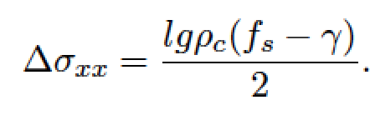

where *l* is wedge length, *g* is gravity*, ρc* is crustal density, *fs* is thrust friction coefficient, and *γ* is the long-wavelength topographic slope of the thrust.

Olympus Mons (height 20 km, radius 300 km) is encircled by structures that are interpreted as evidence for outward-directed gravity spreading. If this interpretation is correct, is it evidence for water on Mars? Explain your reasoning.