Earth and Planetary Surface Processes
Winter 2020 - Lab 5. River channel long profiles.
Walker 303, 9a-9:50a
Grades are not assigned for lab, but attendance is required.
If you are unable to make a lab, email kite@uchicago.edu to set up an alternate time.
Portions of this lab draw on the WILSIM tutorials written by Wei Luo (NIU) and Jon Pelletier (Arizona).

In lecture and in the optional reading, we discussed the case for and against recent (post-6 Ma) incision of the Grand Canyon. In this lab we will quantitatively explore the recent formation hypothesis.

Inspect the below long profile of the Colorado River (from Darling et al., Geosphere, 2012).
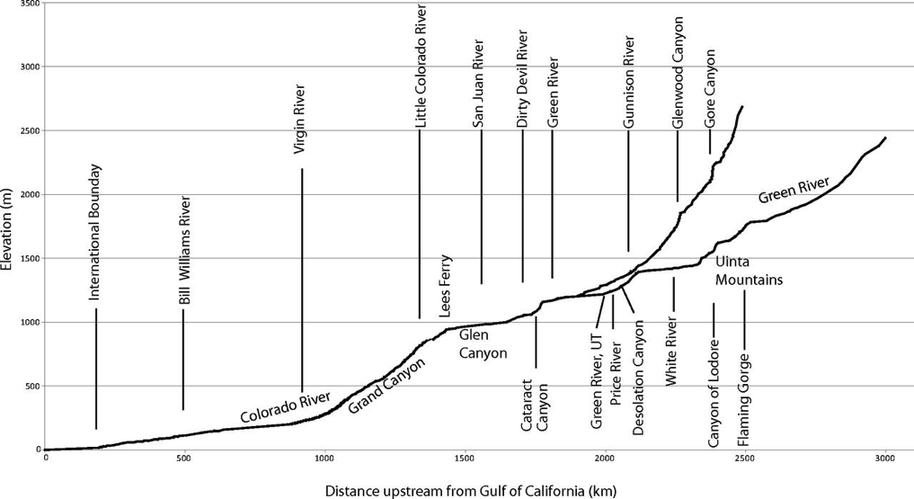
Notice that the Grand Canyon is a knickpoint on the long profile. Cartoon examples of knickpoint migration:
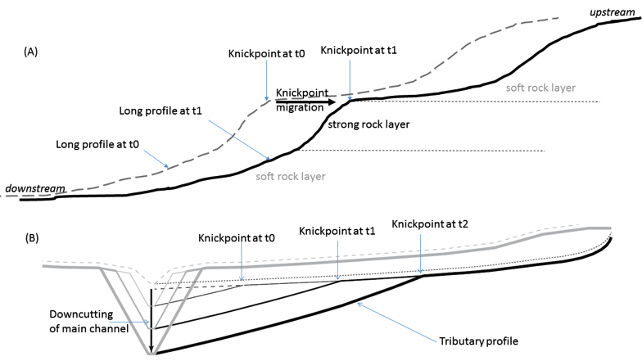

In the “young Grand Canyon” hypothesis, the initiating event is an increase in the rate of uplift on the Grand Wash Fault, which marks the W end of the Grand Canyon, at ~6 Ma:
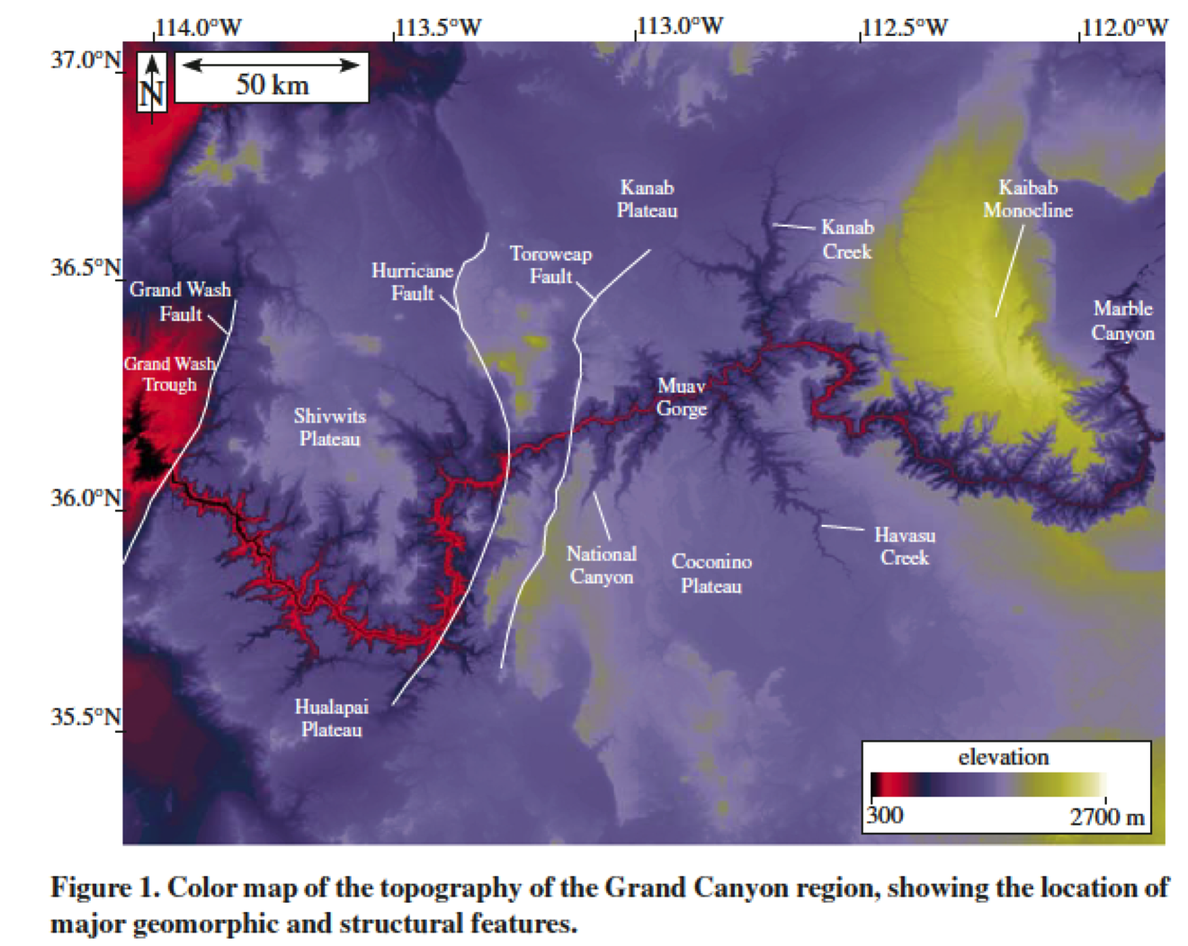

(from Pelletier, 2010). Read the “Model description” section of Pelletier’s 2010 paper (http://geosci.uchicago.edu/~kite/doc/Pelletier_2010.pdf) , up to but not including equation 4.

Strong rocks form cliffs, and weak rocks form benches.
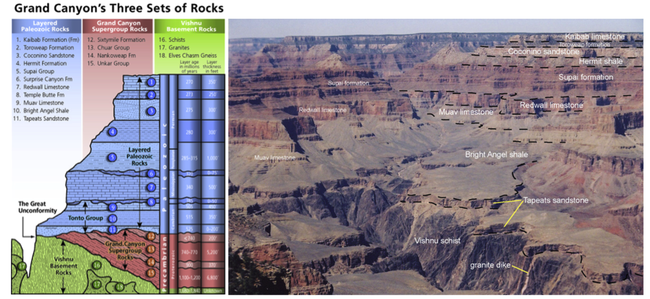
Images from National Park Service (left) and U. Arizona geology department (right)

Now we will run a model based on Pelletier 2010.

Download and run WILSIM-Grand Canyon (http://serc.carleton.edu/landform/start.html). The code may prompt you to install the latest version of Java; you can skip this step.

There are a few simplifications in this code relative to the Pelletier 2010 model.
Comments on the code:
- The initial topography is set to be a muted version of the modern topography (with the Grand Canyon infilled) to ensure that the simulated Grand Canyon looks similar to the modern Grand Canyon. This is a reasonable assumption, but unproven.
- Tectonic motion on the Hurricane and Toroweap faults (up to 600m vertical) is neglected.
- The model resolution is 720 meters per pixel.
- For drawing cross-sections, a good place to cut across the Grand Canyon is the location of the Kaibab Monocline.
- A rock erodibility factor of 0.1 kyr⁻¹ generates erosion at a rate equal to 0.1 meter per thousand years, for a fluvial channel of slope equal to 1 (45°) and drainage area equal to 1 square kilometer.
- The model has a strong layer located 400 m below the canyon rim, representing the Redwall Limestone. Increasing the “hard/soft contrast” decreases the erosional resistance of soft layers.
- Cliff retreat rate is constant for all layers. Data (from packrat middens) suggest the Redwall Limestone retreats at a rate of 0.5 mm/yr (Cole and Mayer, Geology, 1982).
- The default parameter values (when you close and reopen the simulation) are set to roughly reproduce the real Grand Canyon.
- The cross-sectional profile can be drawn anywhere on the map by clicking in “Draw” mode.

Erodibility of different layers within the near-horizontal sedimentary layers of the Grand Canyon is inferred from the relative steepness of the side-canyons crossing those layers (Pelletier 2010). These are the results:
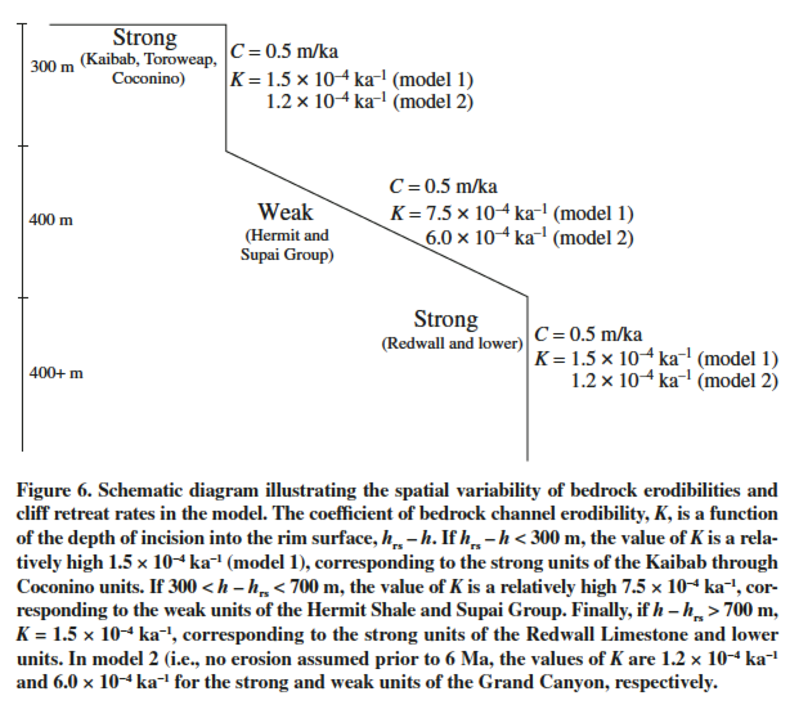

Questions.
With default parameters set, what is the knickpoint retreat rate in cm/yr?

Double the rock erodibility. Run the model. Use the ‘profile’ and ‘cross section’ tools to summarize the (quantitative) differences in canyon width, canyon depth, length of the main canyon, and length of tributaries between this scenario and the default-parameters scenario. You may have to re-run the model to build up cross-sections in different regions of interest. Explain your answers.

Reset the rock erodibility to default parameters. Run the model. Now change the subsidence rate to 0.9 m/kyr. Use the ‘profile’ and ‘cross section’ tools to summarize the (quantitative) differences in canyon width, canyon depth, length of the main canyon, and length of tributaries between this scenario and the default-parameters scenario. Explain your answers.

Intepreting cross-sections.
The following page shows cross-sectional graphs of the Grand Canyon from four pairs of simulations. In each simulation, one variable was changed from the default value (shown in the left image) to its maximum possible value in WILSIM-GC (shown in the right image). The subsidence rate, rock erodibility, hard/soft contrast, and cliff retreat rate are the only variables used in the below scenarios. The image below shows where the cross-section line was drawn to create the images in scenarios A-D. Use the information from the image below and the graphs in each scenario to answer the following questions.
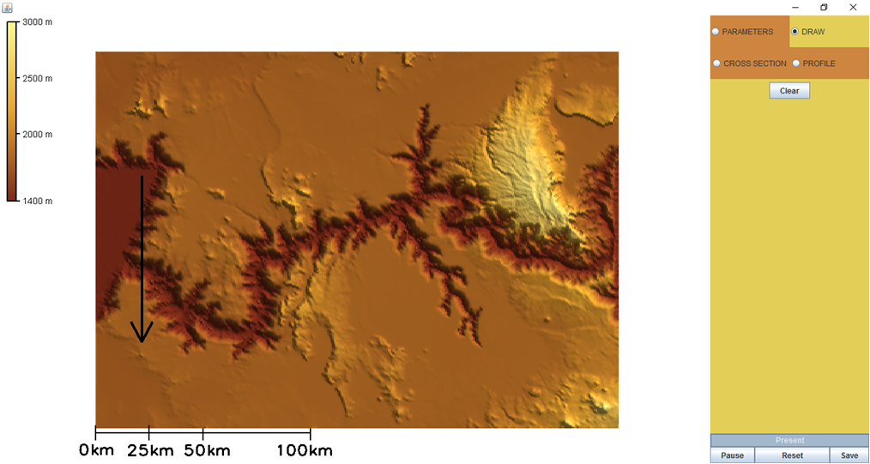

Describe the changes you see in each scenario (A-D) below. The following image displays where the cross-section line was drawn to obtain the graphs in scenarios A-D. Use this information to determine which variable was changed. What characteristics do you see in each image (on the right) that led you to suggest that variable has changed? Now run several simulations by changing one variable to its maximum value in each simulation (with the rest of the variables set to their default values) and compare the simulation results to the cross-section graphs below. Were your educated guesses correct?

Simulated Cross-Sections
---5.0 Myr Ago ---4.0 Myr Ago ---3.0 Myr Ago ---2.0 Myr Ago ---1.0 Myr Ago ---Present
Scenario A
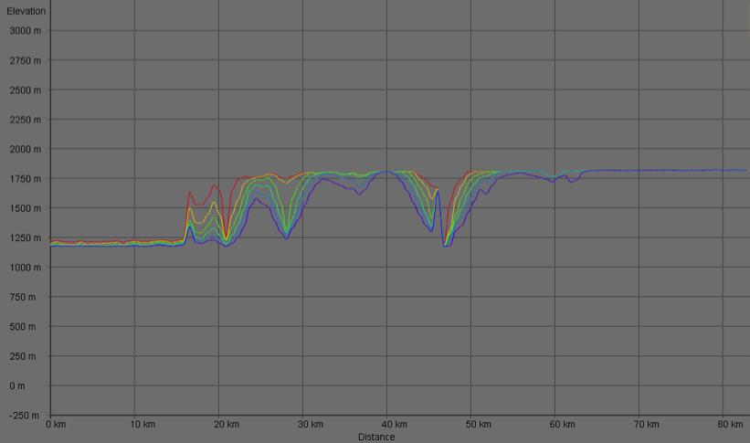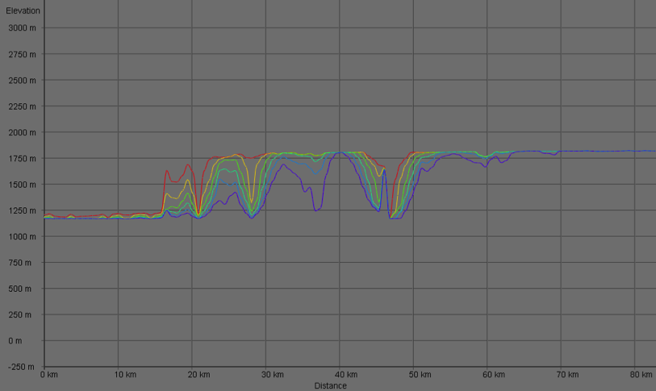
Scenario B
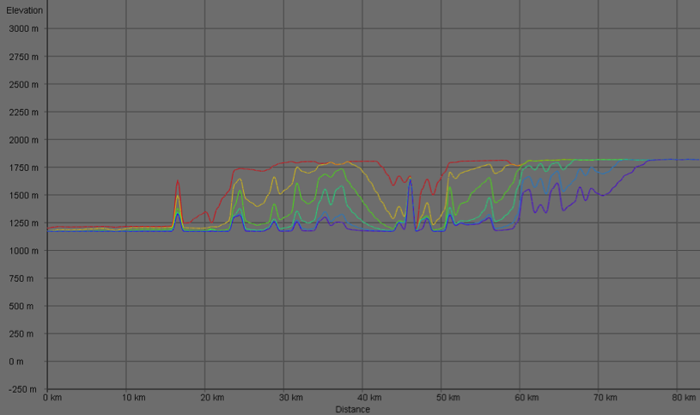
Scenario C
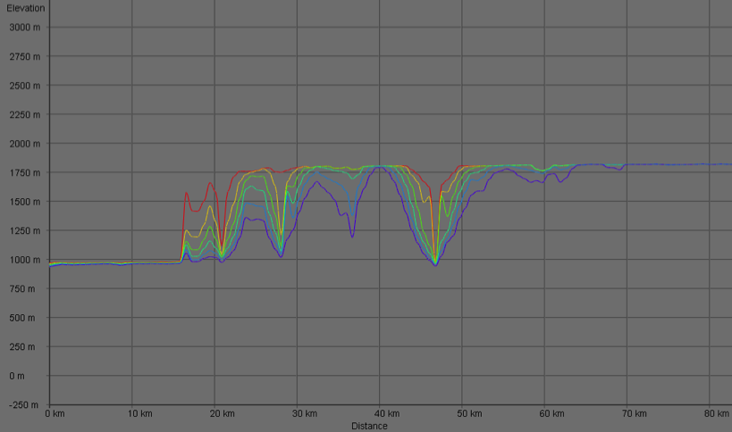

Scenario D
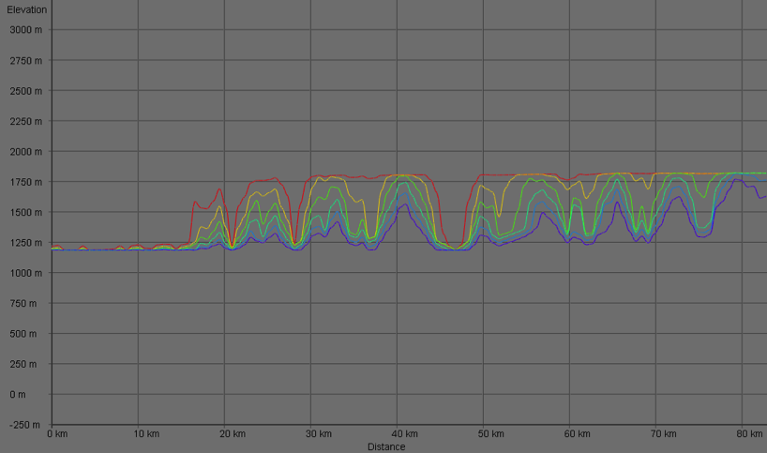

Interpreting (Simulated) Long Profiles

The following page shows long profile graphs of the Grand Canyon from four pairs of simulations. In each simulation, one variable was changed from the default value (shown in the left image) to its maximum possible value in WILSIM-GC (shown in the right image). The subsidence rate, rock erodibility, hard/soft contrast, and cliff retreat rate are the only variables used in the below scenarios.

Describe the changes you see in each scenario (A-D) below. Use this information to determine which variable was changed. What characteristics do you see in each image (on the right) that led you to suggest that variable has changed? Now run several simulations by changing one variable to its maximum value in each simulation (with the rest of the variables set to their default values) and compare the simulation results to the profile graphs below. Were your educated guesses correct?

Simulated Profiles
---5.0 Myr Ago ---4.0 Myr Ago ---3.0 Myr Ago ---2.0 Myr Ago ---1.0 Myr Ago ---Present
Scenario I
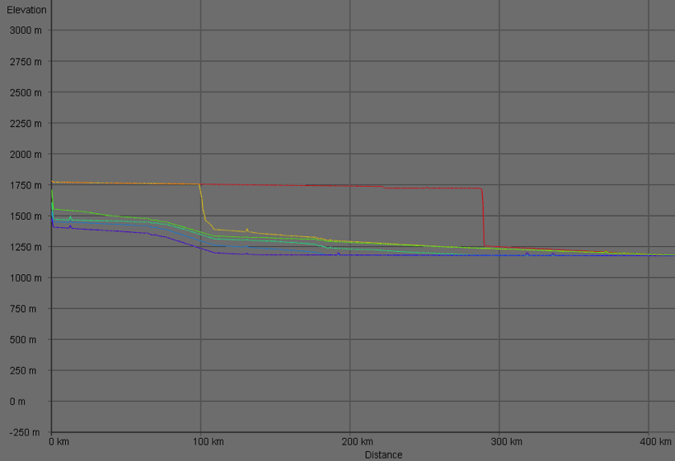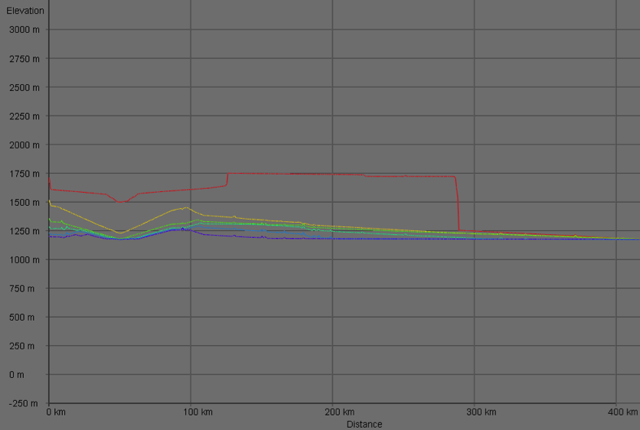
Scenario II
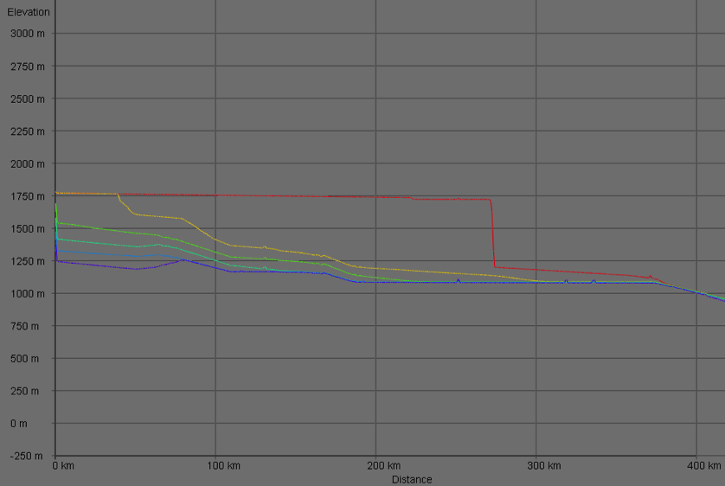

Scenario III
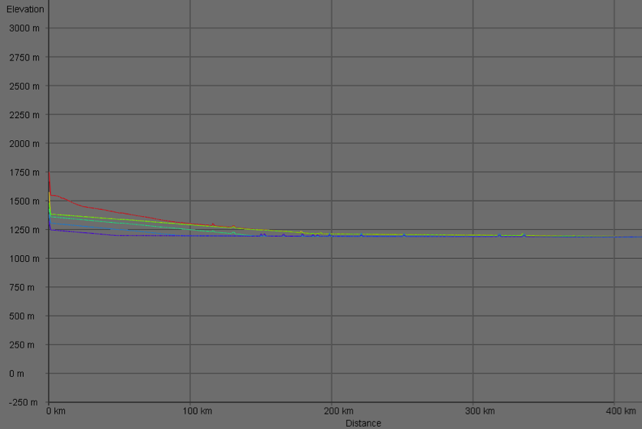
Scenario IV
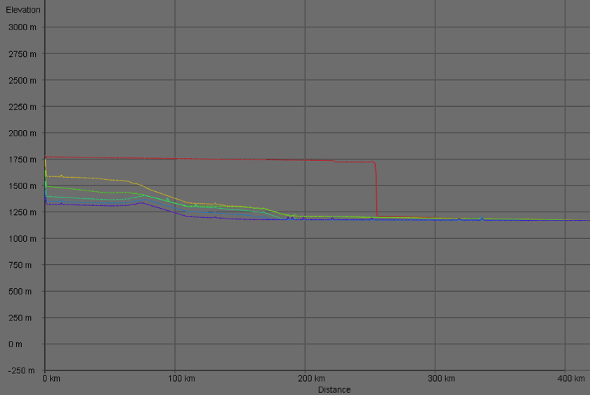

If time remains:
Can you create a landscape similar to the Grand Canyon, using values significantly different than the default values of the model (i.e., by trading-off changes in multiple parameters such that the final form is similar)?

