Earth and Planetary Surface Processes
Winter 2017 - Lab 1
Wieboldt 310C, 10:30a-11:20a
Grades are not assigned for lab, but attendance is required.
If you are unable to make a lab, email kite@uchicago.edu to set up an alternate time.

1. How thick is the man in the Moon?
The “man in the moon” consists of relatively young (mostly 3-3.5 Ga, although there is strong indirect evidence for some volcanism <0.1 Ga) dark basaltic lavas. The white Lunar highlands are nearly-pure anorthosite (Ca-rich plagioclase feldspar) which crystallized >4.3 Ga (from volcanism associated with the magma ocean formed by the Moon-forming impact on Earth).

Lunar impact basins shown by black circles (not all are flooded by lava):
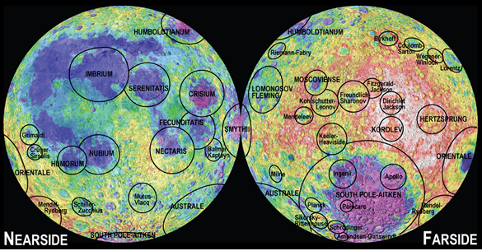
Planetary Science Research and Discoveries http://www.psrd.hawaii.edu/
(The above figure should be enough geography for this lab, if not, refer to https://pubs.usgs.gov/imap/i2769/i2769_sheet2.pdf )

Go to the NASA http://geo.pds.nasa.gov/dataserv/gravity_models.htm
Scroll to planet "moon", mission "Clementine" (Mission Manager Pedro Rustan) click on the Clementine link.
Download fairgrd1.dat and fairerr1.dat. Look at the corresponding .lbl files to see what you are downloading.
Then go up a directory (by removing “gravity”) from the URL, click on “Topo”, and download topogrd1.dat Look at the corresponding .lbl file to see what you are downloading.
Open MATLAB and change directory to the one in which you have downloaded the .dat files. Then type

t = importdata('topogrd1.dat');
t = reshape(t',360,180);

and similarly for the other 2 data files (pick your own variable names).
Inspect the data as follows:

figure;contour(t')
colorbar; grid on

Remind yourself of the units from the label files.
You might want to apply specific contours, e.g.

figure;contour(t’,[500,1000,1500])

Or rotate the data in 3D

figure;surf(t(1:2:end,1:2:end)’)

Elevations in meters
Coordinate system: latitude - 180 = North Pole
Zero longitude = sub-Earth longitude - longitude increases E
Notice: Rugged (cratered) highlands
Smooth (lava) plains
Rugged (cratered) depression on the southern far side (South Pole Aitken Basin – the oldest known terrain on the Moon - a very old impact structure)

Draw a line-of-latitude slice at northern midlatitudes:

figure;plot(t(:,131))

Now inspect the gravity data. What are the main features of the data?

Now inspect the gravity error data. What are the main features of the data?
Given that the gravitational acceleration on the spacecraft is measured by line-of-sight radio tracking from Earth, explain differences in error from equator to pole.

Given that the Clementine spacecraft was out of radio contact over most of the farside (and the Clementine mission predates the GRAIL and Kaguya missions which had workarounds for this problem), how can the Clementine gravity map show any data for the entire farside? (i.e., why does the gravity map for the center of the farside not just show a blur, and why does the error not just blow up to infinity on the far side)?

Gravity to topography ratio. Recall from lecture the Bouguer gravity formula

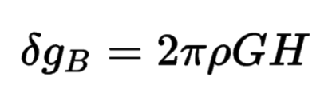
What is your prediction for the Gravity/Topography ratio of the Moon’s Highlands if the density is 2.5 g/cc (porous anorthosite)?
(1 MILLIGAL = 10^-5 m/s^2)

Define

gtr = (g'-min(g(:))./(t'-min(t(:)))); %replace g with your gravity variable
figure;contour(gtr.*(gerr'<40))

Now extract a square patch of highlands:

gtr_highlands_patch = gtr(70:140,100:270) %Notice that this is roughly “degree 2” in spherical harmonics terms

mean(Gtr_highlands_patch(:))

How does this compare to your prediction? What does this imply about lithospheric strength at degrees 2 when the highlands formed?

Assume that the near-side +ve gravity anomalies ('mascons') correspond to lava with a density of 3000 kg/m^3.

Determine the minimum thickness of lava that would be required to explain the mascons if the Moon’s lithosphere did not flex beneath the load of the mascons?

Discuss the difference in gravity to topography ratio between the highlands and the maria in terms of the changes in Lunar geothermal heat flow.

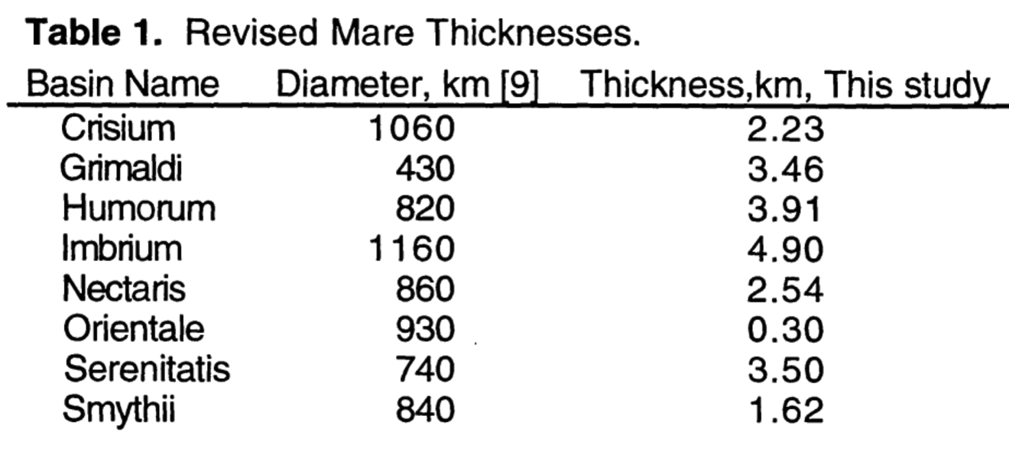
From Williams & Zuber, Lunar & Planetary Science Conference, 1996 – measuring lava flooding depths by comparing the depth of partially-flooded craters to the depth of craters of the same size that had not been flooded.
(Ignore Smythii and Grimaldi.)

Do any of the maria show geologically-inferred flooding depths that are consistent with the lava-fill model? (Which ones?)

Can you think of alternative explanations for the lava-fill model of the lunar gravity anomalies? (The likely solution to the mascon mystery is given in the optional reading for this lab – "Solving the Mascon Mystery" by Laurent Montesi - pdf is on class website).

What are the weaknesses of the dataset you have been working with? What might be the scientific objectives of a follow-up Lunar gravity mission?

In fact, a follow-up mission was flown (GRAIL, P.I. Maria Zuber). Using GRAIL data, Andrews-Hanna et al. Nature 2014. report the discovery of a giant square positive gravity anomaly underneath the basalts of the Moon – missed by Clementine due to limited resolution. They interpret this as the system of extensional rifts through which the lava that forms the flood basalts forms. (Note that the below map shows gravity gradient – positive gravity anomalies plot blue, for negative gravity gradient).
